Armenia e-Health
Feasibility Study Project

2010




E-governance
Infrastructure
Implementation
Unit (EKENG)

Abbreviation
Abbr. | Meaning
ADE | Adverse Drug Effect
API | Application programming interface
ASP | Application Service Provider
BBP | Basic Benefit Package
BPR | Business process reengineering
CBHI | Community-Based Health Insurance
CDA | Clinical Document Architecture
CDSS | Clinical Decision Support Systems
CIS | Commonwealth of Independent States
CPOE | Computerized Physician’s Order Entry
CR | Computed Radiography
DHS | Demographic and Health Survey
DR | Disaster Recovery
EDL | Essential Drug List
EHR | Electronic Healthcare Record
EMR | Electronic Medical Records
ERP | Enterprise Resource Planning
FAPs | Feldsher Accousher Posts
FDA | Food and Drug Administration
HA | High Availability
HIPPA | Health Insurance and Accountability Act
HIS | Hospital Information System
HL7 | Health Level 7
IBRD | International Bank for Reconstruction and Development
ICT | Information and communications technology
ICU | Intensive Care Unit
IDC | Internet Data Center
IE | Internet Explorer
ILM | Information Lifecycle Management
IPS | Intrusion Prevention System
ISP | Information Strategic Planning
LIS | Laboratory Information System
MIS | Management Information System
NHA | National Health Accounts
NIPA | National IT Industry Promotional Agency
NSS | National Statistical Service of RA
O.R. | Operating Room
ODA | Official Development Assistance
OOF | Other Official Flows
PACS | Picture Archiving & Communication System
PHC | Primary Health Care
PHR | Personal Health Record
PK | Public Key
PPP | Public Private Partnership
PR | Public Relations
PSRC | Public Services Regulatory Commission
RDBMS | Relational Database Management Systems
SaaS | Software as a Service
SHA | State Health Agency
SHAE | The State Hygienic and Anti-Epidemiological Inspection of the Republic of Armenia
SHI | State Health Insurance
SLB | Server Load Balancing
SNOMED | Systematized Nomenclature of Medicine-Clinical Terms
UMLS | Unified Medical Language System
VHI | Voluntary Health Insurance
VTL | Virtual Tape Library

Preface
The "Feasibility Study for the development of e-Health system of Armenia“ has been produced by a Feasibility Study Project Team under the supervision of Armenia Ministry of Economy(MOE), National IT Industry Promotion Agency(NIPA), and World Bank.,
The organizations mentioned above Including the team have the ownership on the modification and revision on this report.
For the further information or additional modification, please contact the Feasibility Study Project Team at following e-mail address;

[ Feasibility Study Project Team ]
[Table - 1] Project Coordinator and Manager
Local(Armenia, World Bank) |  |  |  | Korea
Title | Name | Email | Tel | Title | Name | Email | Tel
Project Coordinator | Vahe Danielyan (Deputy Minister of Economy) | vdanielyan@mineconomy.am |  | Project Coordinator | JeongSeok Lim | Jslim2000@nate.com
Project Coordinator | Yong Hyun Kwon (World Bank) | ykwon@worldbank.org
Project Manager | Bagrat Yengibaryan  (Directory of EIF) | info@eif.am |  | Project Manager | YoungEun Lee | flyingwitch@gmail.com

[Table - 2] Project Consultants
Local(Armenia) |  |  |  | Korea
Title | Name | Email | Tel | Title | Name | Email | Tel
Consultant | Ani Manukyan(EIF) | ani.manukyan@eif.am |  | Consultant | SangYong Cha | syc0004@hotmail.com
Consultant | Artur Ghulyan (Director of EKENG) | Arthur.ghulyan@ekeng.am |  | Consultant | ByungSun Park | Wind2sun@gmail.com
Consultant | Gayane Nalbandyan(EKENG) | gayane.nalbandyan@ekeng.am |  | Consultant | SeungHo Lee | lshofree@naver.com
Consultant | Armen Parsadanyan (MoH) | Armen@parsadanyan.am |  | Consultant | SaeHo Jun | seko84@gmail.com
[ Registration information ]
- Document Name: Armenia e-Health Feasibility Study Report
- Document Type: Microsoft Word
- Document Version: 1.1
- Producer: YoungEun Lee
- Last Modifier: ByungSun Park
- Last Modification: 2010-11-24

[Table - 3] Revision History
No. | Version | Date | Reason | Description | Modified by
1 | 0.15 | 2010.10.18 | Armenia Role revise | - Project Supervisor change  - EKENG Activities break down | YoungEun Lee
2 | 0.30 | 2010.11.01 | Revised based on comments | System logic, Organization and etc | YoungEun Lee
3 | 0.90 | 2010.11.11 | Supplement | Supplement of full-set document | ByungSun Park
4 | 1.00 | 2010.11.23 | Supplement | Revised based on last comment | ByungSun Park
5 | 1.1 | 2010.11.24 | Supplement | Fix miscalculated number in Table-60,62,68,69,71 | ByungSun Park

Executive Summary
This report is an output of feasibility study for e-Health project aiming for advancement of Armenia public healthcare. For this report, all matters necessary for Armenia e-Health project were investigated and studied so that the informatization project can go smoothly without any risks.
Since its independence from the Soviet Union in 1991, Armenia’s healthcare sector had faced many difficulties due to disproportionate allocation of insufficient resources, lack of opportunity to get medical services and low service quality. But there were the government’s proactive and continuous efforts with a national healthcare reform policy, Armenia earned significant achievements in terms of public health and welfare.
Even though they have far more way to go for the healthcare sector development, Armenia has been endeavoring to modernize medical services, guarantee appropriate medical care and ensure transparent operation of health system by introducing advanced electronic information system.
Through e-Health adoption optimized in Armenia condition, Armenia looks forward to enhancing service quality in healthcare and protecting public(patients) health. It’s not just automating processes and tasks related in the sector, but upgrading and improving entire national health system by returning benefits to all parties consisting of the system such as MOH, medical institutions, insurance and pharmaceutical companies, medical equipment manufacturers & suppliers and others.
A Central Database implementation will allow public to get sufficient health information, and epidemic disease prevention & monitoring support as well as allow medical institutions exchange medical information including patients’ treatment history; enhancing high-possibility of critical information attainment to health-related public agencies and companies, the system will come to contribute toward the health industry vitalization.
A Central HIS(Hospital Information System) provides a standardized process to hospitals, polyclinics, and primary care institutions, it supports information services without requiring separate investment from each institution, and it provides one big information network connecting all medical relations.
It is such a difficult and complex project to build the systemic and ideal e-Health system demanding lots of time, money and effort. In order to work efficiently, the new e-Health system will be tactically phased in as follows.
Having long-term vision and strategic fulfillment for ultimate e-Health implementation, the project will be run by 4 phases including a continuous expansion phase afterwards.
First phase is a Foundation and here the law and regulation initiatives will be defined by clarifying the basis of project promotion and driving force should be addressed by organizing a project team.
In the 2nd Prototyping phase, medical information standards are established for a Central DB implementation. It will enhance the level of infomatization by allowing information exchange. In addition, hospital business/work processes are analyzed and defined to get support by the health information system. In order to verify the possibility of adoption and expansion of the standards established earlier, CPOE(Computerized Physician’s Order Entry), the core function of HIS, is implemented in a selected hospital as a pilot target. By allowing system operation, it will be able to verity data collected in the central DB and compensate any defects of standardization.
The 3rd phase is Integration, the full-scale deployment phase. In this phase, the additional core functions such as LIS(Laboratory Information System) and EMR(Electronic Medical Records) will be implemented based on CPOE system built in the previous step. Also IDC(Internet Data Center) will be built to expand the system on each medical institution. By implementing a central DB in the center which will play a role as a medical information hub, it allows medical institutions to exchange electronic medical information and allows stakeholders to connect each other and utilize it through interface systems.
The final phase, Expansion, focuses on enhancing the level of medical information utilization and the quality of healthcare service at national level. One side, the system will be upgraded by connecting the central DB system to all health-related institutions along with providing information of all their activities, and on the other side, additional functions will be developed and serviced on the central HIS(in that case, it’s critical to meet the needs of various information provision from several medical institutions.)
The advanced e-Health system will enhance work efficiency of medical institutions by allowing them to collect and utilize information in real-time along with effectual information management. It also will enhance public satisfaction and provide user convenience through the provision of useful health information (e.g. various disease).
Finally, Armenia can seek for industry vitalization of and improve the quality of medical information service.
- Improve the quality of healthcare service and reduce the national health expenditure
- Enhance public(patient) health and welfare by activating the national health surveillance system
- Allow health authorities to establish an effective health policy with reliable information
- Seek for work efficiency and cost savings by Improving work processes of medical institutions
- Enlarge national technology infrastructure by transferring advanced technology and securing technical ability

Above all, any conflicts between parties in health service must be resolved first and it is compulsory to make a national agreement from public for the successful e-Health introduction and implementation. Also the constant attention, effort and cooperation between the parties are absolutely required.

Outline of Project

Project Background
The Armenian government has achieved continuous economic growth with its new economic system based on the market economy after its independence. In the medical and health sector, diverse medical reforms have been carried out such as privatization, new experiments with medical finance systems and high-efficiency hospital systems in order to realize the improvement of medical service quality and efficiency. As part of such reform efforts, much attention has been paid to the adoption of a nationwide e-Health system which is an advanced medical information system.
The Armenian government has studied cases of advanced and neighboring nations to adopt an e-Health system that meets its own needs. In particular, in order to establish a successful medical information system it has been strengthening its partnership with the Korean government which has implemented a high-tech health information system and secured operational expertise.
The World Bank and Korea’s NIPA (National IT Industry Promotional Agency) have determined to strengthen the partnership with the Armenian government and Ministry of Health which are working to improve the county’s medical service quality by introducing an advanced health information system(e-Health). Through a feasibility study, an e-Health system which would satisfy the needs of Armenia has been identified, which is expected to reduce potential risks and errors inherent in introducing a new system. We have started the consulting service for successful project implementation.

Project Objectives
The purposes of the feasibility study are as follows:
- To develop an e-Health model to improve medical service quality and transparency
- To define e-Health architecture which fits to the current conditions in Armenia
- To minimize system implementation risks, and provide a multi-stage roadmap which can be put into an action immediately
- To develop an adequate budget plan for project conduct, and present expected positive effects

Project Scope
Realistic an e-Health model and multi-stage implementation roadmap will be defined by analyzing current informatization level of the responsible medical and health policy organization in Armenia.
Detailed activities for this will be conducted for three months from August of 2010 based on the following schedule:
1) Report of work initiation in Armenia (Aug. 4 ~ Aug. 8)
: Kick-off and interview with related organizations (The Ministry of Health, Central Government, hospitals & etc.)
2) Midterm Workshop in Armenia (Sept. 3 ~ Sept. 13)
: Additional interview with hospitals and related organizations, and defining of “To-Be” direction
3) Completion report in Armenia

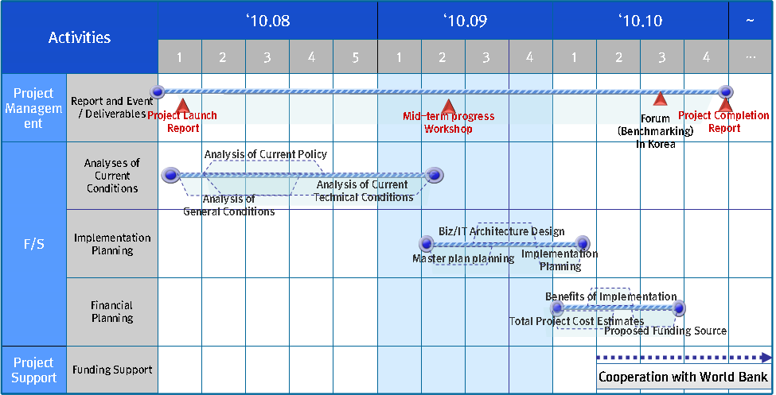
[Figure - 1] Implementation schedule

Project Organization
The following shows the structure and role of an organization for a feasibility study.
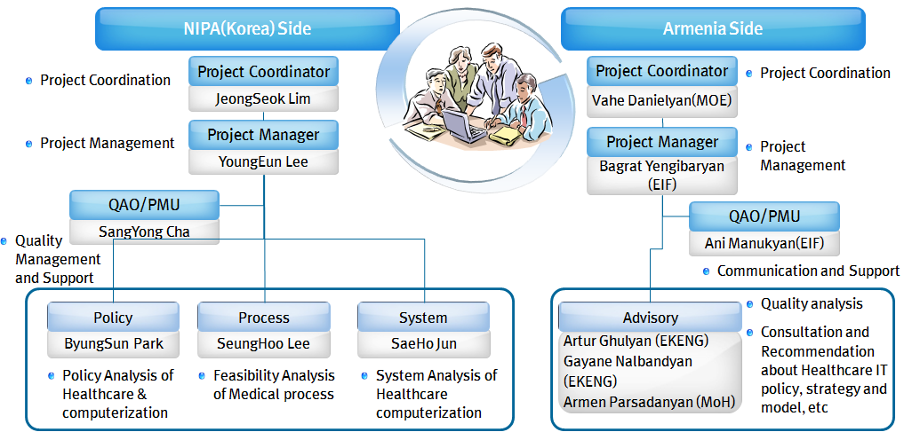
[Figure - 2] Implementation Organizational chart

[Table - 4] Project Implementation Organization and Its Role
Classification | Role | Responsible person | Details | Note
NIPA | Project Coordination | Jeongseok, Lim | - Decision-making of major issues and project support
NIPA | Project management | Youngeun, Lee | - Management of project planning, schedule, and implementation  - Decision-making of major issues
NIPA | Quality control | Sangyong, Cha | - Project product quality management
NIPA | Policy analysis | Byungsun, Park | - Analysis of current conditions  - Analysis of vision, strategy and policy
NIPA | Process analysis | Seungho, Lee | - Analysis of informatization progress  - Analysis of business process
NIPA | System analysis | Seho, Jeon | - Infrastructure analysis  - Establishment of implementation plan
Armenia | Project Coordination | Vahe Danielyan | - Decision-making of major issues and project support | Deputy Minister of Economy
Armenia | Project management | Bagrat Yengibaryan | - Management of project planning, schedule, and implementation  - Decision-making of major issues | Director of EIF
Armenia | Quality control | Ani Manukyan | - Cooperation and support | EIF
Armenia | Advice/consultation | Artur Ghulyan | - Review of Document  - Quality analysis  - Recommendations on the document content  - Review of the direction of informatization efforts and provision of support | Director of EKENG
Armenia | Advice/consultation | Gayane Nalbandyan |  | EKENG
Armenia | Advice/consultation | Armen Pasadanyan | - Review and support in relation to medical policy, informatization progress, and To-Be model | MoH

Political Analysis
This section is to analyze current state on Armenia’s health policies, health service delivery system and the related examples in order to develop the health information system that is suitable for Armenia’s health policy.

Health Policy Analysis

The Status of Armenia Health Policy
[Overview]
Upon independence from the Soviet Union in 1991, Armenia's health sector was faced with a number of challenges. Access to and use of health services was low, resources were poorly and inequitably distributed, and the quality of care was low, especially in the cities and rural areas outside Yerevan. Furthermore there was a high level of payment-on-delivery expenses to doctors, with a large number of narrow specialists and insufficient general practitioners.
In the mid-1990s the Armenian government started a healthcare reform program to improve its system, which at the time provided 7.6 hospital beds per 1,000 people – the worst ratio in the region.

[Table - 5] Some indices of medical care level in the Post Soviet Republics
Nations | Physicians | Hospital beds
Armenia | 3.1 | 7.6
Azerbaijan | 3.9 | 9.9
Belarus | 4.2 | 12.3
Estonia | 3.0 | 8.1
Georgia | 3.5 | 7.8
Kazakhstan | 3.6 | 10.3
Lithuania | 4.0 | 10.6

In the former Soviet Union, the healthcare system was highly centralized. Medical services were basically accessible for the whole population. After independence, the unfavorable socioeconomic and political situation brought forward the need for developing a program of radical reforms.
The system reforms initiated since mid-1990s were based on the condition that health services could no longer be freely provided to the whole population.

The reforms specifically sought to improve access to healthcare for the poorest section of society, which previously had little or no exposure to services.
Armenia began reforming the health care sector including the adoption of the 1996 Law on medical aid and services to the population, and the introduction of formal user charges in 1997. The changes had applied concentrating on the following three main areas:
(1) Decentralization, involving devolution and privatization;
(2) Implementation of new approaches to health care financing; and
(3) Optimization and increasing health system effectiveness.

(1) Decentralization - The decentralization process has expanded institutional autonomy and administrative rights and responsibilities. In brief, it involved both devolution of responsibility for service provision (primary and secondary care) from central level to regional/local health authorities and of financial responsibility from governmental to facility level, as well as the privatization of hospitals and health care facilities in the pharmaceutical and dental care sectors. This was regulated by the Law on privatization and denationalization of state enterprises (later superseded by the 1998 Law of the Republic of Armenia on privatization of state property).
Privatization of health facilities was, however, implemented arbitrarily and without a systematic approach.
Privatization aimed to create an environment that would facilitate individual and organizational investments in the health care system. However, the Government did not set any requirements for private investments but instead continued to provide funding to privatized institutions.
Indeed, instead of providing an instrument to optimize the system – reducing excess capacity and informal payments, and improving management, efficiency and quality of services – privatization accelerated expanding capacity even further without any of the anticipated improvements. The Government has reviewed this process and recently put a halt to further privatization in the health care sector so as to evaluate the results, review the strategy and develop new models of and approaches to privatization.
Overall, the decentralization process, while increasing autonomy and shared responsibility, also brought considerable challenges as a result of the functional disintegration of the system. In particular, relations between health care institutions and health professionals are being undermined, the referral system has become dysfunctional and both internal and external quality control mechanisms are lacking. At the same time, the regulatory capacity of the Ministry of Health has fallen, negatively impacting on health system performance. The administrative autonomy granted to health care facilities did not provide sufficient stimuli to increase the cost–effectiveness and quality of services.

(2) Health financing reforms - From the new approach of health financing, the reforms in Armenia focused on diversifying revenues for the health care sector and linking health care financing to the quality and volume of care provided. In view of the limited resources available, financial reforms also aimed at advancing financial management and increasing financial sustainability and accountability of institutions in the health sector.
Thus, in 1997, the Government decided to earmark budgetary resources as a means of targeting the socially vulnerable population and so-called socially important diseases. In 1998, the Government introduced the BBP which comprises a publicly funded package of services specifying a list of services that are free of charge for the entire population and stipulating the population groups that are entitled to receive any type of health care service for free.
The BBP has been periodically reviewed since, with the range of services and/or population groups covered being extended or reduced, depending on the level of funding available. This has resulted in considerable uncertainty, creating wariness among service users and health care providers alike. Yet, because of the widespread system of informal payments in health care facilities, even those population groups that are entitled to free health care are frequently asked to pay for services provided, a practice also seen in many other countries of the former Soviet Union.

Experience with the BBP since its introduction in 1998 has shown that the allocation of public funds to almost all health care facilities does not guarantee medical care free of charge. It also shows that resources are not being used efficiently, that health care providers are not motivated to support health system development and that, ultimately, and the population has no confidence in state-funded health care.

Health care facilities receive state funding based on a regular reporting mechanism on the provision of services under the BBP. This is regulated by the Ministry of Health through a system of global budgeting, administered by the SHA. However, excessive reporting is a frequent occurrence.

In 2003, the Ministry of Health introduced co-payments under the BBP for Yerevan hospitals. This measure aimed to assess the potential of formal co-payments as a means to increase revenue for health care facilities as well as to reduce the level of informal payments. The newly introduced co-payments have not yet enabled health facilities to generate sufficient additional revenue to cover their costs and the level of informal payments has not been reduced noticeably.

The Ministry of Health is currently experimenting with different models to increase efficiency, financial management, accountability and the financial sustainability of health care facilities. Determining the scope and contents of the catalogue of benefits and services provided by the publicly funded system will be central to health financing reforms, as will be the consolidation of all resources for health care.
Current efforts to develop a system of National Health Accounts (NHAs) go some way towards improving the transparency of health sector financing and informing decision-making in this area.

(3) Optimization and increasing health system effectiveness - Structural and functional reforms seek to rationalize performance and the operation of health care providers and the health care system in general through the reduction of excess capacity, redistribution of resources, elimination of inefficient structural units and the merger of facilities with common functional and geographical attributes. In many ways, the period before 2000 may be considered a preparatory stage for the optimization of the health care sector, characterized by data collection and exploratory projects. In 2000, the Ministry of Health proposed the “Concept of the optimization of the health care system of the Republic of Armenia”, subsequently approved by the Government.
It outlines the conceptual approach, methods and mechanisms for optimization. In 2001, the Ministry took the lead in developing separate optimization action plans for each region.
However, the first phase of optimization met with some challenges. The plan was not comprehensive and limited to separate activities within marzer.
Also, it did not address the substantial capacity gap between urban and rural areas, which is in excessive oversupply in urban areas only. Thus, capacity reduction was almost exclusively limited to hospitals outside the capital and the estimated savings were largely achieved through the closure of small rural hospitals and the reduction of bed numbers in regional and urban hospitals.
This is now changing, with recent efforts concentrating on the Yerevan area. Corresponding policies have, however, created some concern, particularly within the Ministry of Health. Thus, in 2003, the Government issued a decree which designated 37 republican and municipal health institutions in Yerevan to be merged and integrated into 10 health care centers.

The reform of Armenia healthcare sector has brought the positive and negative features. On the negative side, a majority of the population had to pay the full cost of medical services. In spite of the government’s effort to provide free medical care to vulnerable groups of the population by the state-guaranteed programs, the under-financing of the health sector implied that even the persons included in these groups had to make partial payments. Thus, the changes violated the principle of equity and caused concerns about the deterioration of the population’s health.
Also, while the emphasis of current reforms is on improved state budget financing and more efficient use of those resources, the majority of financing is still derived from out-of-pocket payments, both formal and informal. Out-of-pocket payments now constitute an estimated 65% of all health care expenditure.

International and humanitarian assistance programs and initiatives aimed at improving the health care system are often poorly coordinated, owing to the absence of a clear government policy and strategic framework combined with donor restrictions and expectations. Despite significant investments in primary care, a disproportionate share of resources has been allocated to secondary and tertiary care.
Yet, despite these numerous challenges, Armenia is increasingly engaged in reforming the system from one that emphasizes the primary care and treatment of disease and response to epidemics towards a system emphasizing prevention, family care and community participation., As of January 2006, free access to polyclinic services was introduced for all Armenians, which has resulted in the annual number of visits to out-patient facilities per inhabitant increasing from 1.8 to 3.0 in the period 2001 to 2007. The proportion of individuals visiting primary healthcare facilities in the bottom two quintiles of society has also increased from 3.5 percent in 2003 to 6.5 percent in 2005, while between 2002 and 2005 there has been an almost 30 percent increase in inpatient admissions, with 44 percent increase amongst the poor and vulnerable.

Organizational Overview of Armenia Health System
Armenia’s health administration structure consists of two levels, with the first level consisting of 10 provinces (marzes) and the capital Yerevan, considered the equivalent of a province. The second level consists of 37 rayons, which are former administrative units from the Soviet period.
The health care system is divided into three administrative layers: national (republican), regional (marz) and municipal or community. Following the decentralization and reconfiguration of public services after independence, with the exception of the state hygiene and anti-epidemic (SHAE) services and several tertiary care hospitals, operation and ownership of health services have been devolved to local governments (for PHC) and provincial governments (for hospitals).

The health system today comprises a network of independent, self-financing (or mixed financing) health services that provide statutory services and private services. Where formerly hospitals had nominal accountability to the local administration and were ultimately answerable to the Ministry of Health, they now have financial autonomy and are increasingly responsible for their own budgets and management. Regional government, however, continues to monitor the care provided while the Ministry of Health retains regulatory functions.
Almost all pharmacies, the majority of dental services and medical equipment support has been privatized, as have a number of hospitals in Yerevan

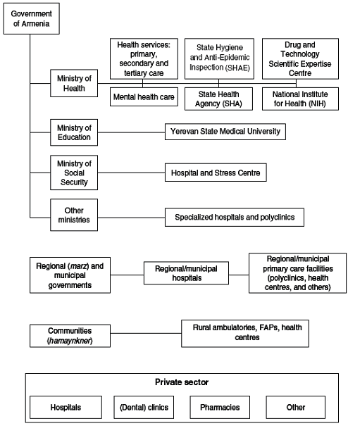
[Figure - 3] Organizational chart of the health care system
[MOH]
The responsibilities of the Ministry of Health have changed considerably since independence. Previously, the ministry was responsible for all the planning, regulation, financing and operation of health services. However, it has gradually reduced some of these functions and activities and has assumed a wider coordinating role and increased its role in developing national health policy in line with country priorities: defining strategies to achieve objectives, defining and applying national health standards and norms, ensuring quality control and developing and overseeing state-funded programs.
Policy objectives are achieved through shared responsibilities with regional and local governance bodies and health institutions. Overarching objectives are to increase the efficiency and effectiveness of the health care system and to protect and improve the health of the population.

[The State Health Agency]
The SHA was established in 1998 as a purchaser of publicly financed health care services.
This move was considered a preparatory step towards instituting a national social health insurance system. The SHA maintains a central office in Yerevan, but also has a capital city department and 10 regional branches in every marz of the country. Though initially created as a semi-governmental organization independent of the Ministry of Health, in 2002 the SHA was transferred to the jurisdiction of the Ministry of Health. The SHA holds a mandate to monitor the effective utilization of state budgetary allocations received from the Ministry of Finance. It is responsible for the allocation of financial resources, based on annual contracting mechanisms with health care provider organizations.
Its main functions include:
- Contracting with health care providers for the delivery of publicly financed health services, according to the law;
- Activity and financial reporting on signed contracts;
- Allocating funds to health care providers;
- Supervision of the quality and quantity of publicly financed health services according to established standards; and
- Participating in the development and introduction of standards, norms, modern approaches to organization, management and financing of health services.

[Other ministries and institutions]
The Ministry of Finance plays a critical role in the verification and adoption of health sector budgets. It is also responsible for the collection and disbursement of tax revenues, serving both the Ministry of Health and the SHA.
The Ministry of Education shares responsibility for undergraduate and graduate medical education including nursing education.
The Ministry of Defense, the Ministry of Internal Affairs and others, including some nongovernmental and professional organizations, run parallel health services that provide health care and preventive services directly to their employees and their families. They operate a limited range of PHC facilities and a small number of hospitals. These facilities are not accessible to the general public and there is little indication at present that this will change in the foreseeable future.
The Ministry of Labor and Social Affairs is responsible for the protection of the most vulnerable segments of the population and, in conjunction with the Ministry of Health, is responsible for providing care for the elderly, refugees, veterans, the disabled and others.

[Regional/local government]
Following the restructuring of Armenian local government, there are now 11 regional governments (10 marzer and the city of Yerevan) that have taken over district responsibilities for health care. Initially, the regional governments were responsible for funding local health care services. This function was, however, transferred to the SHA in 1998. Nevertheless, while regional governments are no longer directly involved in the financing of health care institutions they retain certain planning and regulatory powers in the general governance of health care services. Generally, regional and local governments do not have to report to the central Government; however, they have to comply with the national orders and policies set by the Ministry of Health, in particular those related to the control of infectious diseases, through negotiated procedures and processes. There is still a degree of accountability of regional health care institutions to regional government in that they have to report on funded activity; however, hospitals and polyclinics are increasingly autonomous, at least in financial terms.

[Insurance organizations]
The role of voluntary health insurance (VHI) is relatively small. At present, there are approximately 20 officially registered and licensed private insurance companies but only 20% of these are engaged in VHI.
Only one of them is a hospital-based health insurance company, while others are general commercial companies.
Some steps have been made towards initiating Community-Based Health Insurance (CBHI) schemes in the country. Thus, Oxfam, in partnership with a local NGO “Support the Community”, has been running CBHIs in two rural districts since 1995.
The scheme aims to provide essential PHC, through village health posts, that is affordable, equitable and accessible to all, especially the very poor. It guarantees unlimited use of the health facilities, including free provision of drugs, in return for a fixed monthly fee of initially 500 Armenian drams, just under US$ 1. More recently this has been increased to 2000 AMD per quarter. CBHIs are now operational in 120 villages covering approximately 80 000 people.
[Private sector]
The private sector has been slow to develop, beyond the privatization of former public health facilities. The legislation of 1996 (Law on privatization of public property) allowed private practice by licensed physicians. However, except for some obstetrician-gynaecologists and psychiatrists, only few have taken this opportunity to date.
The legislation also permits the establishment of private hospitals; however, the 1998 Civil Code of the Republic of Armenia which in part also regulates hospital activity, does not foresee the establishment of non-profit-making hospitals. Thus, hospitals in Armenia are generally considered to be for-profit, regardless of status and ownership, even though they may be operating on a not-for-profit basis.
Thus, public health care facilities do not have to pay taxes on profit and/or property only if they are considered to be budgetary institutions. There has been a recent move towards legally distinguishing for-profit and non-profit-making hospitals, on the grounds that the non-profit making hospitals should not be taxed on profits.

[Professional organizations]
There are over 40 professional medical associations, including the Armenian Medical Association, founded in 1992, the Armenian Youth Medical Association, and the Armenian Dental Association as well as a nurses association, founded in 1996. However, with the possible exception of some medical specialist associations, they have not played a noticeable role in decision-making. Trade unions in the health care sector are rather weak, offering little protection to doctors and nurses who are now able to negotiate individual contracts with their employers, be they a hospital or polyclinic director. This is particularly a problem in the private sector where employment rights have been undermined frequently.

Healthcare Financing

Healthcare Revenue Mobilization
Healthcare financing is both directly in the form of out-of-pocket payments and health insurance prepayments (whether voluntary or compulsory), and indirectly in the form of general taxation.
Historically, the state budget was the primary funding source. Currently, the health system is financed both from domestic and from international sources.
The main domestic sources are the state budget and direct out-of-pocket payments by the population. International financing sources are general humanitarian donations and project-specific support. While the emphasis of current reforms is on improved state budget financing and more efficient use of those resources, the majority of financing is still derived from out-of-pocket payments, both formal and informal.
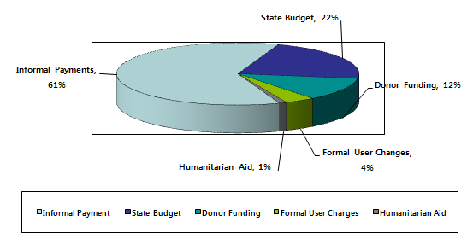
[Figure - 4] Health care financing by funding source, 2003

[Main sources of finance]
The state budget remains the main formal source of financing. As noted above, state funds are derived from general tax revenue, including customs fees, VAT, excise tax, income tax, property tax and ecological fees. There is no tax that is specifically earmarked for the health care sector.
State health expenditure is not sufficient to support the core system and to meet the health needs of the population. Current state financing is estimated to be at just over one fifth of total health expenditure in the country.

[Table - 6] State financing of the health system, 1990–2004 (selected years)
Indicators | 1990 | 1995 | 1999 | 2000 | 2001 | 2002 | 2003 | 2004
GDP (billion drams) | 10.1 | 522.3 | 987.4 | 1,031.3 | 1,175.9 | 1,362.5 | 1,624.6 | 1,896.4
State budgetary expenditure for health (billion drams)
Planned | 0.3 | 12.6 | 18 | 19.9 | 18.6 | 16.2 | 21 | 24.8
Actual | 0.29 | 9.6 | 13.6 | 9.8 | 15.7 | 15.9 | 19.6 | 24.7
State budgetary expenditure for health as % of GDP
Planned | 3 | 2.4 | 1.8 | 1.9 | 1.6 | 1.2 | 1.2 | 1.3
Actual | 2.9 | 1.8 | 1.4 | 1 | 1.3 | 1.2 | 1.2 | 1.3
State budgetary expenditure for health as % of state budget
Planned | 8.4 | 10 | 7 | 6.5 | 7.5 | 6.2 | 5.9 | 5.4
Actual | 8.1 | 7.7 | 5.4 | 4.2 | 6.1 | 5.7 | 5.9 | 5.4

[Out-of-pocket]
As indicated above, out-of-pocket payments now constitute a major source of revenue for the health care system in Armenia, at an estimated 65% of all health care expenditure. These payments can be divided into three categories:
- Official (formal) co-payments charged for services that are only partly covered by the state budget;
- Official (formal) direct user charges for the provision of services outside the state benefits package, and
- Unofficial or informal payments, including gratuities provided on a voluntary basis or demanded by providers for services, over and above the official state payments and user fees.

(1) Co-payment - Co-payment mechanisms are widely used in many countries as a means of balancing access and appropriate utilization and they may constitute a considerable proportion of health care expenditure. The situation is different in Armenia. Following an unsuccessful pilot of introducing co-payments for child delivery as of September 2001 (but lasting for one quarter of a year only), in October 2003 co-payments were introduced for specified inpatient services provided in Yerevan’s hospitals. Co-payments are only charged to residents who are not considered socially vulnerable and are a fixed flat rate of AMD 10 000 (US$ 18) for admission to the hospital and according to a list of diagnoses as approved by the Ministry of Health.

(2) Official direct user charges - Official user charges were introduced in 1997, alongside the introduction of the state BBP for services not covered under the BBP. The actual level of user charges outside the state BBP is not regulated. Health facilities usually adopt their own list of prices or fees, which are generally comparable to those charged within the state BBP or are sometimes even lower. This is because health facilities aim to ensure that the services they provide are affordable to their users even though the fees may not be sufficient to recover actual costs. On the other hand, this practice can be interpreted as an attempt to decrease the taxation burden, and also to charge informally.
The SHA is partly involved in this process by means of verifying the eligibility of patients and services claimed under the BBP. Until April 2001, the SHA collected data on out-of-pocket payments but did so without analyzing them any further because of a lack of capacity, time and incentives.
Overall, there is little monitoring of the actual volume of user charges outside the BBP; while corresponding data have to be reported to marz governments and the Ministry of Health, there appears to be no direct link to decision-making. This lack of monitoring is likely to undermine the appropriateness of services rendered to those segments of the population not eligible for the BBP.

(3) Unofficial or informal payments - During the Soviet period, informal gratuity payments became standard practice in secondary and tertiary care settings. This practice reflected both the gratitude of patients receiving care and an acknowledgment of the low salaries within the health sector; however, informal payments were not perceived as a significant source of health financing. With the economic collapse following independence, informal payments effectively became the sole financing source for the system. The introduction of official user charges in 1997, noted above, aimed to legitimize this revenue stream but with little success thus far. Insufficient reimbursement levels for services both within and outside the state-funded BBP that are provided in health care facilities, along with the lack of correspondence between service production and the remuneration of staff, reinforce this practice.
Informal payments have now developed into an almost formalized system of fees, including barter goods and services in rural areas, for health care providers, auxiliary personnel and administrators. It is difficult to provide accurate estimates of the size of the informal payments patients are being charged when consulting a health professional, partly because few estimates distinguish between the formal tariff payments for services and the additional informal payment. Also, the amount will vary depending on the type of service, health professional, patient and location (urban/rural). Limited evidence suggests that the highest informal payments are being requested for obstetrics/gynaecological services, followed by surgery and any procedure or service related to death or dying.

[Other sources of finance]
Official external health financing sources include humanitarian aid (donations of medical supplies and equipment) as well as credit and grant programs with or in coordination with the Ministry of Health. Following the devastating 1988 Spitak earthquake Armenia received considerable international humanitarian assistance, which continued through the early phase of independence. The volume of humanitarian aid has, however, declined as benefactors have shifted their focus towards development efforts or have left Armenia.

Government Health Expenditure
The government health spending as a percentage of GDP has shown an increase since 2002. Remarkably enough, it was entirely due to the Government of Armenia’s rapid prioritization of health in public resource allocation. Between 2002 and 2007, the increase in government health spending has accordingly outpaced the growth in both the GDP and overall government spending. During this period, spending on health care as a percentage of total government spending increased from 6.7% to 11.6%, while as a percentage of GDP it increased from 1.4% to 2.1%. However, this trend was abruptly reversed in 2008 due to the consequences of the financial and economic crisis on the country. Data from the National Health Accounts (NHA) show that although GDP and total government spending both increased in absolute terms in 2008, public expenditures on health fell significantly from AMD 66 billion to AMD 53 billion.

The Government of Armenia assigned the high priority to health over the last seven years. According to international comparisons for 2006 on health as a percentage of total government spending, Armenia stands out notably compared to other countries of the south Caucasus region.

The international comparisons from 2006 show that in Armenia, a larger share of health expenditure comes from public sources than in the other countries of the south Caucasus. However, the share of health funding that comes from out-of-pocket payments, the most inequitable source of payments, is still quite high, accounting for more than 50% of total funds in 2006. In essence, the overall increase in health spending has been financed through the government budget, while household health expenditures were 50.8% in 2008.

The households in the poorest wealth quintile spend on average more than twice as much of their income (26.2%) for health care. By comparison, households in the richest quintile report spending on average only 5% of their income on health care, while the other three quintiles report spending between 9% and 11%. The 2006 survey also shows that 16% of Armenian households were incurring catastrophic medical expenses.

In the Primary Health Care Strategy 2003–2008, the target for the ratio of government spending on the primary health care sector to its spending on the hospital sector is 60:40. Government expenditures in both sectors have grown significantly, increasing from a total of approximately 12 billion drams in 2001 to 38.5 billion drams in 2008. However, the growth in spending on primary health care has been especially rapid, increasing more than six fold over this time period, reaching the point in 2008 where government expenditures on primary health care and on hospitals were essentially equal.

Medical staff salaries as a percentage of total health expenditures increased between 2006 and 2008 for both the hospital and the primary health care sectors. These results suggest that the share of health expenditures devoted to patient care has increased recently as reforms have been implemented in both sectors.

Health policy and strategy on international investment and cooperation
The World Bank supports Armenia to improve the organization of the health care system in order to provide more accessible, high quality, and sustainable health care services to the population, in particular to the most vulnerable groups. 1,082 family physicians and 988 family nurses have been already retrained through a Bank project. 82% of the population is covered by qualified family medicine practices, exceeding the 60% target for first phase of the Health project. Twenty rural clinics have been newly built or repaired and equipped with modern equipment.

Three pilot hospital mergers in Yerevan have helped to significantly increase efficiency and productivity gains. Hospitals in Hradzan and Ijevan towns have been renovated and equipped with modern medical equipment. All public hospitals use updated financial management and accounting procedures.

[Figure - 5] Active Portfolio by Sector as of September, 2009

As shown in [Figure - 14], the World Bank provides support mainly in water(19.80%), public administration & law sector (17.41%) and the health care & SOC sector (16.31%), which indicates there is high interest of Armenia government and global institutions in improving and investing public sector.
Also, The World Bank launched the Armenia Country Partnership Strategy (CPS) for 2009-2012 in June 2009. The CPS was developed in close partnership with the Government of Armenia and is firmly grounded in Armenia's Sustainable Development Program (SDP). The Strategy was prepared in the context of the global economic crisis and its impact on the country. It focuses on the near-term needs of addressing vulnerability and mitigating the adverse poverty effects of the crisis as well as laying the foundation for promoting medium term competitiveness and growth. The CPS provided for new IDA/IBRD lending of $545 million over 2009-12.
The current portfolio of active projects in Armenia consists of sixteen projects (thirteen IDA credits, three IBRD loans, and a Geofund project) with a total commitment of $429.9million, of which $172.3million is undisbursed.
The following table briefly shows the projects. The health system modernization project(APL 2 – the Second Adaptable Program Lending) which focuses on completing the family medicine-based PHC reform aims to provide high quality of medical treatment and ensure transparency on health care management through such investment including an IT system. Also, computerization project in judicial reform is on-going to improve the efficiency and transparency of judicial operations and services.

[Table - 7] World Bank’s Armenia Project Brief
Project Name | Schedule | Total cost (mil $) | Project Purpose
Irrigation Rehabilitation Emergency Project | 2009.07 - 2011. 06 | 36.33 | The project is aimed at improving water use efficiency in two selected irrigation schemes while fostering immediate rural employment.
Lifeline Roads Improvement Project | 2009.02 - 2013.12 | 126.08 | The Lifeline Roads Improvement Project aimed at rehabilitating a total of 430 km of lifeline roads in twelve regions of Armenia.
Rural Enterprise & Small-Scale Commercial Agriculture Development Project | 2005.07 - 2010.12 | 29.93 | The objective of the project is to support the development of Armenia’s small and medium-scale rural businesses.
Avian Influenza Preparedness Project | 2006.06 - 2010.07 | 11,408 | The objective of the project was to minimize the threat in Armenia posed by the Highly Pathogenic Avian Influenza (HPAI) infection and other livestock diseases, and to prepare for the control and response to an influenza pandemic and other zoonoses or infectious disease emergencies in humans.
Urban Heating Project | 2005.07 - 2010.12 | 23.0 | The project aimed to mobilize communities and the private sector to develop an enabling environment for effective and safe provision of heating services.
Access to Finance for Small & Medium Enterprise Project | 2009.02 - 2011.09 | 50.00 | The project's development objective is to maintain or increase the Armenian small and medium enterprises’ access to medium-term finance.
Second Judicial Reform Project | 2007.03 - 2012.12 | 37.46 | The project objectives are to improve the efficiency, reliability and transparency of judicial operations and services, and to further improve awareness of judicial services and access to legal and judicial information.
Public Sector Modernization Project | 2004.05 - 2010.10 | 10.6 | The objective of the project is to enhance the efficiency in public sector management through piloting innovations in selected institutions.
Health System Modernization Project APL2 | 2007.05 - 2012.12 | 29.62 | The APL2 of HSMP is focused on completing the family medicine-based PHC reform (launched in 1996) to ensure that every Armenian citizen will have access to a qualified and well-motivated family doctor and nurse of his/her choice, consolidating the hospital sector to minimize waste of scarce resources and improve quality of care, strengthening the government’s competencies for effective stewardship in policy making, regulation, oversight and public accountability.
Social Investment FundⅢ | 2006.10 - 2011.06 | 48.3 | The aim of the Project is to support the Government’s policy to raise the living standards of the poor and vulnerable groups.
Second Education Quality and Relevance Project | 2009.05 - 2014. | 31.26 | The second phase of the EQRP continues to focus on the reforms of general secondary education system, also addressing key policy issues in both higher education and preschool education.
Social Protection Administration Project | 2004.06 - 2013.05 | 11.81 | The development objective is to improve the effectiveness of the public employment, pension and social assistance systems through the introduction of improved business processes, administrative procedures and techniques designed to enhance social protection to poor and vulnerable population groups.

Summary on Armenia Health policy
- After independence, Armenia attempted to reform a health sector focusing on decentralizing health system, balancing and increasing the efficiency of the hospital system and establishing the financial mechanism of health system, but it resulted in difficulty in delivering and managing healthcare service due to the lack of comprehensive strategies and directions for the health reform program.
- The health policy has been pushed to strengthen the primary care and prevention system as well as enhance community involvement, but it shows some difficulties with regulating health service delivery and funding due to excessive informal payment both in public and private health sector.
- Despite of Armenia government efforts to improve efficient health expenditure and funding utilization, formal/informal user charges are still the main source of health funding.
- Due to little monitoring of the actual volume of user charges outside the BBP and no direct link to decision-making with corresponding data for reporting to marz governments and the Ministry of Health, it is likely to undermine the appropriateness of services rendered to those segments of the population not eligible for the BBP.
- Insufficient reimbursement levels for services at the state-funded BBP that are provided in health care facilities, along with the lack of correspondence between service production and the remuneration of staff, reinforce this practice.
- The Government of Armenia assigned the high priority to health over the last seven years. A percentage of total government spending, Armenia stands out notably compared to other countries of the south Caucasus region (1.4%-2.1%) but the share of health funding that comes from out-of-pocket payments, the most inequitable source of payments, is still quite high, accounting for more than 50% of total funds.
- The World Bank supports Armenia to improve the organization of the health care system in order to provide more accessible, high quality, and sustainable health care services to the population, in particular to the most vulnerable groups.
- By the Armenian regional health system optimization program in the marzes including Yerevan, the total number of hospitals has decreased from 145 in 2005 to 130 in 2008 along with the number of hospital beds decreased, and it increased the cost-effectiveness.

Healthcare Service and Status

Health Insurance

Public Health Insurance (SHI; BBP)
SHI (State Health Insurance) is a public health insurance for two groups - Social Vulnerable Group and Patients with specific diseases (e.g. trauma).
State Order is a SHI regulation defining the beneficiary list by types of specific groups and diseases.
Among the patients supported by SHI, Social Groups are approximately 400,000 people (13% of total population) with annual average of 23 cases.
Payment of hospital care for SHA beneficiaries are the same in any hospital but for the others, the medical costs vary by hospitals based on each different calculation criteria.
Currently, general patients have to pay almost 100% of healthcare cost for the treatment they’ve offered, while those who with SHI qualification gets free treatment under the government’s support.
Armenia government has insufficient fund for co-payment implementation. Along with the fact that the number of medical staff hasn't been reduced despite of the healthcare reform program, the health sector is under the financial pressure. Hospital collects patient information by manual beside the unified system approach.
Medical institutions annually make a SHI contract with MOH on the basis of their size and capability and they provide monthly report to SHA(State Health Agency) with key information including patient, treatment history, doctors in charge, medical cost, etc. within the first 5 days of every month.(In case of delay, penalty will be applied.)
SHA monthly prepays the institutions medical expenses through the department of Treasury in the Ministry of Finance. (Approximately 45 days of worth). When there are cases of negative supply and demand, SHA cuts and pays the costs in coming month.
The amount of medical expenses varies every quarter and the cases of excessive claim are automatically declined. The medical institutions are required to meet the specific qualification and state requirement and to submit documents to MOH. After MOH assesses their qualification & performance upon contract, and the level of customer satisfaction by several indicators, they make decision for re-contract.
Generally, examiners review insurance claims from hospitals. If there are any mis-claimed cases found, they visit the hospital indicating the problem and cutting the cost from next payment. For the payment, SHA first notifies the department of Treasury under MOF, and then the center of the Treasury informs it the local Treasury. The local Treasury pays money to the local bank and the hospital collects it.
State BBP (Basic benefit package) is available only to the 22 different groups including 3 types of disable person, children with a disabled parent, and children with a single parent.
[Table - 8] The list of BBP groups
No. | Population Groups
1 | I group disability (most severe)
2 | II group disability
3 | III group disability (least severe)
4 | World War II veterans
5 | Single-parented children younger than 18
6 | Orphans younger than 18
7 | Disabled children younger than 18
8 | Children of families with 4 or more children younger than 18
9 | Family members of those who served in the military and who died in Armenia defense or while carrying out professional duties
10 | Persons who participated in clean-up of Chernobyl accident
11 | Exiles
12 | People referred for additional examinations under SMEC
13 | Children who have disabled parents and are younger than 18
14 | Children under 7 years old
15 | People of pre-conscript and conscript age
16 | Military employees and their family members
17 | People in detention
18 | People receiving poverty family benefit
19 | People in orphanages or retirement homes
20 | Children under 8 and also 12 years old, 65 and over population – specialized dental care
21 | People referred by the Ministry of Health, provincial governments or medical facilities
22 | Women in fertility age (in pregnancy, delivery and postnatal period) in order to the Ministry of Health of Armenia
23 | Victims of trafficking
24 | Persons referred by RoA MOH, regional governments and medical facilities

Only 15% of disabled people in BBP groups are registered as the poor, indicating that the government has to make harder efforts in developing the benefit package focusing on the poor group. In fact, Armenia government has been working on the expansion of SHI collaborating with the Central Bank.

Voluntary Health Insurance (VHI)
Recognizing that, even with possible further increases in the share of public spending devoted to health, in the short and medium term, public spending will be insufficient to cover the health costs of the whole population, the Ministry of Health would like to consider alternative financing mechanisms that could reduce the problems of financial protection and barriers to health care access associated with this high share of out-of-pocket payments. The principal mechanism in which it is interested is shifting some of the out-of-pocket payments into privately funded voluntary health insurance.
The 2004 Law on insurance in Armenia allows for the introduction and development of VHI. At present, such schemes are generally limited to the staff of international organizations and a few private organizations and the market is very small with only approximately 20% of the 20 registered insurance companies engaging in VHI. This emerging industry faces numerous challenges. For example, the population has only limited knowledge and understanding of insurance schemes in general, and health insurance schemes in particular, thus difficulties are experienced in effectively assessing the advantages and disadvantages of such schemes. Also, there is little confidence that the quality and safety of care under insurance conditions would be any better than in the traditional system; the extent of informal payments for quality services gives voluntary insurance schemes little added value. At the same time, current taxation policies, especially in relation to income tax, present little incentive for employers to offer relevant schemes to their employees since it will reduce further the size of salaries. Finally, given the current socioeconomic situation in Armenia, further expansion of VHI will be limited largely because of the high costs of commercial insurance premiums, which are unaffordable for the majority of the population.
Nevertheless, work is now under way within the scope of the recently approved credit by the World Bank, supporting poverty reduction policies in Armenia to explore the possibility of expanding the VHI sector further, including strengthening the regulatory framework for VHI in Armenia.

Health Services

Primary Health Care
PHC in Armenia is typically provided by a network of first-contact outpatient facilities involving urban polyclinics, health centers, rural ambulatory facilities and feldsher/midwife health posts (feldsher accousher posts; FAPs), depending on the size of the population in a particular community.
FAPs are located in small villages and are run by nurses, midwives, and/or feldshers who are supervised by staff from nearby polyclinics and ambulatory facilities. Officially, the role of FAP staff has been limited to very basic interventions, and in order to access higher levels of PHC, people in rural areas have to travel to population centers with a population of more than 2000, which are served by ambulatory facilities and polyclinics staffed by physicians, nurses and midwives. Yet, FAP staffs are often forced by circumstances to deliver services for which they are not appropriately trained. Rural health posts have deteriorated since independence, although there is a view that with some minor improvements, FAPs present a viable option for delivering high-quality PHC to rural populations, since they fulfill an important advisory, triage and referral function.

With the 1996 health care Law, residents of the Republic of Armenia now have the right to choose their health care provider. In practice, this option has not been implemented, however, and the populations continue to be assigned to ambulatory facilities by the State according to residence. Still, most Armenians directly self-refer to a primary care provider or specialist, with the latter seemingly the preferred option because of the low professional status and quality of PHC services and the deteriorating infrastructure.

The country, with the support of international benefactors, has since been experimenting with a series of micro and pilot projects as a means to further developing PHC services in Armenia. For example, since 2003, an open enrolment system in 13 PHC facilities to reinforce the role of primary care providers as gatekeepers and at the same time maintain and improve patient choice has been piloted by the Ministry of Health, together with the USAID-funded ASTP. It has involved the design of a new model of PHC that addresses both structural (introduction of family medicine, open enrolment, continuous quality improvement and financial incentives) and functional components (provider training, management information systems, equipment, supplies, etc.). The pilot sites have now formally been recognized as national health system pilots, with the principle of open enrolment incorporated into the Government’s new PHC strategy.

Key to reforms in the PHC sector in Armenia has been the introduction of family medicine as the integrative, “first point of contact” organizational principle for the delivery of care and the main direction for improving accessibility of care.
Training in family medicine began as early as in 1993, with 12 physicians being trained as family doctors, although the laws at that time did not permit them to actually practice as family physicians. Armenia was one of the first countries in the former Soviet Union to establish chairs in family medicine, at the NIH and the Yerevan SMU, and in family nursing at Yerevan BMC, all in 1997, and so to provide specialist qualifications in PHC.
Together, it is estimated that this covers approximately 11% of the demand for family doctors and approximately 5% of that for PHC nursing staff in Armenia. It also involved the establishment of a family medicine training centre in Yerevan, at Polyclinic Number 17, which opened in October 2003 and is used for the in-service training of medical students and family medicine residents. It has since become the National Family Medicine Training Centre.

Beyond these more specific constraints, family medicine as a concept has yet to gain tangible public support. There is little public understanding of the scope of services provided by family physicians. Strengthening family medicine as a specialty within the medical profession remains a challenge, as does the need to make family medicine a more attractive career option among physicians.

Secondary Health Care
Traditionally, hospital doors are considered the boundary between two basic forms of care in Armenia: hospital-based and community-based care. There is little consideration of the level of care or the integration and complexity of services.
Secondary health care is traditionally provided in a range of institutions, including:
- freestanding municipal and regional multi-use hospitals;
- integrated multi-use hospitals (networks) with ambulatory care provision;
- health centers with beds for inpatient care;
- maternity homes, with and without consultation units; and
- dispensaries, i.e. specialized units for inpatient and outpatient care (diabetes, oncology, psychiatric care, etc.).

Tertiary Health Care
Tertiary, highly specialized care is usually provided through specialized single-purpose health care structures (hospitals, centers), mainly concentrated in the capital city of Yerevan and with a major focus on complex technologies. Specialized services in Armenia are generally organized vertically, thus favoring the concentration of resources on a limited range of health problems, and diverting those resources from the development of a more comprehensive health system with a seamless service.

Patient Pathways
Looking inside the patient care system of Armenia, it generally starts from a patient getting the primary treatment in polyclinic. The whole process of treatment can be described with an example below,
A male patient in need of radical prostatectomy due to locally advanced cancer would take the following steps.
- During a free visit to the district physician (“therapist”) with whom he is registered, the physician refers him for an additional consultation to a specialist (urologist) in the polyclinic.
- Following a physical examination and basic diagnostic tests, the urologist then refers him to a hospital surgery (or urology) department; these steps generally do not involve significant charges or fees.
- The patient has access to any (public or private) secondary/tertiary care hospital and his urologist advises him which hospital to select based on the patient’s area of residence, special needs, expected quality of specialist care within the chosen hospital, etc.
- If he opts for public services he must pay the formal charges which apply to selected services, including an admission fee and “hotel” charges; also, he or his family will have to make an additional informal payment to the urologist/surgeon as well as other personnel (such as the anaesthetist, nurse, hospital caregivers and auxiliary staff); formal user charges will be waived if the patient is considered a member of a vulnerable group, as the surgery/ treatment will be covered under the BBP; however, in most cases he will still have to make an informal payment.
- If the patient opts for a private hospital, he has to pay all the charges for surgery and any other type of treatment; some proportion of his expenses might be covered by charity, sponsors or, very rarely, private insurance.
- In either case, referral usually does not involve any waiting time since hospitals in Armenia are generally underutilized; in many cases the patient may choose to bypass referral through the district physician altogether and enter as a “walk-in” customer (self-referral).
- Surgery will be scheduled soon after a further detailed assessment of the patient; this usually involves repeating many diagnostic tests and procedures as hospital specialists generally have little confidence in the quality of diagnostics undertaken in primary care/polyclinics.
- Following surgery and a recovery period at the hospital, which generally does not involve any precise care or discharge plan, the patient goes home, where he might need additional home care; this is provided by his family or a visiting nurse from the local polyclinic; the latter is typically not part of a systematic after-care plan but considered as personal courtesy or paid visits (charged informally).
- In most cases, the patient will pass on the discharge summary to his district physician; there is no formal responsibility for further follow-up either through the district physician or the specialist who performed the surgery; any follow-up will be negotiated between the patient and his service provider.
- For specialist follow-up and further specialist treatment, the patient will be referred to an oncologist at a specialized oncology facility (centre/ dispensary).

Public Health
Public health services in Armenia, as elsewhere in the former Soviet Union, are organized around the old sanitary and epidemiological services. The country’s sanitary legislation is based on the 1992 Law on sanitary-epidemic safety for the population and other legislative documents and bylaws complementing the main document. In 2002, the country’s sanitary and epidemiological services were reorganized as the SHAE Inspection under the Ministry of Health (SHAE: The State Hygienic and Anti-Epidemiological Inspection of the Republic of Armenia). The SHAE Inspection consists of a headquarters office and seven operations offices in Yerevan as well as 10 regional offices and several additional facilities. There are also 14 non-profit-making so-called “testing centers” which were established in 2002 so as to provide the necessary laboratory control, expertise and public protection.
The SHAE Inspection at the Ministry of Health assumes a range of responsibilities including:
- ensuring the sanitary-epidemiological safety of the population;
- inspecting and monitoring legal and physical entities with regard to the requirements of sanitary laws and bylaws;
- protecting the public’s health and coordinating prevention activities for communicable and non-communicable diseases;
- defining sanitary-epidemiological safety standards, rules and norms;
- ensuring healthy living conditions;
- transfer of knowledge and educating the public;
- Identifying and preventing hazards affecting population safety.

[Epidemiological surveillance]
At present, all physicians are required to notify health authorities about all cases diagnosed as communicable diseases. This is expected to facilitate timely data collection, analysis, and assessment in support of disease control and outbreak response.

[Preventive services and health promotion]
The majority of preventive services and health promotion activities are integrated with PHC and partly carried out by nurses, mainly involving immunization programs.

[Immunization]
The planning and management of immunization programs, both routine and special, are the responsibility of the Ministry of Health, which has approved a unified immunization schedule; the actual administering of vaccinations is undertaken by nurses in primary care.

Pharmaceutical care
The Government’s principal role with regard to pharmaceuticals is to regulate the sector and to procure a supply of drugs to meet the Government’s commitments. Regulation primarily involves the registration of pharmaceuticals and the licensing of pharmacists and the pharmaceutical distribution system, both public and private. The legal basis for the pharmaceutical sector in Armenia is set out in the 1998 Law on pharmaceuticals, detailing all aspects of pharmaceutical procurement and supply. This Law has since been amended and additional laws have come into force including the 2002 National Patent Law and related regulations and bylaws that regulate the licensing of production and sales of pharmaceuticals, parallel import and related services (a new draft Law on pharmaceuticals is currently under consideration by the Parliament).
In 1992, the Government established the Armenian Drug and Medical Technology Agency (now the Drug and Technology Scientific Expertise Centre), which is modeled on the United States Food and Drug Administration (FDA).
The FDA is responsible for the evaluation and registration of pharmaceuticals and devices – there are now over 3600 registered medicines in Armenia – as well as the development of relevant regulatory documents. Until 2000, the agency monitored compliance with registration requirements through inspections. However, this responsibility has since been transferred to the Ministry of Health.
The State has also implemented the centralized procurement of drugs for the treatment of specific conditions such as diabetes and TB. Other drugs are considered within per-capita allocations to primary care facilities, allowing individual facilities to stock drugs based on their needs, but at the government rate. The Government also distributes pharmaceuticals and medical devices donated through humanitarian assistance, in place since 1988 and currently valued at US$ 1.5 million.
There are no precise data on consumption, demand and (unmet) need for pharmaceuticals. Unofficial estimates place the annual per-capita financial allocation of public funds for pharmaceuticals at US$ 0.5. The 2001/2002 Armenia Pharmaceutical Sector Report estimated that of all pharmaceuticals consumed annually, approximately 70–80% are purchased through the private pharmaceutical sector, amounting to approximately US$ 12.0 million in gross sales, equating to US$ 3.5 per person per year. Thus, in 2000, a total of US$ 4 per person and year was spent on pharmaceuticals. This compares with a total of US$ 300–400 per capita spent on pharmaceuticals in countries such as France, Germany and Italy, around US$ 80 in the Czech Republic and US$ 48 in Turkey (2000).

[Rational drug use]
Irrational and excessive prescribing has been identified as a major problem and the Ministry of Health has been engaging in efforts to rationalize drug consumption, with the first EDL being introduced as early as 1992. Its latest update from December 2004 includes around 300 different pharmaceuticals.
Yet in practice, the essential drug concept in Armenia is hardly enforced. Data on prescribing patterns indicate that in 1998/2000 only approximately half of the drugs prescribed were in fact included in the EDL; there is also substantial resistance among physicians towards restricting prescriber freedom. Thus, despite the progress made in terms of adopting the essential drug concept in principle, an appropriate regulatory framework is still lacking but needs to be put in place if the EDL is to make a noticeable impact on prescribing patterns.

[Access to pharmaceuticals]
One key feature of lack of access to health care in Armenia has been identified as access to drugs, including essential drugs. The 2003 NHDS revealed that of the 170 communities included in the survey, almost 90% either did not have a pharmacy at all or the pharmacies were not operational. Residents are thus required to purchase drugs elsewhere, usually in the nearest town or even in the capital city, as even small and medium-sized towns do not necessarily have access to drugs, either because of an absence of pharmacies or limited drug assortments.
However, while a lack of physical access is an important aspect of accessing drugs in Armenia, a substantially higher burden comes from the financial inability to purchase the necessary drugs. Available evidence suggests that for a number of drugs, prices are similar to those observed in high-income OECD countries. It has been estimated that, in 2002, the average cost of treating hypertension according to approved clinical guidelines would amount to US$ 14, which, in that year, equated to approximately one third of the nominal average monthly salary. High prices are largely explained by the introduction of VAT on pharmaceutical products in 2001, which led to large increases in profit margins for vendors, to approximately 50% in the wholesale and just over 40% in the retail market, within the space of just three months.
Patients are required to purchase not only drugs prescribed in ambulatory care but also the majority of drugs required for hospital treatment. It has been estimated that as much as 80% of inpatient drugs are purchased privately by patients. Although the Government has provided for exemptions of certain vulnerable groups and the treatment of specific conditions, this order is virtually unenforced. Also, patients covered under the BBP are officially required to pay a nominal sum towards the cost of drugs in outpatient facilities, to then be reimbursed by the State. Yet, there is little reported evidence that reimbursement in fact takes place and it has been noted that even patients covered under the BBP have to pay the full cost of drugs out of pocket.
These problems exacerbate the levels of inappropriate drug use in the country. Anecdotal evidence suggests that patients sometimes resort to drug-based treatments just because they are available and affordable even though they may not represent the most appropriate treatment for their conditions. In other cases, patients in need of health care simply forgo consulting a health professional but choose to treat themselves. This may have serious consequences; with a recent report highlighting findings from the FDA indicating that, in a sample of residents in Yerevan, among the most-used drugs was a pharmaceutical product that had been withdrawn from the market in many other countries because of the high risk involved.
These particular findings date back to the mid- to late 1990s, however, and it is unclear to what extent this problem still exists. There is concern about the potential for antibiotic resistance due to inappropriate and widespread uses of antibiotics bought over the counter in, for example, the treatment of the common cold during a recent influenza epidemic.
As a means of increasing access to drugs and basic health care in remote areas, Oxfam has, in partnership with the NGO “Support the Community”, been active in supporting the establishment of an RDF, or CBHI schemes. In brief, CBHIs were initiated in the Vayots Dzor and Syunik districts in 1995, which are considered to be relatively inaccessible owing to the mountainous terrain and poor public transport links. The scheme guarantees unlimited use of the health facilities, including free provision of drugs, in return for a fixed monthly fee (currently AMD 2000 per quarter).
This and similar schemes now cover approximately 80 000 people in 120 villages. Evidence from CBHI pilots suggests that participation in such schemes has improved access not only to drugs but also medical care offered at primary health care level.

Rehabilitation and long-term care
Rehabilitation and long-term care in Armenia are generally organized as hospital-based clinical services for the chronically ill and/or temporarily or permanently disabled. However, care for patients with severe physical and functional impairment, particularly in rural areas, is often inappropriate as it frequently involves rehabilitative services even though long-term care might be more appropriate.
The most comprehensive facilities are the International Post-Trauma Rehabilitation Centre for patients with spinal cord injuries and the Children’s Rehabilitation Centre. Created in the early 1990s with donations from the IFRCS and the ADRA, the two centers have established close links with health and social services, thus facilitating the coordination of long-term treatment and physical/occupational rehabilitation (kinesotherapy, professional and physical rehabilitation) with social services.
There are virtually no dedicated facilities for long-term care. Most patients requiring long-term care are kept in general hospitals. There is also very little support for community care to facilitate care at home except perhaps for the National Centre for the Provision of Home Care Services for the elderly living alone and the disabled, which serves approximately 1200 elderly and disabled people in Yerevan. While there are little official data, there is a general view that the current approach to long-term care, or more specifically its absence, has considerable financial implications for patients and their families and for the system in general.

Palliative care
Palliative care has been defined as care that aims to relieve pain and suffering and to improve the quality of life of patients facing life-threatening illness and their families. There is no systematic approach to and/or national policy on palliative care in Armenia. According to a 2002 review of palliative care provision in Armenia, there were only three palliative services available as well as one inpatient hospice project, although this was not yet operational. The existing services appear largely to provide home care services.
There is also an oncological dispensary based in Yerevan, as well as a network of district oncologists who provide palliative treatment for end-stage cancer patients at home. There is little information on the actual number of patients requiring palliative care; it is estimated that approximately 3500 patients per year are recorded as incurable.

Mental health care
Mental health services in Armenia are sorely lacking, and what is available is poorly integrated into the primary care system. The current system focuses on inpatient care and a lack of appropriately trained social workers and other mental health providers further limits the potential for providing services at ambulatory and community levels.
Stigmatization of patients with mental health problems remains a challenge for both families and society as a whole. The extent of this problem is illustrated by a recent survey of knowledge of and attitudes towards mental illness in the general population. It found that over half of the respondents believed that people with mental illness should be kept in hospital and that they would have problems working with someone who had a mental health problem. Approximately two thirds also believed that people with mental health problems are usually violent and dangerous.
Essentially, psychiatric care is still exclusively provided in specialized mental health institutions including hospitals and social psycho-neurological centers.
There is an overcapacity of beds and staff in psychiatric hospitals, leading to the unnecessary admission of chronic patients who would be more appropriately treated in an outpatient, community setting. There is no systematic approach to developing community mental health services except for some small-scale pilots, usually supported by international organizations. For example, a joint pilot project by the Ministry of Health and MSF in Gegharkunik marz offers people with mental health problems free psychiatric care that is provided by a multidisciplinary team in a newly established mental health centre.
Similarly, the Armenian Mental Health Foundation, founded in 1996, has been engaged in the provision of community services since 1999, often with the support of international NGOs such as the Open Society Institute’s Mental Disability Advocacy Program (OSIAF 2004). More recently a number of state-related mental health hospitals, a psychiatric dispensary and the Stress Centre in Yerevan, as well as the Mental Health Foundation, have introduced day care services. While promising, these new efforts fall far short of meeting the actual needs of the population and there are few cost-effective alternatives available.
The Mental Health Foundation has, along with other NGOs, also actively been working towards revising existing legislation to produce a Law on mental health that complies with international standards and covers the rights and responsibilities of patients with mental health problems and of physicians. The Law was eventually approved by the Parliament in May 2004.

Dental care
Dental care in Armenia, even under the Semashko system, was largely run in an entrepreneurial manner. Thus, dental services were the least affected by the social and economic transition. At least 80% of dental care clinics are now operating on a private for-profit basis. There are, however, a number of departments of dental care that remain public when located within the structure of municipal or rural polyclinics or ambulatory facilities, usually delivering dental care as specialist services for the catchment area population. While previous efforts to develop a national dental care strategy have not been successful, there is a state-coordinated and funded program of annual school-based preventive dental visits for children from 6 to 12 years old.
Prices for dental health services provided in private dental clinics are largely regulated by the market, with the Government having little influence on pricing policy. Patients usually choose providers on the basis of perceived quality, affordability and access, with few formal, institutional safeguards.
There is no explicit system of quality assurance for dental care services. The re-establishment of the position of “Chief specialist in dental care” in the Ministry of Health may revitalize efforts to develop further quality assurance in dental health care.

Maternal and child health
Maternal and child health care in Armenia is implemented through a system of ambulatory polyclinics and hospitals, with only limited services in rural and remote areas.
Ambulatory health care is provided through children’s and women’s consultation polyclinics; in rural areas the first point of contact is provided by feldsher/midwife FAPs. Obstetric care is provided at hospital obstetric-gynaecological departments, regional maternity homes and at republican centers for specialized care. These are generally confined to urban areas, though, with only few obstetricians being located outside urban areas. Thus, while the vast majority of women in Armenia receive maternal care services, there is a strong urban–rural divide. For example, women in urban areas are more likely to complete the full circle of antenatal care procedures and to give birth in a health facility, whereas in rural areas 16% of deliveries occur at home.
More generally, it has been observed that the current system of reproductive health/maternal and child health care services in Armenia discourages women from seeking health care services except in cases of medical emergency. Thus, because of the payments involved (even where they are eligible to receive services free of charge under the BBP), pregnant women reportedly tend to forgo antenatal care of any kind unless complications demand they seek medical care. The practice of charging informally in this sector contributes to women receiving inadequate ante- and postnatal care, and possibly pressing women to deliver at home instead of choosing to deliver in a hospital, increasing the risk of subsequent maternal and child mortality and morbidity.

Resource of Health System
The following table shows the Armenia health resources from 2000 to 2008.

[Table - 9] MAIN RESOURCES OF HEALTH SYSTEM 2000-2008
 | 2000 | 2001 | 2002 | 2003 | 2004 | 2005 | 2006 | 2007 | 2008
Number of physicians of all specialities (including dentists) | 12,270 | 11,529 | 11,508 | 11,728 | 11,396 | 12,307 | 12,388 | 12,251 | 12,964
Number of medium-level medical personnel | 22,632 | 20,431 | 19,257 | 18,379 | 17,874 | 18,364 | 18,574 | 18,595 | 18,594
Number of hospital institutions | 146 | 142 | 135 | 137 | 140 | 145 | 140 | 135 | 130
Number of hospital beds (thousand) | 21 | 16 | 14 | 14 | 14 | 14 | 14 | 13,1 | 12,4
Number of ambulatory-policlinic institutions | 503 | 459 | 446 | 452 | 448 | 458 | 460 | 467 | 474
Including the System of MoH:
Number of physicians of all specialities (including dentists) | 11,923 | 11,381 | 11,432 | 11,621 | 10,149 | 9,283 | 9,370 | 8,008 | 8338
Number of medium-level medical personnel | 22,164 | 20,171 | 19,110 | 18,216 | 17,265 | 14,331 | 14,427 | 14,246 | 14079
Number of pharmaceutist with higher education | 124 | 121 | 142 | 125 | 133 | 124 | 138 | 141 | 151
Number of pharmaceutist with higher education | 128 | 135 | 113 | 117 | 108 | 85 | 88 | 85 | 89
Number of hospitals | 143 | 142 | 135 | 135 | 133 | 111 | 106 | 99 | 94
Number of hospital beds (thousand) | 20,483 | 16,157 | 13,968 | 14,048 | 13,524 | 9,862 | 9,912 | 8,732 | 8022
Number of ambulatory-policlinic institutions | 497 | 456 | 444 | 449 | 440 | 398 | 386 | 380 | 374
Number of emergency units (departments) | 46 | 45 | 47 | 46 | 53 | 58 | 59 | 72 | 98

The following table shows the number of medical institutions in Yerevan and marzes.

[Table - 10] Number of institutions rendered medical service (2008)
Regions | Ambulatory-policlinic service | Hospital service
Regions | Number of facilities | Hospital service
TOTAL | 474 | 130
YEREVAN | 117 | 48
ARAGATSOTN | 23 | 6
ARARAT | 59 | 7
ARMAVIR | 59 | 4
GEGHARKUNIK | 36 | 9
LORI | 43 | 11
KOTAIK | 44 | 10
SHIRAK | 33 | 19
SYUNIK | 28 | 7
VAYOTS DZOR | 9 | 3
TAVUSH | 23 | 6

Summary on Healthcare services and status
[SHI]
- Government pays medical fee for patients with SHI and annually 23 cases have been supported by the public insurance, SHI (State Health Insurance).
- Medical institutions have a relationship with SHA in getting financial support (i.e. healthcare cost) for SHI patients and reporting information of patients, treatment records and treatment cost.
- SHA monthly prepays the institutions medical expenses through the department of Treasury in the Ministry of Finance. (Approximately 45 days of worth). When there are cases of negative supply and demand, SHA cuts and pays the costs in coming month.
- The medical costs vary by hospitals based on each different calculation criteria and currently the government considers expansion of co-payment system as an alternative of healthcare payment mechanism.
- Medical institutions input information by manual and often modify templates easily that make them hard to share the information in a unified format.
- Due to insufficient public fund in health sector, Armenia has been focusing on improving private health insurance. But, the results are yet insignificant.

[Patient Pathway]
- Patients have a right to choose one of health care services - primary, secondary, and tertiary. If they choose secondary or tertiary care, they have to pay a formal cost and sometimes informal cost also.
- PHC in Armenia is typically provided by a network of first-contact outpatient facilities, and in order to access higher levels of PHC, people in rural areas have to travel to population centers.
- With the 1996 health care Law, residents of the Republic of Armenia now have the right to choose their health care provider. In practice, this option has not been implemented, however, and the populations continue to be assigned to ambulatory facilities by the State according to residence.
- There are government efforts to enhance the role of PHC provider and upgrade the service options for patients.

[Public Health and Other Services]
- Based on the national sanitary legislation, SHAE and other non-profit-making testing centers provide public health services for sanitary-epidemiological safety of the population.
- There are no precise data on consumption, demand and (unmet) need for pharmaceuticals. Also, Irrational and excessive prescribing is increasing but an appropriate regulatory framework is still lacking.
- There is finding that it is hard for patients to access to pharmaceuticals because of high costs and a lack of medicine-buying facilities.
- There are virtually no dedicated facilities for long-term care. Most patients requiring long-term care are kept in general hospitals.
- There is no systematic approach to and/or national policy on palliative care in Armenia.
- The current system focuses on inpatient care and a lack of appropriately trained social workers and other mental health providers further limits the potential for providing services at ambulatory and community levels.
- While the vast majority of women in Armenia receive maternal care services, there is a strong urban–rural divide.
- The practice of charging informally in this sector contributes to women receiving inadequate care, increasing the risk of subsequent maternal and child mortality and morbidity.

Case Study
Before setting the direction for health and medical system informatization in Armenia and designing a TO-BE model, it is necessary to conduct a detailed case study on successful examples of advanced countries.
The IT system for health and medical information of a country reflects its unique history, culture, and socioeconomic conditions, and therefore, different countries have different models of health and medical system informatization. This case study will look into Korea which has established a centralized e-health database, including its laws, regulations, institutions, medical service system, medical informatization progress and the operation unit for its central e-health database in order to develop medical policies and IT system implementation methods for Armenia. This case study will also serve as a standard when designing a TO-BE model.

Case Study (Korea)

Korea’s Insurance Organization and Role
Korea introduced the Workplace Health Insurance as part of its social insurance system in 1977, and achieved a universal health insurance in 1989. In 2000, the country started to provide insurance benefits for medical services such as the prevention, diagnosis, treatment and rehabilitation from diseases and injuries, childbirth, health management etc., thereby contributing to public health improvement and strengthening its social security system.
The responsible organization is the National Health Insurance Corporation. It consists of headquarters, six local head offices, and 178 branch offices, and is in charge of the development and implementation of polices for health insurance and long-term care operations. The following shows the major roles and operational systems of health insurance and long-term care.

[Health Insurance]
- Qualification management of subscribers and their dependents
- Collection of insurance contributions (premiums)
- Management of insurance benefits
- Health improvement and disease prevention operations for policyholders and their dependents
- Operation of medical facilities within corporations
- Training on and promotion of health insurance
- Research and lead international cooperation on health insurance

[Long-term Care]
- Qualification management of policyholders, dependents and beneficiaries of long-term care insurance
- Collection of long-term care insurance contributions (premiums)
- Operation of Grade-Rating Committee, and determination of long-term care grade
- Management and evaluation of long-term care benefits
- Research on and promotion of operations related to long-term care

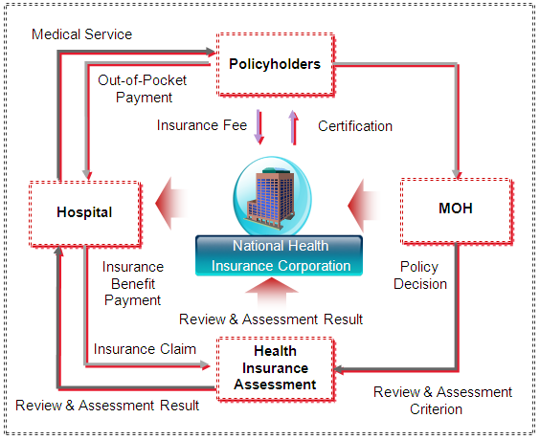
[Figure - 6] Operational Flow for National Health Insurance Corporation

As an insurer, the National Health Insurance Corporation is responsible for the management of policyholders and insurants, determination of insurance benefit grades, and payment of insurance money. In addition, the Health Insurance Review & Assessment Service is in charge of the evaluation of medical care facilities and the examination of appropriate treatments. As such, the functions related to policyholders and insurance assessment are separately managed and operated.
Medical institutions provide treatments to patients, check their insurance qualifications and determine the amount of medical fee paid by patients and insurance claim fee to National Health Insurance Corporation. A request for claim payment is made to the Health Insurance Review & Assessment Service, which then reviews the appropriateness of the treatments and sends a review result to the National Health Insurance Corporation. Then, National Health Insurance Corporation makes a payment to a relevant medical institution.
The Ministry of Health and Welfare is responsible for developing policies related to health insurance notifying the National Health Insurance Corporation as well as for updating assessment criteria under the situations notifying Health Insurance Review & Assessment Service, contributing to the improvement of public health and social security system.

Law and Institution related to Insurance
[Background of National Health Insurance Act]
While the Medical Insurance Act aimed for disease treatment, the National Health Insurance Act is for both disease treatment and health improvement, combining the Medical Insurance Act of 1980 and the National Medical Insurance Act of 1997.
There was a controversy over the financial integration between workplace health insurance and local health insurance due to the difference of each assessment standard. Now, the premiums of local health insurance policyholders are determined based on their average monthly income, in consideration of inflation rates, and in compliance with the grade system set by a Presidential decree. When estimating the annual income of households, incomes from business operation and asset management are considered. The type and scope of income are also determined by the Presidential decree.
Previously, the financing of local health insurance and workplace health insurance was managed and operated in a separate way. However, the Health Insurance Review & Assessment Service was established to integrate them and review medical care cost and its appropriateness substituting the Medical Care Benefit Examination Committee.

[Content of National Health Insurance Act]
The National Health Insurance Act consists of nine chapters and supplementary provisions including general provisions, articles of policyholder, National Health Insurance Corporation, insurance benefit, Health Insurance Review & Assessment Service, insurance premium and formal objection/examination request, and penal regulation.
In the past, the focus of medical fee examination was on preventing the abuse (over-utilization) of medical resources such as medical checkup, examination, treatment, drug etc.
Now, however, the National Health Insurance Act requires the examination of medical resource use in terms of both quantity and quality so as to secure the appropriateness of medical treatment. Therefore, under this act, the under-utilization or mis-utilization of medical resources is also reviewed.

[Establishment of Health Insurance Examination Committee]
Under the Enforcement Decree of Medical Insurance Act, the examination of medical service fee was commissioned to the Medical Insurance Associate. However, with the adoption of the National Health Insurance Act, which became effective in January, 2000, and required to separate the examination role from the insurer, the National Health Insurance Review & Assessment Service was set up to conduct the examination including “the assessment of the appropriateness of medical care benefits.” As such, now the National Health Insurance Review & Assessment Service functions as an independent organization, responsible for the examination of medical service fees and benefits.

[Functions of National Health Insurance Review & Assessment Service]
The purpose of the National Health Insurance Review & Assessment Service is to provide medical and financial protection to insurance policyholders within the scope of the health insurance. Its role is to review medical service fees and to evaluate the appropriateness of insurance benefits.
Before, the examination of medical fees was done based on the basic principle of complete enumeration survey for inpatients or outpatients. However, a sample enumeration method has been gradually introduced for medical institutions or service items with a consistent record so that the examination can be conducted in a way that protects public health with improved efficiency.
The “Quality monitoring and surveillance system for medical service” has been implemented in order to evaluate if appropriate services were provided to patients by medical institutions. For the continuous quality assessment of insurance benefits, medical institutions are randomly selected for the evaluation of selected areas (target disease, medical procedure, diagnosis result documentation etc).
The appropriateness assessment of quality includes: medical resource use (under-utilization or mis-utilization), provision of adequate medical services, patient health improvement, and adverse outcome. Assessment results are reflected in the evaluation of medical service fees, and utilized for corrective actions, training and instruction provision by fields, benefit items and institutions.
Meanwhile, the appropriateness assessment of insurance benefit items is conducted including the evaluation of services covered by insurance benefits. Periodic re-evaluation of items which used to be included in the benefits is also performed. In addition, it is reviewed whether or not certain medical procedures or materials need to be included in insurance benefits.

[Impact of the National Health Insurance Review & Assessment Service on Hospitals]
Now medical institutions must focus on improving their medical services since evaluation is conducted on the management of appropriate insurance benefits. For example, in the case of the use of antibiotics, in the past, the focus of examination was whether antibiotics were used in compliance with the benefit limit. However, under the new system, the overall appropriateness of antibiotic use is subject to assessment. Therefore, now medical institutions need to make an effort to enhance the overall medical service quality in addition to proving the validity of their medical fee claims.
It means shifting the focus of insurance benefit management from individual cases and microscopic perspectives to institutions and macroscopic perspectives, and it requires strengthened internal management. To respond to such changes, more emphasis has been put on the planning and management for medical service quality improvement.
Medical institutions have taken proactive attitudes to respond to expected evaluations on medical quality which would target institutions. As a result, their capacity for medical treatment has been significantly strengthened.
To enhance medical quality and efficiency, medical institutions had to set up a comprehensive system for performance improvement covering assessment, quality, treatment, management etc., moving beyond separated approaches and temporary measures. New organizations and functions have emerged to operate the system. Also, a "performance improvement department" has been created for the comprehensive management of assessment, quality, work efficiency, system improvement etc. New organizations have secured new-concept professionals who are capable of overall operations from system development to problem solving.

[Co-payment Ratio]
Under the Health Insurance Act, medical fees are shared by patients and insurers which called Co-payment. For the medical fees paid by patients, they pay it partially and fully depending on types of medical services and materials.
The patient partial payment system includes fixed rate system, fixed fee system and co-payment ceiling system. The following shows the detailed standards which are subject to changes in medical policies.
[Table - 11] Outpatient Co-payment Ratio
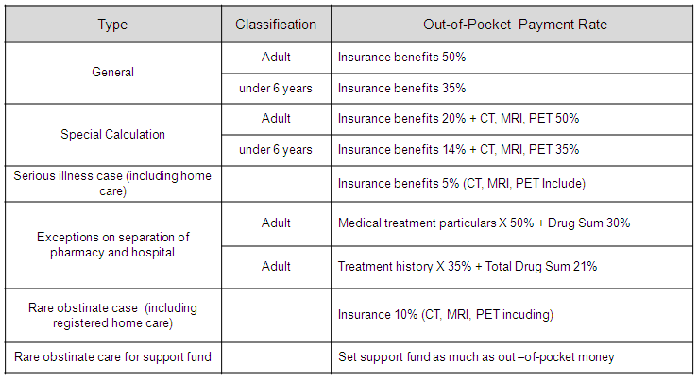

[Table - 12] Inpatient Co-payment Ratio
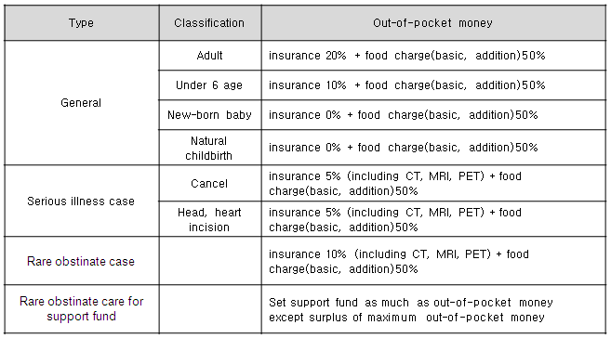

[Non-profit Medical Care Center]
Medical care centers include public and private hospitals. Public hospitals are established and run by the central or local governments, and include public university hospitals, national medical institutions, city/provincial hospitals etc.
Meanwhile, private hospitals are founded and run by private entities, and classified into corporate hospitals and individual hospitals depending on whether they were built by a corporate or individual. Whether it is a public or private hospital, medical fees are determined based on the National Health Insurance Act. Both public and private hospitals should be founded as non-profit organizations.
According to the National Health Insurance Review & Assessment Service, as of 2005, the ratio of public hospitals to private hospitals is 7.4% to 93.6%. As such, private hospitals form a vast majority in the hospital sector. More than half of the hospitals are private practices.
While public hospitals are operated and supported by national budgets, private hospitals are responsible for their management and finance with just little support from the government. Therefore, private hospitals tend to be more advanced in terms of management organizations and activities, and the use of information technology.

Healthcare Delivery System
The healthcare delivery system is to provide the public with the equal access to medical service. It aims to improve the public health by utilizing limited resources in the most efficient way.
The healthcare delivery system provides appropriate medical services to those who need it when and where they need it (to a right person, at right place, and at right time) by utilizing medical resources efficiently.

[Basic Principle of Healthcare Delivery System]
The basic principle of healthcare delivery system is to set up a structural system for efficient resource utilization, to provide high-quality and comprehensive medical service, and to build an integrated healthcare system by considering relevant factors and identifying connections between related systems.
The WHO has defined a rational healthcare delivery system as the efficient regionalization of medical services. It has identified the preconditions for efficient medical service regionalization as follows: 1) determination of treatment rights; 2) provision of necessary medical resources; 3) sharing and link of functions between medical institutions; and 4) establishment of patient transfer request system.
With the adoption of the universal healthcare insurance system in July 1, 1989, the healthcare delivery system was introduced where the insured and their dependants could receive insurance benefits according to medical service zones which were determined based on their life zone. It aimed to utilize medical resources in an efficient way, to encourage balanced development between regions and medical institutions, to expand high-quality medical services, to reduce medical fee burdens for the public, and to stabilize the insurance finance.

[Medical Service System]
With the adoption of the universal healthcare insurance system, the healthcare delivery system was established to include medical service zones of different levels (including large medical service zone, medium medical service zone etc.). For primary medical service, patients can use any medical or public healthcare center within the medium medical service zone they belong to. However, primary medical services at tertiary medical institutions are limited. In other words, without a referral letter issued by a primary medical institution, a patient should pay fully for medical services they receive at a tertiary medical institution themselves. However, primary medical treatment can be offered at a tertiary medical institution within a relevant medium medical zone in the case of family medicine, rehabilitation medical treatment, dermatology, and otolaryngology.
When a patient needs to receive secondary medical treatment after primary treatment, he can use any medical institution in Korea with a medical referral letter issued by a primary medical institution. If a patient needs to go to a different medical service zone to be cared for by a family member staying there, he should have a medical service application for a different medical service zone issued by an insurer.
In the case of emergency or childbirth, however, access to any medical institution in Korea is allowed. A medical institution for secondary treatment needs to transfer its patient to a primary medical institution or a medical institution which made a patient referral request if the health condition of a relevant patient has improved but requires continuous treatment.
In this case, documents requested by a responsible doctor at a medical institution to which a relevant patient is transferred should be provided, for example: treatment records, medical opinions, treatment reports etc.

[Medical institution Classification]
Medical institutions are classified into primary, secondary, and tertiary medical institutions. In other words, clinics, hospitals, and general hospitals are designated as primary, secondary and tertiary medical institutions depending on their functions.
Primary medical institutions include clinics and public health institutions (e.g., public health centers, public health branch offices, public health clinics etc.). Secondary medical institutions include hospitals and general hospitals. Tertiary medical institutions are defined as medical institutions with at least 500 beds or university hospitals. In addition, special hospitals are designated for mental health, tuberculosis etc.
In the case of dental care, clinics are classified as a primary medical institution, and hospitals as a secondary medical institution. The classification is made based on the presumption that a larger-scale medical institution (e.g., in terms of the number of sickbeds) is more advanced in terms of medical professionalism, technology, performance etc.

[Effect of Healthcare Delivery System Implementation]
A patient concentration rate in medical service institutions is defined as the increase or decrease from the number of patients of a previous year or changes in the share of patients by medical institution type. Medical fee change is defined as a relative increase or decrease in medical fees from the previous year.
According to the comparison of the number of patients at tertiary medical institutions one year before and after the implementation of the healthcare delivery system, the number of outpatients was down by 1.1%, and the number of discharged patients up by 10.7%.
In the case of tertiary medical institutions, the number of outpatients was reduced by a mere 1.1%. However, given the increase of outpatients at hospitals and general hospitals from a previous year, it is a meaningful figure as it shows that there was an outpatient de-concentration effect since the implementation of the healthcare delivery system.
The increase or decrease in the number of patients at tertiary medical institutions can affect the total amount of insurance benefits. Since the insurance benefit paid per medical treatment to a tertiary medical institution is more expensive compared to primary or secondary medical institutions, the total amount of insurance benefits can be saved if medical treatments move from a tertiary medical institution to a primary or secondary medical institution. Based on this presumption, it is estimated that the total amount of insurance benefits was reduced by 1.1% (inpatient 1.5%, outpatient 0.9%) between one year before and after the implementation of healthcare delivery system.

[Co-payment System and Healthcare Delivery System]
The Health Insurance System aims to provide high-quality medical services at more affordable prices. However, financial pressures are rising on insurers due to rapidly aging population and overlapping medical services. Financial conditions of insurers are expected to become more difficult as the number of people to pay insurance contributions is on the decline while the number of people utilizing medical services is on the rise.
Currently, various measures are under consideration to promote and stabilize the healthcare delivery system as a way to strengthen the national medical finance. Such measures are for the following purposes of: ensuring the fair and equitable access to medical services geographically and economically; purchasing of high-tech medical equipment for the advancement and modernization of medical institutions; improving service levels for customer satisfaction; establishment of emergency treatment system etc.

Progress in Healthcare Informatization
Korea has launched the EHR (Electronic Healthcare Record) project to apply information technology to the nation’s medical sector in order to handle current challenges, to respond to changes in external environments, to provide high-quality medical services, to prevent unnecessary resource waste, to support active health investment by the government, and to improve the health of the public.

[Current Condition and Problem in Korea’ Public Healthcare]
Korea faces many challenges in the healthcare sector such as rapidly aging population compared to other OECD nations, difficulties in securing healthy working population, increasing medical expenses, unhealthy lifestyle and environment, growing health gaps, imbalance in the supply and demand for medical services etc.
With economic growth and improving life quality, the demand for high-quality medical services is rising. To respond to such public demand, the Ministry of Health and Welfare is now carrying out the Four Major Projects for Public Health Enhancement Plan, which include: promotion of healthy lifestyle; prevention-oriented management of health and disease; health management by population group; creation of healthy environment.
Healthcare cost is rapidly rising, taking up an increasing share of the GDP of Korea. Therefore, it is very important to reduce medical cost by making the medical service system more efficient. However, the quality of medical services has become an important goal as well due to intensifying competition between medical institutions and higher expectation from the public. To achieve medical cost reductions and high-quality medical service as the same time, the application of information technology is essential.
High-quality information secured through the EHR project is at the center of decision-making related to healthcare. The EHR project is expected to provide diverse advantages such as: provision to the public of accurate health information along with convenient and safe medical services; provision of effective and quality medical services by medical service providers; and development of policies for efficient resource utilization by the government.

[Need for Promotion of Healthcare Service]
Healthcare service has characteristics as a public service. Therefore, the beneficiaries of the informatization of healthcare service are the public or medical consumers. In this respect, it is necessary to promote and support the system of electronic healthcare record on a national level.
The government needs to expand the role of public healthcare service through its informatization, and lay the foundation for the distribution of benefits to various participants.
Information technology serves as an essential tool for optimal decision-making, and for significantly reducing communications cost. Many medical institutions have made investments for their health information IT system. However, such efforts by individual institutions are not sufficient to realize smooth information exchange.
Without a national IT system for health information management, significant additional costs may occur for the information exchange between medical institutions and for setting up an IT system for individual medical institutions. As we can see from examples of other countries, the implementation of an IT system for individual medical institutions entails high costs for development and future system upgrade, and provides poor interoperability between medical institutions.
When an IT system for medical institutions and public healthcare centers is established based on the national standard, important knowledge can be shared through information exchange and related social cost can be reduced significantly.
Now, society demands that the government play new roles in respond to the advancement of information technology and the strengthening of medical consumer rights. The new roles of the government include the establishment of networks for smooth information exchange and virtual communities where all stakeholders can freely share and exchange information according to medical consumer choices.

[Major Issues related to Informatization ]
- Information provision in a way that ensures the right of choice of medical consumers
- Health information management by individuals
- Prevention-oriented health investment
- Support for the efficient use of medical and healthcare resources
- Provision of high-quality, safe and effective medical services
- Expansion of medical services through convergence
- Utilization of objective data related to healthcare research
- System and infrastructure for health information exchange
- Improvement of laws, regulations, institutions and instructions for health information protection

[Major Strategies related to Informatization]
- Customer-centered IT system for healthcare information
- IT system for public health management
- IT system for medical institution service
- Promotion of health information sharing and exchange
- Infrastructure establishment for an IT system for health information
- Support for the management and operation of health information

[Information Sharing]
The Health Insurance Review & Assessment Service had a declaration ceremony for examination quality innovation in 2007, and announced its plan to utilize the examination information real-time sharing system as well as its strategy for quality management. The examination information real-time sharing system includes database of medical treatment information, and enables the real-time search of information by examiners.
In the past, the Health Insurance Review & Assessment Service suffered due to slow communication speed when a vast amount of treatment information is handled in real time. However, this problem has been resolved by extracting core information using high-tech communication equipment. Also, while there was a controversy over different examination opinions between examiners about one medical treatment result, and over handling differences between cases of different time points, such problems are expected to be improved now, increasing the consistency of examination and reducing complaints from medical institutions. In addition, now more focus is put on the qualitative growth such as quality management.

Seoul National University Hospital located in Bundang developed a joint treatment system which enables the electronic exchange of patient treatment information in 2008, and started related services.
The system supports the checking of medical treatment information between hospitals, and provides diverse convenient functions such as: checking of treatment schedules, selection of treatment appointment date, documentation of treatment records etc.
When a patient is transferred, medical professionals can refer to medical examination results (sample, imaging examination), medical opinions, and treatment information related to that patient to make their medical decisions. The system focuses on sending and responding to a reply letter according to treatment stages of the patient in order to improve the communication and cooperation between medical institutions.
Bun-dang Seoul National University Hospital has presented an innovative information sharing model for medical information communication by developing and test-operating a medical treatment information exchange system.

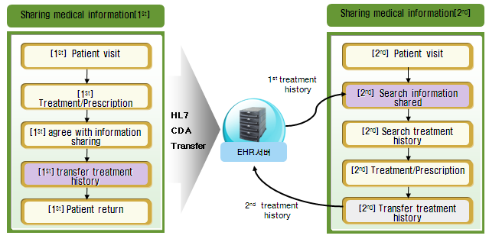
[Figure - 7] Medical Information Sharing Flowchart

The above figure shows a procedure of information sharing when a patient visits a primary medical institution. The following effects have been gained from the procedure.
[Table - 13] Benefits from Medical Information Sharing
Effects | Details
Improvement of medical treatment quality | - Fast diagnosis and prevention of medical error  - Prevention of drug administration error and Reduction in waiting time for treatment
Improvement of medical treatment efficiency | - Reduction in drug and examination cost by preventing overlapping drug administration and examination  - Reduction in medical cost by reducing the number of days of hospitalization and hospital visit  - Reduced medical expense burdens for patients
Efficiency enhancement of medical institution | - Saving of labor cost through improved work efficiency related to patient referral and transfer  - Saving of labor cost (medical professionals) by reducing treatment time  - Securing of extra capacity according to reductions in medical treatment burden  - Improvement of employee work satisfaction through the application of an IT system  - Reduction in medical cost by reducing overlapping drug administration and examination

Summary on Case Study Analysis
- Korea’s Health Insurance System was adopted in 1977, and has provided insurance benefits for the prevention, diagnosis, treatment and rehabilitation from diseases and injuries, and for childbirth and health improvement. Continuous reform measures are carried out to enhance public health and social security.
- There have been efforts to improve the laws, policies and institutions related to healthcare. In 2000, the Medical Insurance Act (1980) and National Medical Insurance Act (1997) were integrated into the National Health Insurance Act which aims to provide strengthened medical services for public health improvement moving beyond disease treatment.
- The healthcare delivery system was introduced to resolve challenges such as the imbalance in the distribution of medical institutions between regions, vulnerability of the public healthcare sector, and weak sharing of functions among medical institutions. The system is expected to reduce national medical costs. However, as new problems have emerged, the government is making efforts to develop appropriate policies to deal with them.
- The IT system for health information aims to provide the government, medical service providers, and consumers with reliable information (medical, administrative, and patient information produced during medical treatments by medical institution or professionals) in a fast and accurate way in order to help rational decision-making by stakeholders. Accordingly, efforts have been made to update related medical policies.

Implication on Policy Analysis
[Government and Central Authority]
As a result of policy analysis from the point of view of government and central authorities such as MOH and SHA, we discovered that Armenia needs including;
- Establishing comprehensible IT strategy and direction based on clarified healthcare policy plan for providing and managing high quality of healthcare service.
- Ensuring an effective policy enforcement and transparent budget execution by addressing valuable information exchange, collection, analysis and utilization system through IT technology and a support scheme for health policy evaluation and monitoring.
- Ensuring user reliability and reducing burden of heavy medical cost through data collection support system to support standardized medical fee criteria establishment, co-payment system vitalization, and private insurance activation policy establishment.
- A data collection and utilization scheme for inclusive management of pharmaceuticals.
- An appropriate management support framework for Irrational and excessive prescribing.
- Ensuring hospital work efficiency and service accessibility of people through implementing standardization and systemization of healthcare delivery process.

[Medical Service Provider]
As a result of policy analysis from the point of view of medical service provider such as hospitals and polyclinics, we discovered that Armenia needs including;
- Ensuring standardization and automation of healthcare service for the effective support of hospital work.
- A data collection and utilization scheme based on timely and accurate information for optimal service delivery.

[Medical Service Beneficiary]
As a result of policy analysis from the point of view of medical service beneficiary such as patients and general public, we discovered that Armenia needs including;
- Information support framework to ensure the high-quality medical service accessibility and reducing its gap between users.
- Technological support to bridge the gap of medical service utilization between rural and urban area.
- Information service to continuously expand health insurance system and provide benefits to all citizens.
- Support for information provision to assess reasonable service cost and help patients choose the right service provider.

Technical Analysis
This section describes analysis on Armenia’s current ICT plan and e-Health policy & situation to set future directions and propose improvements for computerization in healthcare.

Analysis of the National Informatization Plan

Informatization Promotion Policy and Direction
While today the Government is more active in the IT sector than several years ago, many companies, nevertheless, expect substantially higher involvement of the Government in the sector development. Expectations include such activities as fostering the use of locally made software by other sectors and, by that, increasing the demand for domestic IT products and services, improving the legislative framework including reforms in tax regulation, providing larger support to universities, improving telecommunications infrastructure, and supporting IT firms with financing and international marketing.

In 2008, the Government adopted a new 10 year industry development strategy focused on building infrastructure, improving quality of IT graduates, creating venture and other financing mechanisms for start‐up companies. The main goals of this new strategy are:
- build a developed information society in Armenia;
- make Armenia part of the knowledge creation global network;
- Form a strong and advanced information technology sector.

The strategy aims at increasing considerably the rates of computer and internet penetration in all segments of the economy (households, public sector, businesses, educational institutions), building new techno parks and incubators, establishing a major venture fund, improving the quality of university graduates, increasing the number of companies with recognized certifications such as ISO and CMMI, developing domestic market for locally created IT products and services, increasing FDI, and others. The Government body responsible for the implementation of this strategy and overall IT industry development is the Ministry of Economy.

[Table - 14] IT industry’s 10‐year growth targets (2006-2018)
Industry Growth Target Indicators | 2006 | 2018
Home computer penetration | 20% | 70%
Educational computer penetration | 10% | 100%
Public sector computer penetration | 10% | 100%
Population Internet penetration (in terms of physical, financial, content and language access) | 15% | 90%
State entity spending on locally developed IT products, % of state budget | <0.1% | >1%
Domestic spending on locally developed IT products, % of GDP | <0.5% | 1%
Share of e-services in all services provided by the state entities | <1% | 80%
Number of IT companies  (with foreign capital) | 160  50 | 1,000  200
IT workforce | 5,000 | 20,000
Productivity, output per employee | 17,000 USD | 50,000 USD
Industry revenues | 85 mln USD | 1 bln USD
Exports | 53 mln USD | 0.7 bln USD
Companies with ≥ 1,000 employees | 0 | >1
IT companies offering R&D services | <10 | 100-200
Techno-city  Techno-Parks & incubators | 0  2 | >1  >10
Venture capital funds committed | < 1 mln USD | >700 mln USD
Local open joint stock companies (registered at the Armenian Stock Exchange) | 1 | 50-100
Local open joint stock companies (registered at international Stock Exchanges) | 0 | >5

[Strategic Vision for year 2030]
Develop advanced information and knowledge based society in Armenia with sophisticated ICT infrastructure, high computer literacy, high computerization and internet penetration rates, large domestic IT market, and widely deployed e-government and e-commerce systems.
Transform Armenian IT industry from a provider of low-end outsourcing services focused on cost advantages into an R&D powerhouse offering higher-value added research, development, and engineering services in specialized technology segments.

[Table - 15] Strategic Objectives: Information Society and IT Industry
Strategic Area | 2006 | 2030
Computerization: households, % of total households | 5% | 50-70%
Computerization: educational sector, % of employees / professors and ¼ of students | 10% | 70-80%
Computerization: public sector, % of all employees | 10% | 90-100%
Internet penetration, % of total population | 5% | 50-70%
Government spending on locally developed software and services, % of national budget | < 0.1% | > 1%
Domestic spending on locally developed software and services, % of GDP | 0.5% | 2-4%
Government services online, % of all services | <1% | 80-90%

National Organizations for Informatization Promotion
[Ministry of Transport and Communication of the Republic of Armenia]
The Ministry of Transport and Communication of the Republic of Armenia is responsible for establishing and implement policies in transportation, communication and ICT sector.
Armenia’s Public Services Regulatory Commission(PSRC) takes on the authoritative roles such as defining the rate of payments for mobile, managing disputes between market participants, and obtaining license for electronic communications service and etc.

[The ministry of Economy]
The history of the Ministry of Economy goes back to 1965 when Material and Technical Supply Department within the government of the Soviet Armenia was established by the decree of the Supreme Council of Armenian SSR. In 1978 the Department was renamed to Material Supply State Committee, and later in 1992 the Committee became the Ministry of Material Resources of the Republic of Armenia.
During 1995‐2002, the Ministry of Material Resources, the Ministry of Trade, and the department of Foreign Tourism, and later the Ministry of Industry, and the Ministry of Economy merged together and then in 2002 were reorganized into the Ministry of Trade and Economic Development. According to the President’s Decree on April 21, 2008, the Ministry was renamed to the Ministry of Economy of the Republic of Armenia. The Minister of Economy is Mr. Nerses Yeritsyan.
Today the Ministry covers a number of areas including economic policy, regional development, science and innovation policy, foreign cooperation and FDI policy, information technology industry development, EU and WTO, natural resources, trade policy, standardization and metrology, intellectual property, tourism sector development, and others.
The 3-year strategy of the Ministry recently adopted by the Government aims at:
- Creating a productive and transparent management system
- Forming an environment supportive to the stable long‐term development of the Armenian economy
- Building an entrepreneurial and investment‐friendly business environment, supporting productive public‐private sector cooperation
- Improving Armenia’s competitiveness and increasing its integration in the global economy, designing and implementing a diversified industrial policy aimed at developing priority sectors of the economy
- Supporting the transition of Armenia towards knowledge based economy.

[EIF: Enterprise Incubator Foundation]
Enterprise Incubator Foundation or EIF is a business development and incubation agency operating in Yerevan, Armenia. EIF was established by the Government of Armenia within the framework of the World Bank’s “Enterprise Incubator” project to support the development of Information Technology sector in Armenia. EIF objectives are to improve competitiveness of Armenian IT companies in the global marketplace, build linkages with business communities in key technology markets, improve access of local companies to knowledge and information on best practices and experience, and assist Armenian firms with attracting local and foreign investors.

[EKENG]
15 staff in EKENG work on the whole business across e-Government project involving in several projects such as e-Signature, e-ID and e-Passport as a part of e-Government.
EKENG also supports e-Health project relating to planning, team setting, technology research and development such as system interchange and connection in government units, security and privacy protection along with assisting MOH with expertise and providing business consulting from hiring project team to investing.

[UITE]
The Union of Information Technology Enterprises (UITE) is the primary IT Association in Armenia. It was formed in 2000 as a non‐profit association of ICT companies operating in the Republic of Armenia. UITE was established by the private sector to consolidate industry’s advocacy efforts, facilitate business, and encourage advancement of research in the ICT sector.
Member firms are involved in offshore development, Internet applications, e‐commerce, IT services, chip design, and other areas. Several UITE members are global players with office locations all over the world. From May 2004, UITE is a member of World Information Technology and Services Alliance (WITSA).
UITE is involved in a variety of activities such as:
- advocacy of member interests,
- organization of trade shows and programming contests,
- workforce development through custom training programs,
- design of online information and collaboration portals on IT sector,
- conducting industry surveys and research,
- assisting its members with business development

UITE leads a number of policy related initiatives aimed at the development of ICT sector in Armenia. As part of these initiatives, the association formed seven working groups, which will formulate Armenian ICT sector development strategic plans and activities. Groups cover different areas vital to the sector development including regulatory environment and advocacy, ethics, global marketing and promotion of the industry, education and workforce development, telecommunications infrastructure, domestic ICT market development.

Current State of Armenia IT sector
Historically, Armenia was on the forefront of high-tech research, development, and manufacturing. Since early 1950s, Soviet Armenia has been a main hub of USSR’s critical scientific and R&D activities in a number of technology industry segments such as mainframe and industrial computing, electronics, semiconductors, software development, and others. Before the collapse of the Soviet Union, Armenian technology sector focused primarily on the large-scale R&D and production projects targeted at industrial and military applications. After the independence of 1991, the industry switched its focus to the software development, outsourcing, and IT services. The software and services segment really gained its momentum during the last 10 years, during which the sector grew at 27% per annum. In 2009, the share of the industry in Armenia’s GDP was 1.1%1, which is comparable to that of India (1.4%) and Germany (1.3%).
In recent years, the sector has witnessed major inflow of foreign investors who have located in Armenia to capitalize on the young and highly qualified workforce.
Around 55% of the industry’s output is exported to over 20 countries, mainly USA, Europe, and CIS. The major specializations include embedded software and semiconductor design, custom software development and outsourcing, financial applications, multimedia design, Internet applications, web development, MIS and system integration. In particular, Armenia has outstanding achievements in semiconductor design software and IP solutions. Foreign companies specialized in chip design place their R&D facilities in Armenia to benefit from the talented and creative workforce pool and highly competitive wage rates.

[Table - 16] 2009 – 2006 Main Indicators
 | 2009 | % from Industry | 2006 | % from Industry | % change 2009  /2006 | CAGR 2009/  2006
Operating Companies
Industry total | 196 | 100% | 160 | 100% | 23% | 10.70%
Local firms | 122 | 62% | 112 | 70% | 9% | 4.40%
Foreign branches | 74 | 38% | 48 | 30% | 54% | 24.20%
Industry Revenues, millions of U.S. dollars
Industry total | $129.90 | 100% | $84.20 | 100% | 54% | 24.20%
Local firms | $49.60 | 38% | $36.70 | 44% | 35% | 16.30%
Foreign branches | $80.30 | 62% | $47.60 | 57% | 69% | 29.90%
Industry average revenue per company | $0.66 | 100% | $0.53 | 100% | 26% | 8.00%
Local firms | $0.41 | 61% | $0.33 | 62% | 24% | 7.50%
Foreign branches | $1.09 | 164% | $0.99 | 188% | 9% | 3.10%
Domestic market | $58.50 | 45% | $30.90 | 37% | 89% | 37.60%
Exports | $71.50 | 55% | $53.30 | 63% | 34% | 15.80%
Software and IT consulting | $100.70 | 78% | $75.20 | 89% | 34% | 15.70%
Internet Services | $29.20 | 22% | $9.00 | 11% | 225% | 80.20%
Productivity (weighted average output per technical employee), U.S. dollars
Industry total | $31,900 | 100% | $26,500 | 100% | 20% | 9.70%
Local firms | $30,400 | 95% | $22,500 | 85% | 35% | 16.20%
Foreign branches | $32,800 | 103% | $28,900 | 109% | 13% | 6.50%
Human Resources (persons)
Industry total | 5,190 | 100% | 4,020 | 100% | 29% | 13.60%
Technical professionals | 4,370 | 84% | 3,390 | 84% | 29% | 13.50%
Business and management | 820 | 16% | 630 | 16% | 30% | 14.10%
Local firms | 2,140 | 41% | 2,010 | 50% | 6% | 3.20%
Foreign branches | 3,040 | 59% | 2,010 | 50% | 51% | 23.00%
Students in IT related specialties at major Armenian universities (2008) | 6,800 | 100% | 5,280 | 100% | 29% | 8.80%

During the last 10 years, the industry saw a sharp increase in the number of newly formed companies, both local start-ups and branches of foreign companies. Nearly 90% of the foreign companies were established in 2000-2009. The number of operating IT companies in 2009 reached around 200 representing nearly 17% growth from 1998 to 2009. On average 20 IT businesses were launched annually in 2000-2009. This is in sharp contrast to 1990s when only 5 companies were formed each year. At the peak in 2008, annual number of newly started firms reached around 30.

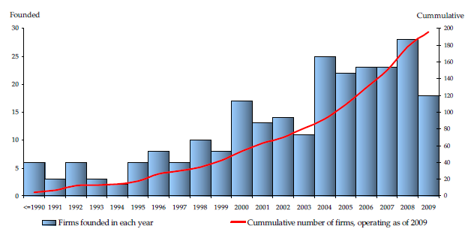
[Figure - 8] IT Companies in Armenia: 1990 - 2009

The IT industry is shifting to higher value added services. More companies are now involved in engineering, systems development, and R&D services. Primary gainers were local firms, which are now also active in the chip design and systems engineering areas. Foreign companies are specialized primarily in customized software and outsourcing (around 30% of all branch specializations)

The largest share of exports, almost 60%, goes to the United States and Canada, the second largest is Europe with 24%, and third comes Russia and CIS with 22%.

On average, salary costs per one employee have increased at 13% CAGR, which is almost completely driven by the change in the exchange rate of Armenian Dram.

Summary on National Informatization Plan
- Before independence, Soviet Armenia has been a main hub of USSR ’s critical scientific and R&D activities in a number of technology industry segments (e.g. mainframe and industrial computing, electronics, semiconductors, software development, and others). After the independence, the industry switched its focus to the software development, outsourcing, and IT services with 27% per annul growth.
- The IT industry is shifting to higher value added services with the share of exports going to the United States, Canada, Europe and others.

Analysis of National e-Health Plan

e-Health strategy and policy
In "CONCEPT OF INTEGRATED HEALTH INFORMATION SYSTEM OF THE REPUBLIC OF ARMENIA", Armenian government defines the concept and the objective of integrated medical information system as follows, and plans a conceptual roadmap for implementing this plan.

Integrated health information system, is one of the most important infrastructure ensuring healthcare information integrity and effective usage by country scale. This system implementation is supposing universal modernization of healthcare services by means of information technologies.
The system new solutions will ensure more qualified and useful healthcare services to the society. Besides, it will impact directly on healthcare system transparency.
Therefore, the objective of integrated health information system in Armenia is the establishment of the necessary infrastructure, which will ensure integral medical information for each Armenian citizen.

For the implementation of Health Information System project, following participants will be mainly involved,
- The Ministry of Health of Republic of Armenia: The Ministry of health is the main responsible and supervising structure for health integrated information system.
- Medical institutions: All medical institutions including hospitals, policlinics, family medicine centers, obstetrical units, medical ambulances, healthcare centers, and dental clinics are the participants of the system. These institutions are authorized to observe, change and use the information included in the system. These are the authorized parties that may observe, change and use the information included in the system.
- Pharmacies: Electronic prescriptions, their integrity in the information system and pharmacies information received via electronic means may essentially improve the effectiveness of healthcare system.
- Patients-insured persons: The group of patients or the insured persons covers the major part of the society, infants included. In the future, it is projected to store in the system the infant’s medical history during mother’s pregnancy.
- Insurance companies: Medical Insurance companies are the participants of the system. They may use the medical information for insurance tariffs estimation.

The health system will be more effective through:
- lower costs for administrative activities,
- a higher level of targeted disease prevention,
- lower costs of health care by removing the duplicities in treatments, fictive treatments and wrong prescriptions,
- lower secondary costs of health care due to the reduction of errors in diagnostic, treatments and prescriptions,
- Lowering the rate of corruption in the health system.

Citizens will profit by:
- higher quality of provided health care,
- ability to communicate electronically within the health system,
- overview of provided medical services and costs,
- continuous availability of patients’ health records to authorized entities, confidentiality and integrity of these health records and protection against their loss,
- shortening the administrative delay of treatments,
- reducing duplicities in examinations,
- improved quality of the health services by reducing diagnostic and therapeutic errors, by improving diagnostic processes and by monitoring the whole therapeutic process,
- Available data for decision making about their health or for choosing a health care provider.

Health care providers will profit by:
- their ICT systems, which will be able to connect to the core registers and use them effectively,
- lower costs of administrative activities connected with health care,
- the defined standards for an electronic identifier, frames for creating and storing the records, forms for communication with the other subjects in health system,
- different ICT systems will be fully interoperable at the hospital level and will be capable of communicating with their external environment in a defined format,
- Communication with the other subjects in the health system in a secure electronic form, automated prescriptions.

Healthcare insurance companies will profit by:
- lower costs on provided health care through removing treatment duplicities, reducing the mistakes in treatment and shortening the time necessary for carrying out medical services,
- lower costs of administrative activities,
- defined electronic identifiers for patient and for health care providers,
- data for near on-line monitoring of provided medical services,
- Communication with health care providers in a secured electronic form and thus being more effective.

To implement integration e-Health system, each phase will be operated individually.
- Phase 1 – Development of strategic and implementation plans, TOR(Terms of Reference) or SLA(Service Level Agreement)
- Phase 2 - Establishment of the central system (with Regulatory Body)
- Phase 3 - Integration of system main participants, ongoing training of users

Current e-Health Solutions
- [MIDAS]
The MIDAS system is aimed at automation of activities of MoH State Health Agency (SHA) and its marz departments. The system was developed and implemented by Yerevan Computer Research and Development Institute (YCRDI) with USAID financing and PADCO (USA) company support during 2001-2002. The system was implemented at SHA, all its marz departments and in two hospitals (Republican Ophthalmologic Center after S.V. Malayan and "EREBUNI" medical center).
SHA is responsible for targeted and efficient use of finances allocated by State Order for medical care and services. It checks the quality and volume of delivered services by medical institutions and their correspondence to the existing criteria. SHA signs contracts with medical institutions and medical organizations and carries-out according to these contracts supervision of financial flows, checks reports about actually delivered services and prepares general reports.
SHA has departments in all Marzes and in Yerevan. Each department receives reports from all medical institutions in its catchment area. Three types of reports (standardized forms – hospital form for State Order services, policlinic form for State Order services and a form for paid services) are developed in paper form and ought to be entered into the database.
The MIDAS system is developed as a uniform one but is implemented in three versions:
- In SHA (as a republican database incorporating in it all data from all republican medical institutions), in SHA marz departments (as a marz database with data about medical institutions of given marz) and in medical institutions (hospital-policlinic database). Versions are defined during installation of the system.
- The MIDAS system uses modern hardware and software.

The system function of MIDAS is as below,
1. To define a list of medical services and their costs for the volume guaranteed by State budget.
- Distribution of financial means allocated by state budget among medical institutions
- Contracting procedures between SHA and medical institutions which deliver medical services within the limits of State Order
- Data entry and formation of database of information about patient service delivered by medical institutions
- Two modes of data entry: 1) traditional (manual), 2) by scanning with semi formalized forms
- Calculation and generalization of expenses for a given period of services rendered by a medical institutions.
2. To find out omissions, errors and deviations from the planned finances of medical services.
3. To prepare financial and generalized reports.
4. To service requests from medical institutions.
5. Statistical analyses of database information and search for typical patterns

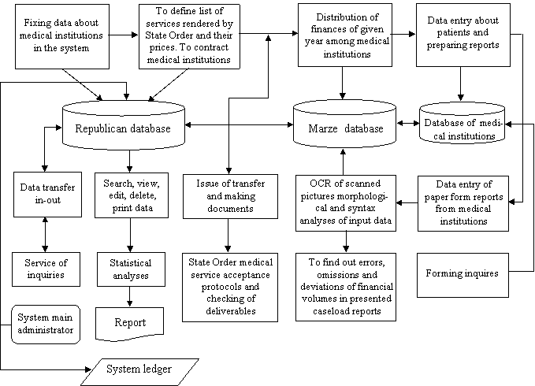
[Figure - 9] Functional structure of MIDAS system

In the area of computerization of Health system and automation of activities, the MIDAS system makes it possible to supervise expenses by medical institutions within the finances allocated by State Order budget, to check their effective and efficient use. Information of the database makes it possible to supervise quality and volume of rendered services according to the defined criteria.
The MIDAS system ensures information exchange hierarchically (medical institution – Marz department – SHA) with timely and accurate delivery of information.
The system automatizes the whole chain of information flow about patients and medical services from the source of information up to the republican database. Data entry is done manually and by scanning the semi formalized forms. Optical Character Recognition System "Mashtots", developed by YCRDI for handwritten Armenian symbols, is widely used. The "Mashtots" system processes the scanned pictures and transforms them to text files.
The system has software package for making statistical analyses and reports about rendered medical services, deceases and financial expenses.
For its outstanding features the MIDAS system was awarded 2003 President's of Armenia prize in Information Technology.

- [MIDAS-2]
Local company in financial management information system development has been selected by HPIU to improve MIDAS-2 software package at the State Health Agency as well as to develop new subsystems. The local company has worked on software means development for standardization and coding of primary health care standard reports and data, including personal information about the patients, social security card number, forming, updating and transfer of standard information tables. Software means for forming and transfer of reports about the treatment process of a given patient as well as about ambulance visits of patients are also under the development.
Based on all requisites MIDAS-2 package has been successfully developed and installed. In addition, internet site for State Health Agency was developed. The web site contains Laws related to SHA mandate, information about all SHA procedures and structure, services provided under the State Order and data about hospitals.

- [PROJECT "ELECTRONIC/MEDICAL RECORDS (EMR)"]
This project is sponsored by Sun Microsystems, which provides logistical and financial support. "EMR" will offer healthcare providers, hospitals, polyclinics, diagnostic centers a comprehensive, web-based, easy-to-use and user friendly solution to effectively automate all the vital processes within the practice, improve information sharing, customer service, reporting and many other functions.

The geographic target will be Armenia for the early stages of the project. During the project we will be collaborating/ working with Armenian Ministry of Health, "Chamber of Doctors" ("Bzhshkakan Palat") NGO and Sourcio, American Armenian Wellness Center and American University of Armenia.

Summary of the interview about e-Health
[MoH]
Armenian government boosts e-Government project which encompasses the entire government departments. MOH also involves in the project aiming for improving health indicators and the quality of treatment. To accomplish their goal, they have initiatives for strategy establishment in health sector, core function development of health system, prototype development, implementation progress monitoring, data collection and analysis, assessment, and briefing.
MOH, as an agency for policy development and application, recognizes the importance of changes and realization by IT through data collection, analysis and communication. MOH has started a program to strengthen its capacity and has a plan to execute project management in various aspects such as financial flow, project monitoring & control, HR Management, and Health facilities).
The "Healthcare system performance evaluation report" is a document to report conditions of Armenia Health System and includes information of trends, performance, population data, mortality rate, and pattern analysis.
MOH's ideal model of a Health information system can be described as below,
- A system that provides data collection, classification and extraction for policy-making, program review and mediation
- A system that integrates heterogeneous data flows connecting all necessary components
- A system that analyses causes of disease and death, and also examines the main factors of lung cancer (e.g. smoking, air pollution, and etc) allowing finding the reason of increase in lung cancer whether it is resulted from an environmental factor or individual life style
- A system that shows a patient flow in hospital from admission to discharge in real time and allows MOH to control hospitals based on the highly reliable information by the system.
- An information system that considers Armenian health insurance.
- A system that controls efficient and effective distribution of financial resources and monitors patients and their treatment processes.
- An information system that controls a co-payment system and its process, which government supports 60-70% of medical fee and a patient pay the rest
- An information system that MOH allows to control resources and manage the quality of treatment services provided by medical institutions helping MOH to make decision for insurance payment to the institutions.
- A system that allows managing patient information saved in secure system utilizing security card with sophisticated security function to protect information misuse.

[MOE]
Armenia government desires to build a secure transaction system with a cloud computing technology aiming for two themes including import/export transaction system and e-health system.
MOE recognizes that a project completion in a timely manner is a matter of trust, and it is important to plan practical schedule and minimize changes since Armenia has undergone many trials and errors from the past.
In case of developing e-Health as a part of e-Government project, it is required to proceed in two steps as below,
- Step [1]
(1) Estimate reasonable cost and time frame through technical consulting – clearly define time-table and unit cost structure and verify them at simulated level (e.g. equipment prices, EMR development cost in each hospital)
(2) Demonstrate a small system running on a small size server (i.e. desktop) including a service visible in an off-line status

- Step [2]:
(1) Build a PPP (Public Private partnerships) structure, clarify the government roles (e.g. law enactment and contract), service level, and technical requirements and make a time-table.
(2) Proceed the project with partners or bidding process
(3) Along with a HIS development plan, the government plans to issue an ID card with a concept of Armenian citizens’ identification based on their information archived in a server.
(4) With the goals for the Internet expansion in every family and sufficient internet hubs provision in every town for next 2 years, Armenia sees the introduction of ID card system positively and expects it to be active as a contact point of post offices, government offices medical facilities and others.

[EKENG]
Considering the total population of Armenia is only 3 million, the number of initial HIS users will not be that huge and the current network bandwidth could be expanded. Physically many HIS systems would be installed across the country but they actually mean a one big system from a logical point of view. Under the centralized system, it is effortless to change and control them.
Big-sized hospitals as a Erebouni would have complex business processes and may need self-investment for system development. But the most hospitals do simpler business which means the cost and time can be saved by function minimization through the centralized system model.
Estonia, Russia, Romania and Bulgaria control systems adapting the centralized model and in that way, they can be important references to Armenia having similar processes. Also, the size of land in Armenia is small enough to build such a good central model showing flexibility to cope with events.
Hospitals in Yerevan cover the 90 % of entire population and it is important to have some of them to be involved in e-Health project.
Time consumption of documentation for doctors can be reduced by HIS system, saving costs also. According to this, most of medical institutions(e.g. hospitals, polyclinic, dental clinic, etc) would have desire to build the system.
Since most hospitals in Armenia has no good self-maintenance capability of information system, it is required for any medical institutions to use the central system if they are willing for and they would have benefits in that way.
Eventually, the central system will target for hospitals across the country by starting a few hospitals, polyclinics and pharmacies.
The central system and hospital information system should be capable at customization with flexible structures for mutual compatibility.
Basically, the Government of RA will be responsible for providing facilities or buildings for the central system management. Also, it will be necessary to define a management team and rules for the efficient management and maintenance.
The past e-Tax system, no one was willing to use the system due to its slow network speed but the number of users had reached to 3,000 people in 6 months. The reason could be government’ legal force but the ultimate reason would be advantages they found from using the system.
Armenia has long-term plans to apply e-ID project to e-Health as well as implementing smart card(e-ID) on it. But it is still under the consideration.

Summary on National Computerization Plan in Healthcare
[MOH]
- An integrated information system is required that integrates heterogeneous data flows and provides core data to allow MOH to establish policies, make decisions and review and control programs.
- A system is required that provides all information related to activities in a hospital (e.g. a patient flow) and allows MOH to control and assess medical institutions.
- The government who is in charge of insurance payment should have a capability to control patient flows, patient management, medical treatment methods and service quality before it assigns insurance fees to medical institutions. Thus, an information system is important to control resources and manage the quality of medical services.
- MOH considers introducing a patients ID system by utilizing an information management card with sophisticated security functions.

[MOE]
- MOE considers building Cloud Computing and a secure information transaction system.
- MOE considers managing patient information through a central smart card system and emphasizes finding the best solutions for information security and information misuse through in-depth analysis on that.

[EKENG]
- Time consumption of documentation for doctors can be reduced by HIS system, saving costs also. Especially, most of primary hospitals do simpler business which means the cost and time can be saved by function minimization through the centralized system model.

- The size of land in Armenia is small enough to build such a good central model showing flexibility to cope with events.
- Since most hospitals in Armenia have no good self-maintenance capability of information system, it is required for any medical institutions to use the central system if they are willing for and they would have benefits in that way.
- Basically, MOH will be responsible for providing facilities or buildings for the central system management. Also, it will be necessary to define a management team and rules for the efficient management and maintenance.
- Armenia has long-term plans to implement e-ID project and considers the possibility of applying it to e-Health.

Analysis on Current Computerization in Healthcare

Current Computerization Status of Central Authorities
[SHA]
SHA(State Health Agency) has an application system named MIDAS(Medical Institutions Data Analysis System) which was awarded 2003 President’s of Armenia in IT. MIDAS now needs more improvements and budgets to monitor both medical institution activities and financial flows.
All medical institutions have an obligation to use Hospital MIDAS as a purpose of reporting. Each region has a local server getting information from medical institutions, and then this information is transferred to a central server.
SHA gets only basic patients information and financial report from each medical institutions through MIDAS. From the first quarter of 2011, they will start assessment based on the data.
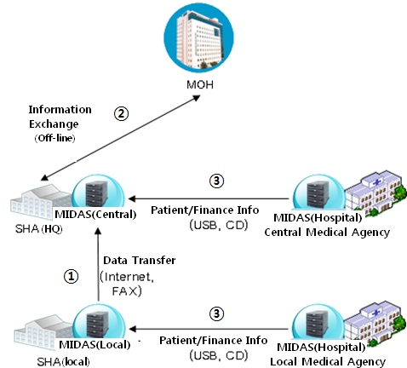
[Figure - 10] MIDAS connectivity between SHA and medical institutions

① Currently the local servers and the central servers are connected on normal type of internet connection and the SHA headquarters gather information from regional office through the Internet and fax. MOH is in charge of MIDAS server management and SHA is in charge of the system utilization. Each regional head office has MIDAS H/W and S/W and they maintenance the infrastructures by themselves.
② The electronic connection between SHA and MOH is connected only by the Internet and building a separate line is under way.
③ Hospitals in Yerevan and Marzes input and share information by flash memory (USB memory).
It is such inconvenient that medical institutions and the MIDAS central server have no direct connection(Internet connection) between them due to the poor network infrastructure and only a bank and MIDAS are connected on 100% secure internet link.
Currently, the chief of each medical institution stores information on CD and often visits to SHA directly. There is a concern that it may lead information security issues. (As an auditing/monitoring authority, it is not advisable for SHA to meet doctors or chief officers in medical institutions.)
When a new patient is registered to the hospital, the information should be automatically transferred to SHA and this is significantly being considered by SHA. For instances, the hospital should be able to immediately assess whether the patient is qualified for BBP and provides appropriate treatment from it. However, this information is reported to SHA after the completion of treatment and payment. If there is false assessment of BBP benefits, hospital should re-work the process.
MIDAS can search only for the general cases for insurance claims and all false cases are reviewed by examiners. If there are any mis-claimed cases found, the examiner visit the hospital indicating the problem and cutting the cost from next payment.
Report should be done within the first 5 days of every month. In case of delay, penalty will be applied. This is because SHA is also under the obligation of payment within the first 12 days of every month.
Currently, development of a system is ongoing for performance assessment of medical institutions by key indicators.
A pilot project of electronic reporting system between SHA and a hospital in Yerevan has been successfully tested. However, it has failed at expansion.
If there is a central database existing, it will require most of records including a patient information from family doctors. SHA will have all patients’ personal information(currently SHA has 85% of total visits) classified by family doctor, occupation, sex and etc., and also it will be able to identify the number of hospitals patients visit per year upon NSS requirements. It is complex but very critical process in catching redundant cases of treatment.
For the patients who carry SHI, a hospital will get medical cost support from the government but the hospital sometimes ask the patient informal cost. This informal payment is called, “Shadow Money”. This happens because they cannot get sufficient amount of money from the government out of original medical cost and ask the patient for the rest. Or even they get full support it happens.
Before the introduction of SHI, everything was offered at free and this more encouraged Shadow-Money. Since 1997, it has been changed that the government provides financial support for specific cases and tries to put the wealthy class under the obligation to pay insurance. However, this hasn’t been yet started properly by policy makers. To extend the opportunity of insurance benefits to public, Armenia is planning a pilot project implementation - the introduction of Co-Payment.
SHA collaborates on a health insurance policy with central bank and plans to present a proposal to policy maker by the end of the year. SHI further should be consistently improved along with health insurance system step-by-step.
There are three versions of MIDAS including a registration system(for primary care), a primary care system(for SHA data transmission), a hospital system(for SHA data transmission). However, the hospital MIDAS system is the oldest version and needs functional extension. SHA currently has a plan to upgrade or replace MIDAS in hospitals. So far, USAID has focused on implementing a primary care system (as a part of primary health care – reform, PHC-R), but the hospital system hasn’t been updated.
If there is a further possibility of time and cost saving, integrating MIDAS during e-Health implementation can be considerable which would be up to MOH’s decision.

[USAID]
Even though Armenia will develop a new database and software integrated in central and will provide to public, hospitals will have difficulties to use them because the current hospital processes are too diverse to use one central system. It could be difficult to realize standardization but Armenia sees the possibility in the primary care sector which has simpler and similar processes.
For the health information system development, it would be the best at starting in a public specialized hospital providing few treatment services under the 100% of government support rather than a big-sized hospital such Erebouni hospital. After that, it would be helpful for efficient expansions to proceed enlarging the systems targeting the hospitals with similar processes.
There are two information management formats for patients with/without insurance, but currently only the information of patients with insurance are recorded on the system.
If the central DB is established, two types of information such as patient information and treatment service information should be recorded on the database.
First of all, it is required to design and construct a database for treatment service information. Information will be searched on the local database and if there are no results found on the database list, then it sends a request to the central database for update. In this case, defining the maintenance policy for treatment services is also critical.
Secondly, it is vital to standardize a maintenance policy targeting one or two hospitals for pilot. Because the present policy and treatment services will be changed after the new system development, the maintenance policy of changed information should be defined first.

Current Status of Computerization in Hospital
[Erebouni medical center]
① Features: Erebouni medical center is a large medical complex including Ereboni hospital and it is a private institution which gets 50% of financial support by the government. It consists of each component of polyclinic center, obstetric clinics, dental clinics, emergency centers, pharmacies, and universities in a format of independent business and finance system.
Each Erebouni Hospital and polyclinic center have an information system. But most information is transferred by manual when a patient is sent to one from another. After the patient referral, necessary information is also recorded on a computer by hand.

② Work Status: Erebouni Hospital is a tertiary care hospital which has the most complex cases and processes with 511 beds and 8000 operation cases per year, 30-40% higher than other hospitals.
Erebouni Hospital has 10% of total inpatients in Armenia. That is, if a system or program works in the hospital, it will work in any hospital in Armenia.
Most hospitals have obligation to annually report the number of patients by diseases, duration of hospital stay, performance indicators & etc. to the Medical statistics department under the MOH and then the government/MOH will make policies and strategies based on this information.
The Hospital Performance Report with various financial related statistics is sent every month to the government and there is also annual report. MOH desires to get more report from them. This reporting is done by e-mail and paper documents. The digital signature is not yet used.(The document without autography and sealing is not regarded as an official document)
MOH annually makes a SHI contract with medical institutions by force on the basis of their sizes and service capabilities. And the medical institutions provide monthly report to SHA with key information including patient, treatment history, doctors in charge, medical cost, etc. through MIDAS.
There is no obligation to report about general patients, but if it relates to the specific diseases (e.g. infectious disease), medical institutions should report the patients and disease information to government according to defined regulations.

③ Computerization Status: Erebouni Hospital has two ongoing telemedicine projects – a pilot telemedicine system connecting three hospitals as well as a telemedicine system using mobile station(equip telemedicine devices in a car).
There is a network and each department has computers but no S/W is installed in the hospital. It is unreasonable to manage the large hospital without automation. All S/W used in hospitals must be approved by Armenia government.
There are several healthcare software in use, but the most of them has lower quality than average. Eventually, it leads the waste of time and resources to use the software so there is a need of high quality software.
In other words, the hospital desires to involve in the process of software development, use high quality of software and draw user requirements during the progress.
The hospital recognizes the importance of a IT system for doctors and nurses expecting to reduce heavy workloads. So several projects are in a process of planning and a network has been configured in the hospital.
However, it will take long time to develop a system accompanying requirements such as a large investment and consulting in order to do more quickly and efficiently.
All information including inpatients, doctors, date& time, payment and treatment services is recorded on paper forms by hand, and a staff in IT department inputs data on a computer. The information is updated daily.
Even there are EMR and PACS, the information sharing and all other activities in hospitals are performed based on hardcopies.
There is a e-Prescription system which electronically transfers a prescription from a hospital to a pharmacy.

[Nairi Medical Center]
Nairi medical center has a outpatient system and plans to introduce information systems in other parts.
A base program is developed and currently being used, on which only 70% of the information is exchanged.

Using a newly introducing program around October, the information exchange is expected to be 100% possible. It will include patient information, test results, financial input / output, and the program is currently in the status of beta test.
After completion of the program testing, it will be installed in Erebouni hospital and the final version of the program will get approval of MOH and hospital management boards.
Nairi Medical Center would be the only hospital in Armenia where has computer systems in every part. There are three networks systems in the center, doctors can access to the network on their personal computer in the office, and they can search and record patient information through the network.
In addition, the center has connections with major hospitals in Germany, France, & etc and they get a consultancy for special or complex cases.

[St. Grigor Lusavorich Medical Center]
St. Grigor Lusavorich Medical Center spends approximately 400~500 USD every month to pay the cost of Internet access among their IT budget. The hospital bought computers with their own budget and was supported with 30 computers from World Bank.
There are network systems and 100 computers in the center.
For the purpose of consulting and linkage with doctor to doctor, the center has built a telemedicine system in 1996 and the system is currently connecting with other two hospitals in the same area.
There is a ongoing new telemedicine project connecting two hospitals in Yerevan (St. Grigor and Erebouni) and hospitals in each marze, which aims that Yerevan hospitals can provide health care services in each marze.

Summary on Computerization Status in Healthcare
[SHA]
- SHA collaborates on a health insurance policy with central bank and thinks that health insurance system further should be consistently improved step-by-step based on solid finances and infrastructures.
- MIDAS system runs to monitor medical institutions’ activities and financial flows. Current MIDAS needs to be updated with functional expansions as it is old version.
- All medical institutions use MIDAS when they report the financial information to SHA. However, people still input the information by manual and even there is a problem with sharing the information using the system. Hereafter, integrating MIDAS with e-Health system should be considerable when starting e-Health implementation project.
- Currently, the information is exchanged by manual with CD and USB memory stick between central server and medical institutions, not using direct (electronic) channel. Regarding this matter, there is a concern that it may lead information security issues.
- SHA headquarter shares information with regional office through the Internet and fax and with MOH through documentation transfer.
- The information of patient registration information and hospital information where the patient visits needs to be collected through the Central DB.
- MIDAS can search only for the general cases for insurance claims and all other detail false cases are reviewed by examiners. It takes 2 years to verify false or illegal claims.
- It is important to keep SHA updated automatically when there is new information recorded in hospitals such as new patient registrations.

[USAID]
- Most of medical institutions in Armenia show reluctance for policy to collect treatment information of all patients including insured patients. For the central DB development, there is more possibility of realization by starting with treatment service database construction, verifying its effectiveness and expanding functions step-by-step along with setting maintenance policies and standards for the functional continuity after development.
- For the health information system development, it would be the best at starting in a small-sized hospital providing one treatment service under the 100% of government support rather than a big-sized hospital. After that, it would be easy to expand the system.

[Erebouni medical center]
- Erebouni Hospital has two ongoing telemedicine projects – a pilot telemedicine system connecting three hospitals as well as a telemedicine system using mobile station.
- There is a network system and each department has computers but no S/W is installed in the hospital.
- Each Erebouni Hospital and polyclinic center has their own information system. But most information is transferred by manual when a patient is sent to one from another. After the patient referral, necessary information is also recorded on a computer by hand.
- There is an e-Prescription system which allows staffs to transfer prescription electronically to pharmacy.
- Most hospitals have obligation to annually report the number of patients by diseases, duration of hospital stay, the number of death, performance indicators & etc. to the Medical statistics department under the MOH. Also they report medical performances (financial and others) to government by e-mail or documents.

[Nairi Medical Center]
- There is an outpatient program currently being used but only 70% of the information is exchanged.
- A new outpatient program is currently in the status of beta test and the information exchange is expected to be 100% possible through the program. It will include patient information, test results, financial status, and etc.
- There are three networks systems in the center, doctors can access to the network on their personal computer in the office, and they can search and record patient information through the network.

[St. Grigor Lusavorich Medical Center]
- There are network systems and 100 computers in the center.
- There is an ongoing new telemedicine project connecting two hospitals in Yerevan and hospitals in each marze.

Summary on Technical Analysis
[Government and Central Authority]
As a result of technical analysis from the point of view of government and central authorities such as MOH and SHA, we discovered that Armenia needs including;
- Promoting the e-Health strategy considering national ICT plan to be a knowledge-based country with advanced ICT infrastructure and high computer literacy.
- Establishing a data collection standard and developing an integration information system for effective resource utilization and health policy creation.
- An automatic support scheme to assess and monitor medical institutions including their activities and financial flows.
- Considering computerization in healthcare to provide fast and optimal medical service to public targeting primary hospitals which have more possibility of standardization.
- Developing electronic network for automatic information sharing between medical institutions, SHA, and Central authority for information exchange efficiency.
- An analysis system for health system transparency including Insurance mis-claim verification and shadow money removal.
- A technological support to establish timely and reliable policy through integration information DB archiving various sources of medical information.
- Setting operation and maintenance teams and regulations for successful and stable management of the system in each institution.

[Medical Service Provider]
As a result of technical analysis from the point of view of medical service provider such as hospitals and polyclinics, we discovered that Armenia needs including;
- A diagnosis support information system to reduce doctors’ time consumption from documentation and help them to focus on medical treatments.
- An IT training scheme to secure human resources in system maintenance and increase their IT capability to prevent the shortage of professional technicians in medical institutions.
- Improvement and functional expansion for MIDAS used in hospitals.
- Considering gradual development after the system standardization and systemization of primary care which has more success-ability with its less complex process.
- An automatic online information exchange system to prevent security issues from the physical information sharing by USB memory stick between MOH, SHA and other institutions.

[Medical Service Beneficiary]
As a result of technical analysis from the point of view of medical service beneficiary such as general public and patients, we discovered that Armenia needs including;
- A technological support and system enforcement to ensure public confidence and transparency security in medical expenditure.
- PHC oriented-computerization to increase public accessibility and service satisfaction in medical services.

Technical Plan

e-Health Project Direction
For the systematic implementation of e-Health system, we need to establish goals and leverages for the project based on the clear definition of e-Health system. Also, the foundation should be established for governance and standard establishment.
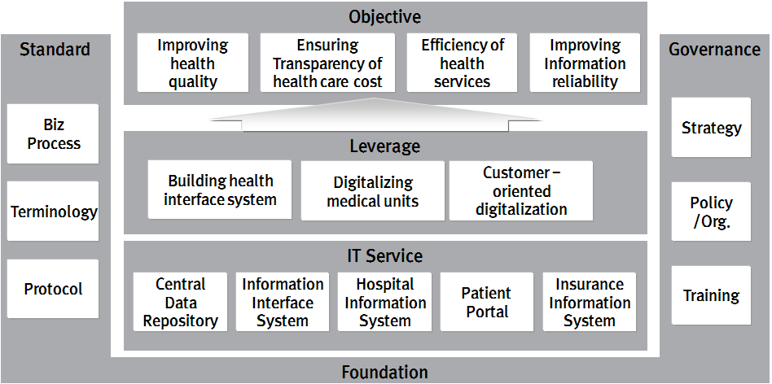
[Figure - 11] e-Health Framework

Implementation Goal
The MoH of Armenia is pursuing diverse policies for the improvement of its medical service quality. However, it is faced with many challenges such as: difficulties in evaluating the current conditions used for policy development; the lack of utilization of advanced IT due to budget shortage at most medical institutions; and paper-based work process. In addition, patients cannot enjoy sufficient medical benefits due to high medical costs and regional gaps in medical services. Therefore, Armenia is advised to pursue the following goals and strategy for its e-Health system.

[Implementation Goal]
① Medical quality improvement
- Resolving unbalance between health service provider and consumer thru securing the right to know.
- Building an infrastructure and securing the right of medical choice to guarantee the high-quality medical services thru offering lifetime health record, service provider information etc.
- Improving accessibility on medical services thru developing various medical service channel such as portal service and call center etc.

② Securing of the transparency of medical cost
- Reduction of medical resource waste and saving of medical cost by enhancing the efficiency of hospital operation
- Strengthening of monitoring system for medical treatment and prescribing to regulate inadequate prescribing practices
- Preparation for medical system expansion by ensuring system operation reliability and reducing budget waste through diverse ways of preventing errors and irregularities related to insurance operation.

③ Improvement of medical service efficiency
- Applying health information standard to health institution for utilization and management efficiency health institution
- Contribution to the stimulation of various medical service markets (e.g., private insurance, medicine etc.) by providing accurate information on current medical market condition and trend.

④ Securing of the reliability of medical information
- Preparing infrastructure of analyzing public health information in order that building an evidence-based health policy is possible.
- Information exchange in an accurate, fast and reliable manner to support the decision-making by medical stakeholders
- Application of diverse security policies and technologies to prevent the leakage, abuse or misuse of patient information

[ Leverages and IT Services for computerization in Healthcare]
To realize the above-mentioned goals, the following IT services are required under the consideration of leverages.
- The latest information technologies will be introduced to improve work productivity and to achieve medical advancement through a hospital information system for medical institutions, including, in particular, hospitals and insurers.
- An IT system will be established for medical information related to patients, diseases, diagnosis and treatment along with information exchange system to be used for policy development and provision of high-quality medical service. A central DB for data collection and provision is required for the implementation of a medical information exchange system. The MoH, R&D centers and other stakeholders can use the central DB in order to gather and use information they need.
- Additionally, patient-oriented services should be provided to support easy accessibility to a large amount of accumulated medical information. A patient portal service is a precondition for providing customized information services to meet various needs of each patient.

Service Scenario
Medical information generated by health information system can be utilized in various medical institutions and allow a central organization of MOH to provide new value-added services with more information from the medical institutions.
The services provided by a central health information system include;
- Allowing patients’ medical information exchange between medical institutions and analyzing central health information to allow medical organizations to reuse it.
- Providing medical institutions with HIS (Health Information System) application S/W programs with standard processes.
In the next, possible scenario for the utilization of central database and HIS application will be described.

Scenario for a Central Database Service
The main function of a central database is to provide health information generated in the process of patient treatments to patients, service provider, government etc. in a timely, accurate and safe manner to help the parties make reasonable decisions. The information from the central database is expected as follows;

Examples of Information from Central Date Base
- Personal information: information of insurance eligibility, cost, disease, referral and treatment results, etc.
- Medical Institution Information: information of hospital, medical staff, billing, and cut-back, etc.
- Medical information: information of medical history, order, medication, test, and operation, etc.
- Financial Information: information of budget, claims & collection, billing & payment, etc.

The scenario next shows decision support between stakeholders by selecting medical institutions who would utilize information on the central database.

MOH
MOH is supervising health service providers providing the following services, whose decision can be made based on information from the central database.
[Health Insurance Services]
- Qualification management of subscribers and their dependents
- Health improvement and disease prevention operations for policyholders and their dependents
- Training on and promotion of health insurance

[Long-term Care Services]
- Qualification management of policyholders, dependents and beneficiaries of long-term care insurance
- Operation of Grade-Rating Committee, and determination of long-term care grade
- Research on and promotion of operations related to long-term care

Assume that the number of suspected influenza is rapidly growing in Europe and Asia and the trend has been monitored by the national surveillance system. The next scenario describes the process of analyzing the statistics data of reported suspected flu, detecting the increasing number and alerting emergency alarm. In other words, it indicates the case when there is no existing medical information stored in a central DB and need to collect new information for the new disease.

①The surveillance authority officially requests for the information of influenza infection.
②The technical team then configures functions on HIS system for influenza infection to be monitored and checked.
③HIS system monitors events on medical information. If the events are identified, the system sends a "save" request to a central Database.
④When the identified clinical event is detected, the system sends notification to the authority.
⑤Staff in the authority gets permission and accesses to EHR system.
⑥Then, the authority gains desired information relating with Bio-Surveillance.
⑦Process ends along with sending notification for any updates on policy.

[The relation between Central DB and HIS DB]
HIS is a system which computerizes the processes of a medical service in medical institutions. The transaction information generated from all processes includes from patients’ registration, prescription, test result, diagnosis, to treatment cost payment. And all of them are stored in HIS DB as it is(intactly), allowing checking the current situation and progress of services in medical institutions.
In contrast to HIS DB which stores all data untouched, the information in Central DB is originated from HIS and stored with some changes – integrate and save information in a way of analysis and identification.
There is no technical problem to connect the Central DB and HIS DB, but there are inefficiency and limitation. If Information in HIS DB is intactly stored in Central DB, the medical information might be nationally duplicated, which is inefficient. Also data handled within HIS are transactional, which means these are created while doing daily business so staffs cannot fully understand and analyze medical information only with it. Therefore, data coming from HIS should be stored by subjects so that staffs can easily search and analyze information. Additionally data integrity can be verified during data gathering process between HIS and Central DB.

[Table - 17] Example of Physician Order Information on HIS
Patient No. | Hospitalization Date & Time | Hospitalization Type | Treatment Department | Issuing Date & Time | Physician No. | Order Code | Classification Code
Billing Code | One time Amount | Max. amount of usage a day | Treatment Frequency | Dose Duration | Drug Usage | Input Check | Payment
Examination Portion | Pre-treatment (Before Payment) | Cancellation | Date of payment | Test Reservation | Reservation Date | Order Time | Fulfillment Department
Attending Physician | Attending Nurse | Exceptions | Emergency | Day/ Night/ Midnight | Attending time | Personal Charge | Reimbursement Type

[Table - 24] shows examples of information handled within HIS. Above items are recorded every time when prescribing and fulfillment information generated along with the information of prescribing cancellation and change. However, when the information is transferred to the Central DB from HIS DB, it is processed and stored by a patient, a doctor who issues, a doctor who fulfills, and etc in various ways as show in [Table - 25]. When there is a need of detail information, the only thing required is that the central DB just handles HIS information’s location, therefore, it is more efficient to search the information directly.

[Table - 18] Example of Central Data Base Information
Patient No. | Order Code | Treatment Department | Issuing Date & Time | Physician No. | ………… | …………

Issuing Physician | Treatment Activity Code | Number of Cases | Examination Portion | Issuing Date & Time | Attending Date & time | …………

Attending Physician | Treatment Activity Code | Number of Cases | Examination Portion | Attending Department | Attending Date & time | …………

Insurance Agency
Insurance Agency is in charge of performing a series process of selecting subscribers to provide health services and determining the type and content of service provision.
Based on the subscriber's financial situation, insurance coverage and service type are listed. These institutions make efforts to analyze treatment history to avoid over-treatment, under-treatment and misdiagnosis and provide proper treatment by collecting information from the central Database.

[Public Insurance]
Public insurance is a compulsory insurance targeting the whole nation and insurance rate is decided based on individual’s income. People will get benefits by paying a certain amount of monthly insurance cost to a public insurance company. When insured person uses a service offered by a medical institution, the total insurance cost is divided with a certain ratio, imposing the cost on a company and the patient according to the ratio. An assessment authority examines the cost claimed by the medical institution, informs the result of adequacy and then pays the medical cost to the institution with cost adjustment.
① People have obligation to sign up for national health insurance and pay insurance fee to an insurance agency, the insurance fee is calculated based on the amount of individual’s income. Otherwise, they are disqualified and have to pay full treatment cost. Signing up private insurance is optional and it helps people to reduce the financial burden from medical treatment.
② For the provision of treatment service, the medical institution checks patient's insurance eligibility from the central DB(in real-time). Accordingly a cost calculation method is decided.
③ When data are generated during patient care, medical institutions send and store them in the central database on a periodic basis as defined in the database.
④ Among the information transmitted to the center, medicine related information is transmitted in real-time. With the information, the central system checks the adequacy and harmfulness of medicines patients take and informs assessment results to the medical institution boosting the adequate prescribing.

[Medical Institution]
After a certain period of patient treatment, a medical institution claims its medical cost to an assessment authority. Then the assessment authority examines the medical history, informs the result to the medical institution and pays the medical cost to the institution.

⑤ A medical institution partially collects the fee for treatment from patient and requests evaluation for the rest to the assessment authority.

[Assessment Authority]
An insurance agency had 2 main functions; one is charge & collection of insurance premium from subscribers and medical fee payment to medical institutions, and the other is assessment and evaluation of insurance payment.
In case of Korea insurance institutions was running both functions however both functions have been separated into insurance agency and assessment authority for each in order to ensure the fairness of assessment. Even in case of other countries, independence type of assessment authority is various for each country depending on the character of insurance system.
An assessment authority is the organization to examine adequacy of medical services provided by medical institutions as well as examine suitability of service criteria used in insurance agencies. Also it is responsible for managing the quality of service by examining abuse, misuse and shortage in healthcare. The assessment authority gets medical cost claims by medical institutions and informs the result of adequacy to insurance institutions and medical institutions after the examination.

⑥Then the assessment authority gets the claim information of the medical institution from the central database and reviews the appropriateness of treatment. After checking indicators to assess the quality of service provided by the requester, the assessment authority saves or updates the result in the central database.
⑦After the assessment, the assessment authority informs the result and order the requester to take appropriate actions such as reducing the medical expenses and correcting their inadequate medical care.
⑧The insurance agency confirms the completion of the assessment and pays the amount of cost as determined by the assessment authority.
⑨ The insurance agency analyses finance enforcement history, assesses its appropriateness, and checks the insurance coverage and information to adjust premium rates.
⑩ To formulate a new health policy, MOH obtains information from the central database for analyzing statistics on various diseases and service level of medical treatment
⑪ To improve the service quality of medical care, MOH informs the assessment authority about the assessment criteria for institutions and their services including treatment.
⑫ Technical team who is in charge of the central database updates its information architecture based on up-to-date requirement following MOH's health policy.
⑬ The central database provides health information for those who have symptoms that require attention.
⑭ Private insurance subscribers can claim the expense of medical care they already paid by themselves.
⑮ After check up on the Central Database, the private insurance agency pays the medical cost claimed by subscribers.

[Private Insurance ]
In contrast to a public insurance agency which has connection with medical institutions under a contract and provides medical benefits to subscribers, the private insurance company shown in [Figure – 30] has only connection with patients who subscribe a private insurance. Because a private insurance is not a compulsory but an optional insurance, it covers a certain amount of patient’s share imposed after medical service. Accordingly, there is no need of additional examination by the private insurance company since the examination for patient treatment has been already completed by a public insurance agency and the payment is completed by the medical institution, public insurance agency and patient. The patient submits evidence of medical expenses after paying it to the medical institution and then he/she gets paid back the cost. So, there is no information flow between a private insurance company and medical institutions.
The payment system mentioned above is called “Personal Reimbursement Insurance Payment System” and described as follows in [Figure-30]. Even it might be not easy for patients to directly claim money to the private insurance company in this system, it could resolve a fairness issues on medical fee schedule between public and private insurance companies. (e.g. in case there is a gap in medical schedule fee between SHA and private insurance company in Armenia). Also it could reduce the additional investment to introduce new insurance claiming system between private insurance company and medical institutions.
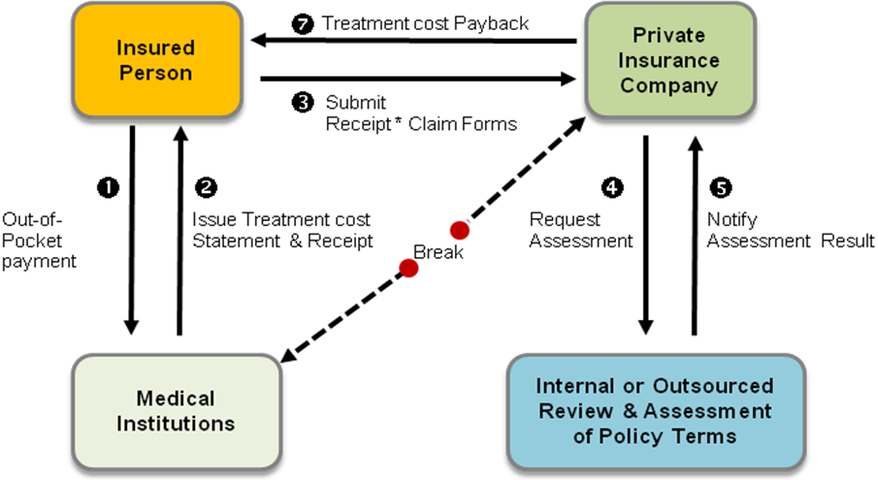
[Figure - 12] Flow of Personal Reimbursement Insurance Payment System

However in case of this personal reimbursement system, patients should redundantly submit receipts and documents to private insurance companies for medical expense claims so it can raise inefficiencies in cost and time such that patients could have additional financial burden and the private insurance company might have to re-enter the information on their system. Therefore, we could consider “Mutual Insurance Payment System” as shown in [Figure -31], which medical institutions and private insurance companies deal with the medical fee claims on behalf of patients. But it has some disadvantages that if the assessment organization is private other than public (e.g. SHA), personal information could be leaked; and it can influence the medical activities because of cost cut on medical expenses according to the assessment result coming from private assessment organization.
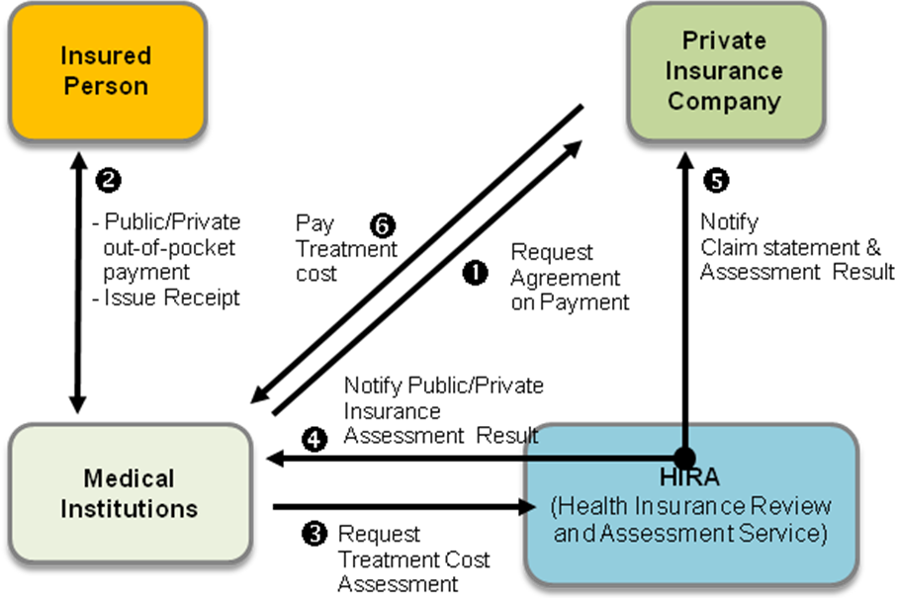
[Figure - 13] Flow of Mutual Insurance Payment System

[Relations of each Organization]
The public insurance agency, assessment institution, medical institution and private insurance agency are all independent organizations and they do not belong to each other. It means that a hierarchical structure does not exist between them. However, they are in close relations and intimately connected to one another aiming for public health delivery.
The Ministry of Health in Armenia, an government organization in charge of health policy, will have a similar role as the “MOH” shown in [Figure - 29].
The State Health Agency in Armenia will also have a similar role as the “Public Insurance Company” in [Figure - 29] but the only different thing is, it will provide benefits to a specific group of patients, not all patients. The one in [Figure - 29] targets all public.
There is no similar or related organization to Central Bank of Armenia in [Figure - 29].
The private insurance agencies in Armenia can be different from the “Private Insurance Company” depending on their own insurance policy, but basically they are similar.
The health facilities in Armenia is the same as “Medical Institutions” in [Figure - 29].

[Scenario]
The process of collecting and analyzing information from the central database to fetch indicator values when reviewing misdiagnosed inpatient cases such as re-operation without proper reasons:

① Insurance agency evaluates medical institutions after evaluating the quality of operation referring to the number of re-operation in those medical institutions.
② Each medical institution configures a calculation method on its HIS based on re-operation indicators officially notified.(objective setting)
③ HIS transmits the created indicator values to the central database.
④ When the indicator values from HIS are processed and stored in the central database, the central database automatically notifies insurance agency that the information is available.
⑤ Insurance agency acquires authentication and accesses to the central DB system.
⑥ Insurance agency gets information relevant to re-operation indicators the way they wanted.
⑦ Insurance agency assesses the collected indicator values and asks correction to medical institutions that don’t meet the standards.

Medical institution
Medical institutions produce the largest amount of data among organizations participating in the health information system project during their treatment services for inpatients and outpatients.
Also, medical institutions account for most of medical expenses by the government, and there are many opportunities to reduce medical cost by encouraging joint treatment and treatment information sharing between hospitals.

- Entitlement management, acceptance and treatment for outpatients and emergency patients
- Provision of treatment to inpatients for a certain time period (except for hospitals specialized in outpatient treatment)
- Medical fee collection and claim in accordance with patient entitlement (co-payment, payment by the government, payment by insurer etc.)
- Transmission of information on diseases, symptoms, and medical examinations after patient treatment to the Central Data Base so that the information can be used as data for policy making and analysis for public health delivery

The following shows how to use the central database to refer to patient examination information in order to prevent overlapping and unnecessary examinations through information sharing between medical institutions. This will help to reduce medical cost and to improve the quality of medical treatment service.
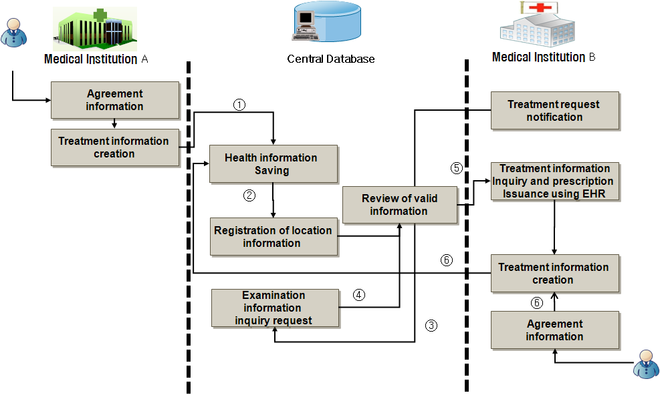
[Figure - 14] Medical Treatment Information Sharing using EHR

To access to patient’s personal treatment information, it requires to get an agreement from the patient. The doctor in medical institution checks the patient agreement and records whether the personal treatment information can be shared or not with others.

① Medical institution A diagnoses a patient, sends and saves the information in Central Data Base along with the information of agreement from patient .
② With medical information, the location information is stored in the central DB.
③ If the patient’s not recovering, send referral to a medical institution B. Then B requests to get the patient information from the central DB.
④ The system checks if it’s allowed to share the patient’s information per request.
⑤ Allow B to get the information if it’s agreed to share.
⑥ After providing treatment service, B stores the information in the central DB including the permission level to share.

Patient
The central database is needed for the management of personal health information so that the lifetime health information of individuals can be provided from a comprehensive perspective.
Personal health information should be protected by related laws and latest security technologies. Individuals should be able to access and manage their own health information whenever and wherever they need to do.
① The PHR portal system is managed by a specific organization under the Government of RA. It complies with the law related to personal information protection, and provides services based on medical information of the central database.
② The general public including patients can use services provided from the PHR portal system by registering for the PHR service.
③ As the portal system can be used by whole nation, it is required to define management functions such as information authority, user authentication, information security and others. See the below for more details.
 The central database may include the information produced by medical institutions and general health information recorded by individuals themselves (e.g., height, weight, blood pressure, blood sugar level etc.), and provide the following functions.

[Health and disease information]
Considering a patient’s condition, provide various health and disease information including disease-related news, how to maintain the health and adverse cases to help the patient keep the condition better.

[Self – Examination Service]
Based on existing medical record and self-checked symptoms of a patient, the system may give recommendation depending on the level of health and risk factors. Especially it is useful for critical diseases which need self-management or appropriate treatment such as chronic disease.

[Search of treatment details]
It is available to check the medical history and test result of a medical institution as well as information of other medical institution, schedule and procedure for further treatment service.

[Vaccination service]
Against various infectious diseases and pandemic disease, it provides information on vaccination, post-treatment, symptoms or problems after vaccination, and etc.

[Family doctor Service]
It provides medical services dedicating a personal physician for each patient to manage their medical history and prevent chronic disease and irrational drug use in advance.

[Treatment appointment]
It provides a convenient custom-service by supporting a medical user to have reliable information and choose the right medical provider for her/him as well as providing a reservation service for them.

[Telemedicine service]
It provides a remote medical service for those who have troubles in accessing medical service by assigning a personal doctor to each.

[Portal User Rights Management]
It decides whether content services in the portal can be provided based on the patient’s permission. For instance, while a patient has a permission to add or modify own self-checkup information, it’s not allowed to change contents for doctor service but allowed reading the contents. The system administrator have all permission so it is allowed to control site layout and management tasks.
The permission to read is a basic level of authorization which granted to most of user groups allowing them to search, read the contents and open documents and directories. Yet the permission to access personal information, specific health information, lists, document libraries, directories and files are granted differently. Those permissions to access, read, write and modify contents are managed for each user.

[Add portal users]
Users (individual or corporate) can use the portal site after registering as a member by enter personal information and provide private information for authentication. Depending on the type of permission or content in the site, the level of user permission is determined to read, add and modify information.

[Security & Identification]
The methods of information security include access control, audit control, integrity, and authentication of access & entity as well as transmission security. A unique identifier should access to medical information and it must be accessible with proper procedure in emergency situation. Audit control and authentication of access & entity should be provided to make information trace (e.g. access and change) possible.
The actions for information security control include access control, encryption, and the internet information security. Among them, the most important action for control is the “access control” which allows only authorized persons to access the information while it blocks unauthorized persons’ access. The access control on information system divides into two: physical access control and connection access control.
In the cyber world like current days, two main approaches are taken for user and personal authentication. First, the user sets own ID and password and conducts a personal authentication. Second, the user registers a certificate on a system so the system can verifies user via the certificate file. Both of two methods are intended for use in most portals by giving users options to select. Smart card, PKI, finger print recognition, iris recognition and etc. are also used for the security methods.
- Certificate : A digital signature medium. When a user needs authentication or sends & receives information on the Internet, representative institutions with credibility such as public institutions or banks check user authentication and grant the certificate.
- PK: When users communicate on unsecure public network, a representative institution with credibility grants a public and private key to each user to exchange information securely.
- Mobile SMS: It authenticates a user(e.g. a credit card holder) identification by matching the information of credit card and the personal identification number issued via mobile phone.
- Smart Card: An ID card with IC-chip to enhance the level of security, information processing & storage, and application adoption. It is used for not only personal identification but also authentication. A separate reader device is required.
- Biometrics: It is one of the robust security methods with its benefits – there’s no need to remember or carry it out preventing illegal use. The biometric technology identifies and authenticates a person with a personal behavior or a specific body spot which shows a clear characteristic of the person, ranging from fingerprint, hand geometry, voice, iris, retina, blood vessels to signature. A separate reader device is required.
- Even though those effective technical actions for security are taken, the conflicts between parties in health service must be resolved first. Also it is compulsory to establish a framework for personal medical information security in any way to make a national agreement from public; even it would take a considerable amount of time.

[Monitoring]
Information of all users using the portal site are managed and monitored via LOG including the contents delivery status and work history. Also it effectively monitors system load, real-time events, security, backup and network status by applying load balancing & distributed server technology to stably manage the server and monitor the information transfer.

Pharmacy and Research Institute
Patient prescription details are saved in the central database permanently, enabling the share between medical institutions and pharmacies and the comprehensive evaluation on a pharmacy’s e-prescription implementation. In particular, since the drug administration decisions by doctors have direct impacts on patients’ health, the prescriptions need to be reviewed before being filled. The central database reviews drug prescriptions. The following shows the details on prescription evaluation.

- Review of the appropriateness of drug prescription for the minimization of drug side effects
- Review of drug interaction to prevent potential risks
- Review of possible side effects due to patients’ other existing diseases
- Review of allergic or oversensitive reactions to drugs
- Review of important issues such as: overlapping drug prescription; drugs not allowed for pregnant women; and drugs which should not be taken together

①It is not common that two medical institutions A and B issue overlapping drug prescriptions at the same time. But it happens frequently that one patient is prescribed for different diseases respectively during a certain time period. In this case, a drug prescription issued to a pharmacy is stored in the central database without review.
②Under the drug dispensing support system, prescription information is reviewed by a responsible organization under the Ministry of Health based on the review method No. 2 or 3 before being saved in the central database. The review can be done using the method No. 2 only, or using the method Nos. 2 and 3 in consecutive order. The method Nos. 2 and 3 are as follows.
③In the case of the method No. 2, a written drug prescription is send to an examination organization for the review of its effectiveness using the central database. In the case of the method No. 3, a pharmacy is also required to send drug dispensing information to an examination organization for a second review.
④Unlike the method Nos. 2 and 3, an examination organization extracts data produced over a certain time period from the central database to see if there are problems or errors. If problems or errors are identified, medical institutions are notified about them with correction instructions. In this way, medical institutions are encouraged to take preventive actions to prevent similar problems.

In addition to drug prescription, medical treatment information of medical institutions is checked by research institutions for safety review. The information can also be utilized as data for medical research including the development of drug, medical equipment, examination equipment, reagent etc.

Central HIS (Hospital Information System) Service Scenario
So far, it was described how to produce e-health information, save it in the central database, and utilize it. Now, the process to be followed by medical institutions will be explained. Medical institutions follow their own medical processes which are determined based on the number of wards, medical professionals, patients etc.
However, this causes difficulties in establishing the central database and has risks of undermining the quality of medical services. Therefore, core medical treatment processes are identified to be commonly applied to all medical institutions.
In the meantime, medical institutions are allowed to determine non-core processes themselves so as to ensure the flexibility. The treatment processes at medical institutions are classified into two categories: outpatient treatment process and inpatient treatment process. The core processes for outpatient and inpatient treatments are as follows.

Outpatient Process
The primary treatment process at medical institutions is outpatient treatment which is performed as patients move between relevant treatment departments. It is almost impossible to set up a standardized process for outpatient treatments since medical institutions have different procedures. However, as it is required to standardize procedures related to treatment processes in order to establish the central database, the core processes will be identified and defined for their standardization.

①Registration
- When a patient visits a medical institution, it is checked whether it is his/her first visit or not, for the purpose administrative management and medical treatment. Hospital also checks personal information including medical insurance subscription.
- Then patients may be able to choose a treatment department and a doctor. However in case hospital has few numbers of doctors, hospital may assign a doctor to a patient depending on the scale of hospital.
- In case of patient who already visited before, the patient’s history records are searched and transferred to the treatment department so that the medical staffs can refer to the records for medical treatment.

②Initial treatment
- An outpatient treatment reception desk is notified of the first visit of a patient. Records of interview examination and previous treatment are prepared and sent to a doctor.
- A doctor examines the patient and issues an examination instruction for diagnosis.
- A nurse provides necessary information about the examination to the patient, and books for the use of an examination room.

③Examination
- A relevant examination room sets up an examination schedule after reviewing issued instruction and booking status.
- A patient receives the examination.

④Examination review
- After examination, the result is recorded (in number, or as doctor’s examination opinion).
- The examination result is notified to a responsible treatment department to be used for patient diagnosis.

⑤Second treatment
- The examination result is reviewed by medical staff in the responsible treatment department, and a treatment instruction is issued.
- Treatment instructions are made for drug administration, injection, surgery etc.
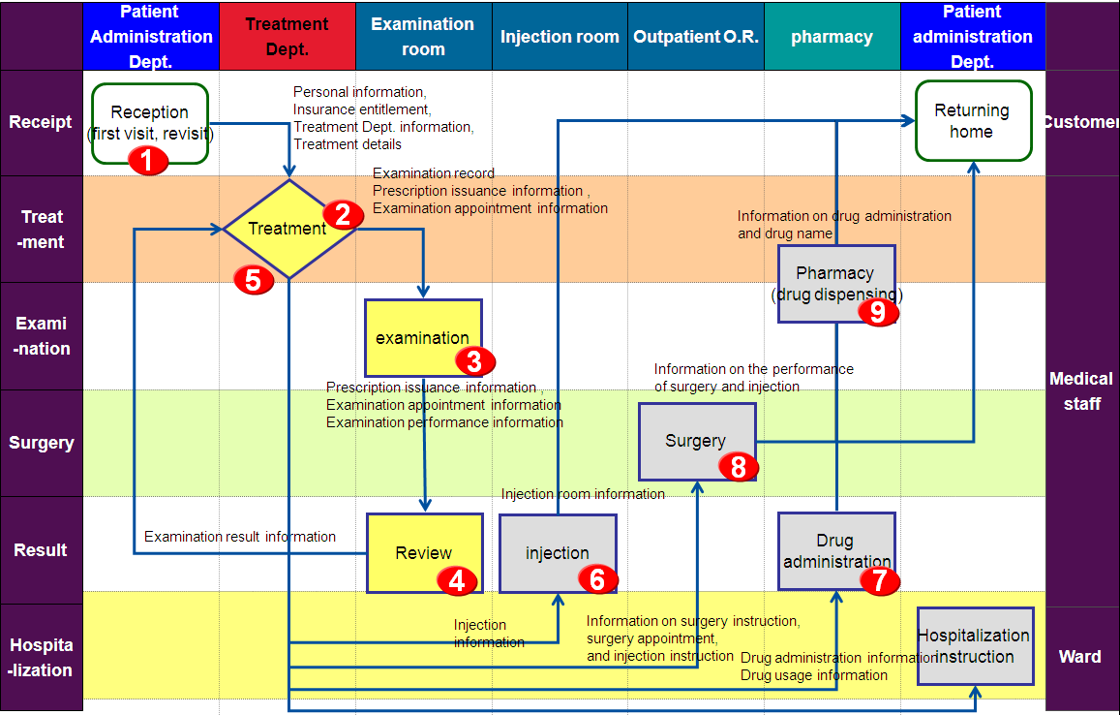
[Figure - 15] Outpatient Treatment Process Flowchart

⑥Injection
- In case of minor symptoms, injections or simple medical treatments are performed, and this treatment is completed in an outpatient department.

⑦Drug prescription and administration
- When a symptom can be treated by drug administration, a drug prescription is issued after checking if a patient has sensitive reactions to relevant drugs or if a patient is on taking other drugs.
- In case of drug administration, the prescription with the name of medication ingredients is issued.

⑧Surgery
- When anesthesia is needed, anesthesia is performed by an anesthesiologist.
- In most cases, hospitalization is recommended for surgery patients. However, a day surgery may be performed in a DSC(day surgery center) if it is necessary to reduce medical fees.

⑨Pharmacy
- A drug prescription issued to a patient is saved in the central database, and it is referred to when a patient gets the prescription filled in a pharmacy outside a hospital.

Hospitalization Process
If the symptom of a patient is critical and requires hospitalization, a doctor issues a hospitalization instruction. However, there is not much difference between inpatient treatment and outpatient treatment.

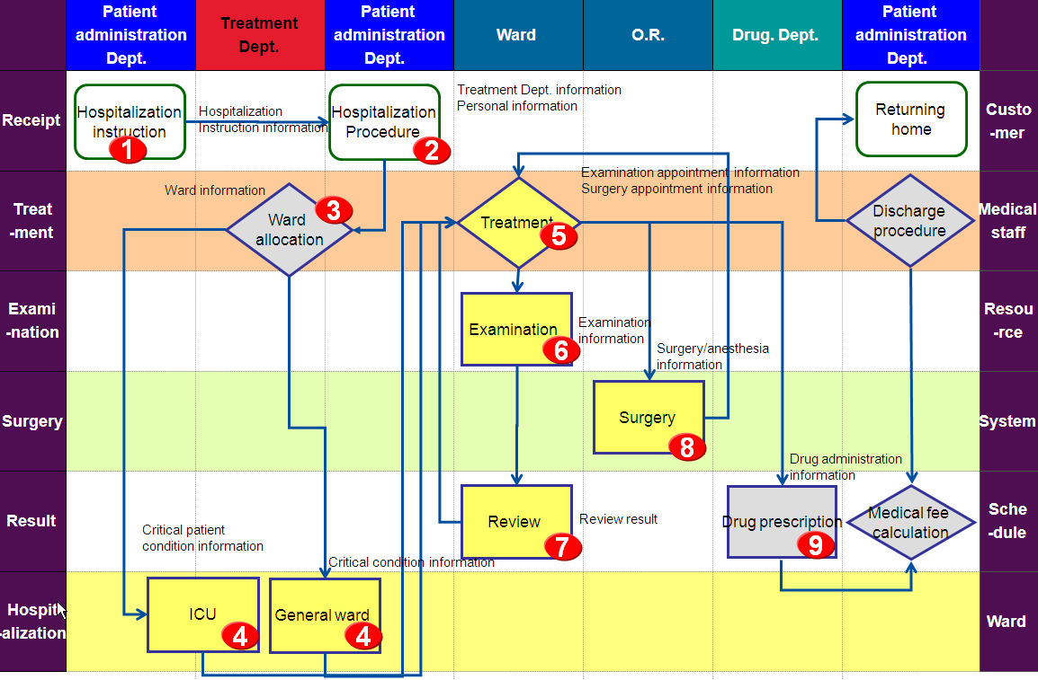
[Figure - 16] Inpatient Treatment Process Flowchart

①Hospitalization instruction
- An attending physician determines whether hospitalization is needed based on the result of outpatient treatment.
- An attending physician’s permission is required for hospitalization or discharge.

②Hospitalization procedure
- Forms (documents) created for outpatient treatment are transferred for hospitalization procedure, and are modified to reflect changes. Doctors and treatment department may be changed.

③Patient’s room allocation
- If the occupancy of patient’s room is over 100%, a facility reservation system should be developed. Through the system, patients will be notified in advance regarding availability of admission.

④Admission to patient’s room
- Patients are sent to general or special patient’s room depending on the severity of their conditions. Special patient’s room include ICU, delivery room, newborn unit etc.
- An attending nurse is assigned.
- Inpatients are examined for the severity of their conditions, and the possibility of their discharge is reviewed in advance.

⑤Inpatient treatment
- The medical staff examines the condition of patients everyday, and instructs necessary treatments such as examination, drug administration etc.
- An attending nurse checks if a doctor has issued a treatment instruction, and if so, implements it.

⑥Examination
- A relevant examination room sets up an examination schedule after reviewing treatment instruction and appointment status.
- A patient goes to a relevant examination room according to the appointment schedule.
- Prior checkup is required before hospitalization which requires medical examinations of various kinds.

⑦Examination review
- After examination, the result is recorded (in number, or as doctor’s examination opinion).
- The examination result is transferred to an assigned treatment department so that it can be used for treatment decisions.

⑧Surgery
- After checking the reservation status of O.R.(operating room), anesthesia and surgery are scheduled at the assigned operating room.
- When anesthesia is needed, it is performed by an anesthesiologist.
- All necessary treatment instructions should be performed during a surgery.

⑨Pharmacy
- For inpatients drugs are offered from a hospital so an attending nurse is mostly responsible for injections
- A prior review should be done before drug dispensing using the central database to ensure the appropriateness of drug prescription.

Implementation Strategy
The implementation of an ideal e-Health system is a complex project which requires a large amount of time, effort and budget. Some of the major and important issues that the Armenian government needs to consider for the successful implementation of the project are as follows.

[Major issues and strategies related to system implementation]
- Expansion of Basic Infrastructure
In order to establish information sharing and utilization system, network that guarantees the stable business process should be built and confidentiality should be ensured due to characteristics of health information. However, since the establishment of network infrastructure requires a large amount of time and money, it is more cost-effective to adopt an incremental approach for the installation and expansion of national network infrastructure and e-Health system.
Along with the expansion of national network infrastructure, it is important to encourage the use of PC and Internet by the public. In addition, a systematic plan needs to be developed to promote the use of PC and Internet so that the general public can utilize the e-Health system in a more efficient way.
For the use and exchange of medical information on a government-wide level, the standardization of data should be conducted, which requires instructions for medical work standardization. Therefore, the establishment of the standard should be done in a flexible and expandable way, fully reflecting the characteristics of Armenia’s medical system. It is critical for Armenia to implement a standard information system optimized for those standard procedures, forms, and guideline.

- Incremental experience acquisition
Most countries that planned and developed a national e-Health system suffered trials and errors due to diverse reasons during their initial attempts. Despite sufficient plans and preparations, countries tend to face unexpected challenges stemming from their unique historical, cultural and economic environments. To avoid such challenges, it is necessary to adopt an incremental approach where implementation and validation are conducted repeatedly so as to minimize investment risks.
To help medical professionals including doctors to accept and utilize the e-Health system, it is important to convince them that the system will improve their work productivity and treatment in an efficient way. With this recognition, priorities should be determined for efficiency maximization, and incentives for the active participation by medical professionals need to be considered.

- Nationwide cost minimization
The effect of e-Health system is enormous. However, it will not be easy to secure sufficient budget for the expansion of hospital information system given huge installation costs and current economic conditions. Therefore, it is necessary to implement a system that benefits a number of medical institutions within a limited budget. One way of doing so is to install a standardized hospital information system using IDC-based SaaS (Software as a Service) instead of different systems for individual hospitals. This way, the cost of system expansion can be minimized.
Also, initially, the project should focus on representative institutions to identify potential problems and to prepare measures for handling them. The project needs to be expanded gradually afterward. This is an efficient way to minimize risks and to avoid mistake that other countries have made.
Given the medical environment in Armenia, its e-Health project needs to be implemented based on the following steps.

[Roadmap]
The e-Health system project will be conducted based on the following three implementation steps and follow-up expansion step.
The first step is “foundation step” where related laws, regulations and institutions are established for systematic project implementation based on a long-term and clear view.
The second step is “prototyping step” where interoperable medical standards are established which available for different medical stakeholders. It takes precedence over the design of government-wide central DB. The standard in work processes is also defined suitable for e-health system. After all that, the e-health system is developed at target hospitals based on these standards and, later on the feasibility and efficiency of standards are checked. This way, a standardized system can be test-operated and it is possible to verify and improve data collected by a central DB.
The third step is “integration step” where system installation is conducted in earnest. In this step, an IDC is developed for the expansion of the e-health system built in the previous step. In addition, a central DB is developed to serve as a medical information hub to allow related parties to share and utilize the medical information.
In the final “expansion step”, the medical activity information from all medical institutions is connected to the central DB system aiming for active utilization of medical information and service quality improvement on a national level. Also, additional functions and services are developed for the central hospital information system satisfying diverse requirements from medical institutions,.
[Table - 19] e-Health Roadmap by steps
Step | Purpose | Major tasks | Note
Foundation | Establishment of task force team and  legal foundation for e-Health system implementation | - Establishment of law, security regulation, policy and institution related to e-Health service  - Establishment of e-Health task force team
Prototyping | Development and validation of standard information service model for medical institutions | - Development of Armenia’s medical standard based on the international standard  - Standardization of work processes for the central hospital application services  - Development of hospital information system based on standards(in General hospital and Polyclinic)  - Contents definition of the central DB and capability verification | Interoperable system development available for several hospitals considering the central service(SaaS)
Integration | Implementation of central information system for e-Health application at a government-wide level | - IDC development for central services(HIS & DB)  - Adaptation of standard-base e-health system of 2st phase on a central service  - Central DB system development  - Repository(DB) development  - Portal and information link system development  - Training for operator and user | - Expansion focusing on metropolitan area  - System development in conjunction with national e-ID system
Expansion | Expansion of e-Health service | - Expansion of target hospitals for Central HIS  - Function expansion of central HIS(PACS, ERP, other modules)  - Expansion of connectives between a Central DB and all medical institutions in Armenia (DR implementation)

Foundation

Establishment of Related Law and Institution
Laws, regulations, and institutions should be established in relation to the implementation of an IT system for health information. Potential problems related to the IT system operation should be identified, and solutions to such problems should be found. In this respect, a guideline for the protection of medical information needs to be provided in consideration of the following:
- Development of regulations related to the protection and utilization of health information
- Establishment of legal foundation for necessary standard and certification
- Establishment of legal foundation for operation

Need for Law and Institution
- The protection of personal information is critical. Proactive measures need to be taken for health information protection to deal with many potential risks.
- The legal foundation should be prepared to provide the regulations, standards, certification and operational guidelines in relation to the protection and use of health information.
- Laws and regulations should be enacted in relation to medical information protection, and the standard and certification for the expansion of information exchange and sharing.
- When the legal foundation for the adoption of an IT system for health information is established, responsible organizations and committees can be set up and assigned with necessary roles.

Major Details related to Regulation Establishment
The following includes key details of regulation regarding information protection, standard establishment and system management of e-Health.
Refer to the appendix (2. Background and State of Legislation, 3. Draft for Legislation of「Act on Health Information Protection and Management 」, 4. Guidelines for Personal Information Protection Maintained by Medical Centers).

[Regulation related to the protection and utilization of health information]
- Compliance with the principles related to the collection, provision and use of personal information
- Compliance with the principles that allow individuals to check and correct their own personal information
- Compliance with the principles that require the specification of reasons for information collection (whenever the reason to gather certain information changes).
- Compliance with the principles to protect personal information from loss, and unauthorized access, use, modification or publication.
- Compliance with the principles that require the publication of the development and operation of an information processing system and related policies.

[Legal Foundation for Standard and Certification]
- Establishment of standards for medical information exchange such as the names of diagnosis and symptoms; determination of procedures and cycles for standard development and management
- Defining of data structure, data transmission, data content, and data management method at the central level so as to determining the way of information sharing
- Defining of the standards for application integration, network, security, directory and data storage related to the creation, modification and deletion of information at the central level.
- Defining of the standards for operational policies and procedures related to information management at the central level
- Defining of policies and procedures and selection of physical tools for the protection of information system, buildings, and equipment from natural disaster, environmental risk, and illegal intrusion.

[Legal Foundation for Operation]
- Team/organization setting plans should be developed to form a foundation of management and ensure operability and sustainability of computerization strategy in healthcare.
- Task force teams/organization should be formed both for formation of standard certification authority and for operation of computerization and standard certification.
- Noncompliance protection methods such an accreditation scheme should be put in place to ensure the standard compliance.
- Operation plans should be developed for managing and guiding cooperative organizations (e.g., advisory consultative body), and nurturing specialists.
- System vitalization schemes should be established to encourage the participation of public and private medical institutions through financial / non-financial expansion strategies.

Plan for Organizational Structure
An organization for managing and operating a project of a health information IT system should be able to reach the consensus among the experts and stakeholders as well as their participation. The project management needs to be conducted by adjusting and coordinating its scope, time period, and resources until its completion.

Need for Organization Operation
- The establishment of an electronic health record system is a long-term project, and therefore, it requires the consistency in project management including planning, securing of experts, organization formation, and budget allocation.
- By establishing a smooth communication system, the efficiency of project implementation needs to be maximized.
- For consistent project management, a working group and an organization of experts and stakeholders need to be operated.
- Detailed plans should be developed for internal organizations, external organizations, and project management organizations.
- Social consensus should be made on sensitive issues such as personal health information protection, and necessary and proactive measures need to be developed.
- Necessary finance should be secured, and the promotion and diffusion of an electronic health record system should be pursued.
- A project should be conducted in a way that prevents waste and eliminates overlapping investments between ministries and agencies of the government.

Formation of Task Force Team
It is necessary to set up a task force for the project of a healthcare information IT system under the Government of RA to be responsible for the development of a project roadmap and for the overall project management including the information infrastructure and standards for the informatization of public and private medical institutions, medical information exchange, healthcare service etc.

[Advisory Committee]
- It is necessary to form a national advisory committee in order to reach the consensus among stakeholders and to encourage their participation.
- Representatives and experts from the Ministry of Health, the Ministry of Finance, business-related government agencies, medical industry and academies, and public & private medical institutions.
- The role for establishment of related laws and standards, privacy protection, business funding, and advocacy is needed to discuss.
- The nationwide efforts for the computerization in healthcare takes 5 years for Korea(Center for Interoperable EHR) and 10 years for the United States (American Health Information Community, AHIC) by forming a professionals organization.
- Also this unit will be in charge of suggesting breakthrough technologies and developing standards of interoperable EHR implementation.
- MOH establishes medical policy, evaluation policy and direction of central DB utilization.
- MOE establishes operating policies and seeks funding source for the project of healthcare computerization.
- Medical institutions and health-related universities research and gather opinions of health system interoperability including process standards of central DB management, terminology, standard formats and etc.
- Medicine and medical device related companies get rid of hazards of the medical materials and establishes solutions to provide adequacy of the materials.

[Health Information Board]
- Playing a role as a control tower of health information system project, Health Information Board manages several projects simultaneously. It performs project management including budget and manpower, leads to make quick decisions by playing a central role of communication between organizations in the project and enhances efficiency of reporting system as a role of dashboard.

[Information Working Group]
- It is an actual working unit processes the national health information project. Reflecting expert opinions and national agreements, it is responsible for suggesting an ideal model and researching practical information by area of the system. Also it sets and assigns goals for team and manages them to achieve.

[Role of Sub-project Team]
- Health Information Planning Team: project planning, information protection, and security measure development
- EHR Architecture Team: designing of information exchange channel, and development of messaging technology such as HL7.
- Clinical Content Model Team: format management such as data dictionary, medical form, CDA etc.
- Medical Institution Process Team: development and management of HIS standard process

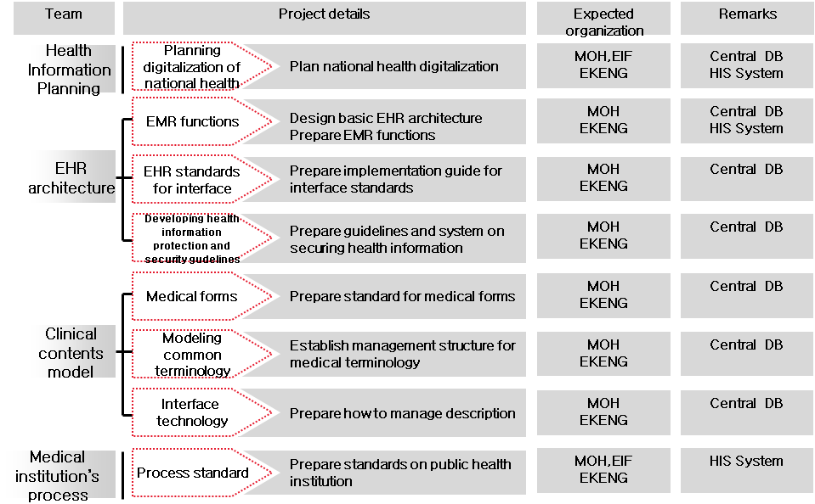
[Figure - 17] Role of TFT

Plan for Operational Organization Formation
The Task Force Team(TFT) mentioned above is a temporary unit to develop core technology and applications for the central DB and central HIS through dealing with law & legal improvement, medical process standardization and medical terms & medical forms standardization. Once the initial technology development of central DB and central HIS completes, the role of TFT is over. After that, a team called Operation Unit is responsible for operation and utilization of both central DB and central HIS. The organization’s goal is not developing technology but maintaining system efficiency and enhancing the level of system utilization along with amendment of additional law & regulation.
However, it is recommended that the TFT members continue to take the role of Operation Unit for work efficiency and specialty as they have gained valuable skills and knowledge during their initial implantation of e-Health project.
An operational guideline that medical institutions must follow to operate central database and application should be developed considering personal information protection and complying with national e-Health policy.
The guideline is a basis for the continuous and stable development of a national health information IT system, and requires an operational organization. The following is an example of such an organization.

[Steering Committee for system and guidelines]
It is a consultative body responsible for the review of the level of information protection required by the law and information protection and management policies at home and abroad in order to identify what should be included in a guideline.
It is required to analyze the information protection policies in the medical sector presented in international guidelines such as ISO27001, and HIPPA of the U.S.
It determines the policies for the protection and security of health information handled by medical institutions in order to supervise the protection of the rights of the public.

[Steering Committee for Health Information]
Playing a role as an advisory committee in the project promotion organization, it is a temporary unit which is put into operation when operational issues arise. It is consisting of experts from the academia, industry and civil organizations, and is responsible for providing consistent support for the project of a health information IT system, presenting professional opinions, and working to reach a consensus on a national level.

[Health Information Operation Unit]
It manages budget and human resources in order to create foundation of operating national computerization in healthcare; It promotes and implements functional expansion and diffusion of the system in order to activate the information system use; It is in charge of system management for efficiency and stability of system maintenance.

[Central Database Management Team]
A Central Health Database Management Team works in connection with the information systems of other medical institutions to collect and provide health information. It develops the policies and procedures for health information protection, and is responsible for creating an account for administers of other medical information systems and for identifying the purpose of those accounts.

- Compliance with and management of templates for medical information exchange
- Management of the compliance with and modification of medical terminology standard
- Management of the users of central database and their utilization purpose
- API provision to and management of the users of central database
- Management of user account and security authentication
- Management of the backup and recovery of central database

Responsibilities of the Central DB management staff
- Core Central Data Base Maintenance: Central Data Base Service's core services are up-to-date information collecting service, location information service to support the linkage of main hospital, registration service to register and lookup patient, personal health information protection services, standards service, and shared support services
- Platform development support for technical support: Infrastructure management to make sure if information-sharing participants follow guidelines or policies, and support management service for information exchange
- Standard Management: Update newly created standards and policies in medical authority unit
- Change management process support: Organize and operate a change management support team in order to form and successfully activate a main organization by main participants of information exchange.

[Central HIS Management Team]
The central HIS management team publishes a document stating system operating procedure and ensures users to utilize information following the procedure. Also the team handles unusual conditions or errors that may occur during operations, which is reported by the medical institution and supervises the progress of issue management.
- Upon the change requests regarding user requirements and processes from system users in medical institutions, Health Information Operation Unit decides whether it needs changes or not and provides final decision to the central HIS management team so that it can be reflected in the central application (HIS).
- The applications provided in the central DB (i.e. portal and information link services) can be modified by being aware of changes on health policy and user requirements, accepting opinions of the steering committee in all levels and following a decision made by Health Information Operation Unit.

Responsibilities of the Central HIS Management staff in medical institution
- Change management through collaboration with a central DB team: Promote services provided by information sharing system and provide training to medical institutions and stakeholders
- By connecting a standard and policy service provided by the Central Data Base, ensure that related standard and policy can be reflected to the medical institution.
- By promoting and informing related function of patient information exchange, encourage participation for it.
- It requires a representative field expert who has an understanding of To-Be business process playing a role of specialist of business process integration and improvement.
- It is responsible for a field expert for the Central HIS(Hospital Information System) changes.

[Outsourcing-possible Area]
Apart from the part related decision making, the technical part such as database and application modification can be outsourced including items below;
- PC and Network maintenance in all medical institutions across the country
- Modification of the central HIS application, portal and connecting service application
- Periodic speed and capacity monitoring for optimal processing performance and storage utilization of e-Health.
- Service management based on the security policy decided from the level of security by occupation and task. (in case of access to e-Health system)
- Source management of sensitive information from the system
- Periodic inspection for malicious code; installation of anti-virus software; regular updating of anti-virus software

Establishment of Medical Standard

Plan for Medical Standard Establishment

Need for Medical Information Standardization
The standardization of medical information is a precondition for the establishment of an efficient e-health information system in Armenia which is to improve the healthcare system for the public, to strengthen the management at medical institutions, and to save medical cost.
An e-health information system which is not based on medical information standardization leads to a number of isolated health information systems, undermining the purpose of the e-Health project which is to improve the quality and transparency of medical services.
Therefore, the standardization of Armenia’s medical information should be achieved by complying health information standardization policy in order to prepare the basis for an e-Health system, to enhance the efficiency of its national healthcare system, to improve the quality of medical services, and to secure the safety of patients.

Target of Medical Information Standardization
Standardization area of health information can be divided broadly into two kinds: First, an information scheme to be standardized to manage structured data in each medical institution through the central DB, and second, an information scheme to be standardized to efficiently carry out tasks within each medical institution.
For example, a central unit defines a high-concept category for Disease Control and Prevention, and each medical institution defines and uses a fine-grained category based on the top of the high-concept category for the disease.

Central DB Standard
The medical information archived in the central database is transferred from each medical institution. The government, medical institutions, medical insurers and patients utilize this information for diverse purposes such as research, training, statistics, hospital administration, healthcare policy-making etc.
A standardized information framework is essential to allow various organizations to utilize medical information. From the stage of information acquisition, the standardization should be conducted covering medical terms, treatment details, treatment results and other related information so that each different medical institution can access the information.
[Table - 20] Standard for Central DB System
Classification | Outline | Composition | Related International Standard
Terminology standard | Standard for medical terms and treatment record formats which are used for information exchange within hospitals and with outside organizations | Medical terms,  medical practice terms,  diagnosis terms,  nursing terms etc. | UMLS, SNOMED,  ICD-10 etc.
Format standard | Document formats for treatment information sharing | Medical record forms etc. | CDA (Clinical Document Architecture) Release2 at HL7
Code standard | Code standard for e-health information system | Organization, medical staff, medical service, materials etc. | No international standard
Information exchange standard | Information exchange standard to support the decision-making and communication between medical information providers and recipients | Message Transfer Protocol, Information Exchange Protocol, etc. | HL7 (messaging standard),  CDA (Clinical Document Architecture)

Standard for Medical institution
Medical information used at medical institutions is utilized for patient treatments as well as the communication between medical professionals and patients, and between medical institutions. In more detail, it refers to the information and data recorded during medical processes including patient diagnosis, treatment, progress observation etc.

[Table - 21] Standard for Medical institution
Classification | Definition | Composition | Related International Standards
Terminology standard | Standard for medical terms used in relation to patient treatment at hospital | Medical terms,  medical practice terms,  diagnosis terms,  nursing terms etc. | UMLS, SNOMED,  ICD-10 etc.
Format standard | Standard for document formats used in relation to patient treatment at hospital | Medical record forms etc. | CDA (Clinical Document Architecture) Release2 at HL7
Code standard | Code standard for e-health information system | Organization, medical staff, medical service, materials etc. | No international standard

Plan for Standardization
A “clinical content modeling team” of the TFT for the Armenia e-health project will be in charge of establishing medical information standard. Under the team’s lead and with the participation of the government and relevant medical institutions, the standardization will be conducted.
In other words, when initiating the e-health project, it is important to suggest underlying policy and guideline for standard implementation by reviewing international standards, reflecting opinions from professionals from outside, the government and medical institutions and eventually finding an optimal scheme considering Armenia situation.

Generally, medical information is used for patient treatment. Therefore, it is important that standardized medical terms are used for clear communication between medical institutions. The standardization of medical information should cover medical records and data of various kinds, and should be conducted in way that ensures the efficient information exchange between stakeholders as well as the consistency and scalability of data content, structure and exchange system.
In particular, the language and cultural differences should be considered when establishing the standard for medical information in order to ensure its consistency and usefulness. Additionally, in the case of information exchange, the international standards should be used to reduce unnecessary development efforts and to prevent global isolation.

The followings are principles of medical information standard establishment.
First of all, leading by the clinical contents model TFT team, the standard development should be conducted on a national level with proactive participation of diverse stakeholders so as to ensure the policy consistency and relevancy by preparing the basis for standard development strategy, organization and legislation.

Secondly, the standard development should be done in a way that ensures the harmonization with the existing standards in each field. Priority should be given to the adoption of the existing standards, then to their adaptation, and then to the development of a new standard. To develop the standards optimized in Armenia, the active participation of professionals from outside who are expert at domestic and international standard should be encouraged.

Thirdly, the participation by stakeholders on a national level should be encouraged so as to reflect the complex healthcare environment in an efficient way. The standard development for healthcare information sharing can be achieved fast by supporting the interactions between stakeholders of diverse kinds. Their active participation and cooperation will maximize the efficiency of standard development as well as its application and diffusion.

Finally, by considering the maintenance, management and diffusion of healthcare information standard, policies should be put in place for future standardization activities and necessary tools should be developed for standard maintenance and management. At the same time, user training also should be consistently provided for standard application and diffusion.

The following is an example of general procedure on standard establishment.
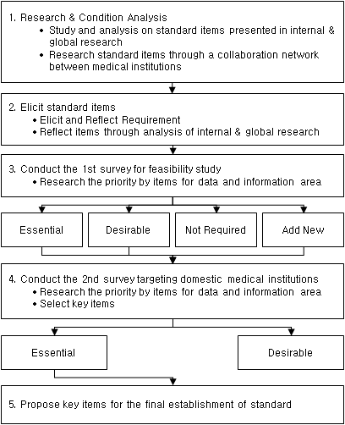
[Figure - 18] A procedure on standard establishment (Example)

Plan for Medical Service Standardization

Outline for Medical Service Standardization
Medical services at medical institutions include; patient management, planning & management of internal services, medical treatments & related work, facility operation, payment receipt, contracting etc.

For the standardization of services at medical institutions, medical services need to be classified into detail processes. Based on these processes, common application services will be identified which all medical institutions can comply with the standard when providing their services.

Target for Medical Treatment Service Standardization
The following shows the analysis of operations process at medical institutions which is based on the operation model presented by advanced organizations in Korea.

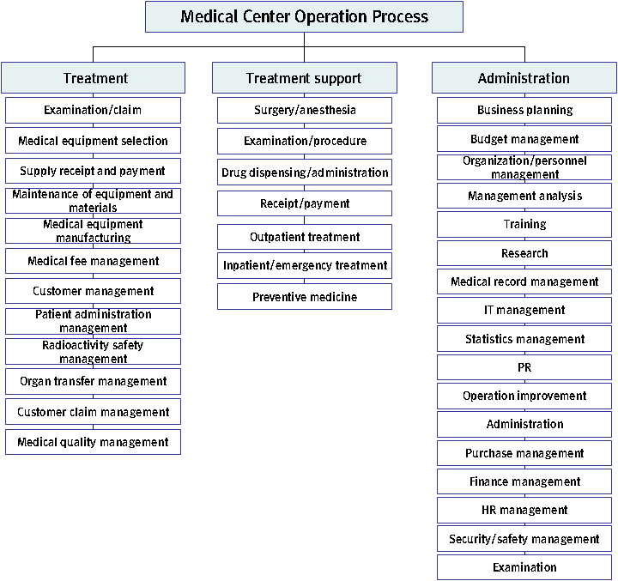
[Figure - 19] Operational Service at Medical institution

The operational service functions at medical institutions consist of level 1, 2, 3 process. Level 1 consists of 3 areas of treatment, treatment support, and administrative support. For the definition of the level 1, 2, 3 processes, refer to the appendix (1.The operational service functions).
The above-mentioned operational service processes may differ between medical institutions depending on their roles and purposes. In particular, it might not be easy to provide services based on the central DB due to the difficulty in standardizing individual operational services at medical institutions.
Therefore, core and common medical treatment services need to be identified so that they can be provided using the central HIS at all medical institutions. As for non-core unique services at individual medical institutions, service provision shall be made based on their own standards.

Action Plan of Medical Service Standardization Implementation

Plan of Common and Individual Service Identification
The analysis will be conducted on past successful projects to identify common treatment services to be provided using the central HIS. Based on the analysis, the classification will be made between common and compulsory services to be provided through the central HIS, and non-common services to be provided based on individual standards of medical institutions.
As the basis for the identification of common and non-common services, the Analysis on the Operational Status at Public Medical institution will be referred to, which was conducted covering 159 public healthcare centers for the establishment of the Hospital Information System by Korea’s Ministry of Health and Welfare.
In Korea, A census was conducted targeting 159 public medical institutions and through this, common and non-common processes of medical services were drawn. For the standardization of medical services of Armenia, it is required to select representative hospitals by types, analyze medical process and draw common and non-common service functions at the prototype stage in the future.

In the above analysis, operations at medical institutions (a total of 159 primary, secondary and tertiary medical institutions) were classified into 6 primary processes including customer management, treatment, treatment support, administrative support, patient administration, and training/research, and 75 secondary processes. The following shows the analysis results.

Based on the result of common and non-common operations classification shown as above and comparing it with business processes at Armenia’s medical institutions, the target services for future medical service standardization will be identified and suggested.
The matter whether to apply service functions providing on central HIS will be assessed based on the common and non-common area brought in best practices.
The decision criteria for application divides into two : Defining medical service functions with top priority of standardization as “Application-Yes” and defining administrative tasks apart from the medical services as “Application-No” to successfully manage and monitor medical service at the central level as follows;

[Table - 22] Identification of common and non-common services
classification | Exemplary case |  | Armenia | Application (Y/N)
classification | Operation | Detailed functions | Related services | Application (Y/N)
Common  (in total, 61) | Customer management (7) | Planning for customer, outside doctor, and region, customer satisfaction management, support for outside doctor, community service | Customer management | No
Common  (in total, 61) | Treatment/treatment support (19) | Strategies for medical service quality and safety improvement, management for medical service quality, safety, health prevention, and nursing, treatment of inpatient and outpatient, reporting of diseases subject to report, radiology, diagnosis and examination, physiological examination, drug management, medical record, nutrition and meal provision, social welfare, infection control, central and quality service | Payment receipt, outpatient treatment, hospitalization, emergency treatment, preventive medicine, surgery/ anesthesia/examination/procedure, drug dispensing/drug administration, examination/claim, selection of medical equipment, receipt of supplies | Yes
Common  (in total, 61) | Patient administration (11) | Administration strategy, patient management strategy, insurance review, management of patient, income, medical fee, patient registration, certificates, hospital room, and basic data, patient referral service | Medical record management, administration, purchase management, finance management | Partial application
Common  (in total, 61) | Management (21) | Management strategy, operation strategy, planning for marketing and promotion, management of performance, cost, personnel, employee salary, operation, and schedule, compliance with law and regulation, management of risk, knowledge and evaluation | Business planning, management analysis, management of organization and personnel, budget management, promotion, work improvement, HR management, security and safety management, statistics | Partial application
Common  (in total, 61) | Training/research  (3) | Training planning, training program management, job training | Training and research | No
Non-common  (in total, 14) |  | Emergency  treatment, surgery service, special treatment, specialized center, health examination,  visit treatment service, pathology, nuclear medicine, research and research fund planning, R/D center management, research fund management, research regulation, research cost administration, management of information and research results | Training and research | No

Definition of Common and Non-common Service Function
Based on the above example, the medical services in Armenia are classified into common services (based on the central HIS) and non-common services (based on individual systems of medical institutions) as follows.

[Treatment]
Medical treatment service will be provided based on the central HIS covering all treatment processes from patient acceptance, prescription, to drug administration in order to achieve the following: provision of optimal patient information to individual patients; input and search of prescription information in a fast and convenient way; highly efficient treatment processes at medical institution; maximization of user convenience etc.

The following shows functions of medical treatment service.
[Table - 23] Definition of Medical Service Functions
Service function | Definition | Necessary information | Location of Service Provision
Acceptance and payment receipt | Outpatient management service related to acceptance and payment receipt | Basic patient information, insurance information | Central HIS
Outpatient treatment | Management service related to outpatient treatment | Information on treatment department and medical staff | Central HIS
Hospitalization  /emergency treatment | Management service related to hospitalization, emergency treatment, nursing management, nutrition management, patient consultation | Information on medical staff, prescription etc. | Central HIS
Preventive medicine | Service related to medical examination including registration and appointment | Information related to appointment and medical examination details | Central HIS
Surgery/  anesthesia | Management service related to surgery preparation, surgery, anesthesia etc. | Information related to prescription and implementation of surgery or anesthesia | Central HIS
Examination  /procedure | Service related to medical examination and procedure | Information related to examination decision and result | Central HIS
Drug administration  /dispensing | Service related to drug prescription and dispensing | Information related to drug prescription and dispensing | Central HIS

[Treatment Support]
Treatment support refers to the support for medical administrative services. Services are classified into core and common and non-core services.
The core and common services have a high relativity with establishing government policy and understanding present situation in medical institutions. Therefore, it is important to provide the services through the central HIS and it includes : medical fee calculation after medical service provision; review of the appropriateness of medical treatments and medical fee claim; medical record management; patient administration management; medical fee schedule management, and medical quality management.
Other services will be provided based on independent service system of medical institutions.

The following shows the definition of medical treatment support service.
[Table - 24] Definition of Medical Treatment Support Service
Service function | Definition | Necessary information | Location of Service Provision
Examination/claim | Service functions related to examination, fee claim, and medical fee management | Details of diagnosis and treatment | Central HIS
Patient administration management | Service functions related to recording of charts and medical records | Details of diagnosis and treatment | Central HIS
Selection of medical equipment | Service functions related to the management of medical equipment selection | Information on medical equipment use | Individual system
Receipt of and payment for supplies | Service functions related to the receipt of and payment for medical equipment and supplies | Information related to the receipt of and payment for supplies | Individual system
Maintenance of medical equipment | Service functions related to the management of surgery equipment and other medical equipment | Information on medical equipment repair | Individual system
Management of medical service fee | Service functions related to the management of health insurance, medical fee standard, training, promotion and material publication | Information on medical fee standard | Central HIS
Customer management | Service functions related to customer management including patient condition identification and ward patrol | Details on medical treatment at ward | Individual system
Patient administration | Service functions related to patient administration such as medical treatment system improvement and ward operation | Information related to patients and sickbeds | Central HIS
Radioactivity safety management | Service functions related to safety management including radioactivity contamination measurement before and after examination | Information on radioactivity safety guideline | Individual system
Organ transplant management | Service functions related to the registration of brain death and transplant candidate, and the management of organ donor and recipient | Information on organ transplant | Individual system
Complaint management | Service functions related to the management of customer complaint | Information of complaint handling | Individual system
Medical quality management | Service functions related to contamination inspection, and management of patients of a disease legally designated as an epidemic | Information on infection control | Central HIS

[Administration Support]
Administration support refers to the support for general administration at medical institutions. Medical institutions are to establish their own service processes suitable to their administrative needs. However, statistical management is provided from the HIS since it is regarded as a common service function.

The following shows the definition of administration support services.

[Table - 25] Definition of Administration Support Service
Service function | Definition | Necessary information | Location of Service Provision
Business planning | Service function related to hospital policy making, short-term/long-term business planning etc. | Information on business planning | Individual system
Budget management | Service function related to budget management | Information on business budget | Individual system
Management of organization/personnel | Service function related to the management of medical organization and personnel | Information of organization member | Individual system
Management analysis | Service function related to the management of management performance and cost | Information on management and treatment statistics | Individual system
Training/research | Service function related to medical staff training and clinical trial management | Information on training target, research, and training performance | Individual system
Purchase management | Service function related to tangible asset acquisition and supply request management | Information on asset purchase and acquisition | Individual system
HR management | Service function related to HR including employment | Information of HR management
Finance management | Service function related to the management of accounting, finance, cost, tax etc. | Information on finance and accounting | Individual system
IT management | Service function related to the operation and maintenance of IT system | Information on system maintenance | Individual system
Statistics management | Service function related to statistics management at medical institution | Medical treatment statistics | Central HIS
PR (Marketing) | Service function related to PR activities including PR material production | Information on hospital promotion | Individual system
Work improvement | Service function related to regulation revision and management | Information on operations between internal teams | Individual system
General affairs management | Service function related to general affairs management at medical institution | Information on general affairs management | Individual system
Security/safety management | Service function related to security and safety | Information on security and safety management | Individual system
Audit | Service function related to audit data collection and management | Audit information | Individual system

Medical Service Evaluation Standard Indicator
The Armenia government should be in charge of not only providing the HIS service but also evaluating service quality regularly based on medical service indicators of institutions for the effective service quality assessment and improvement. The indicators includes from the level of patient convenience (e.g. the average waiting time of outpatient and an emergency room) to the level of service usage(e.g. the number of infection control training and hospital bed usage rates). To support the evaluation, it is important to build concrete information scheme for the indicators and the results of medical service evaluation should be automatically created in reality.
MoH is required to encourage medical institutions to improve their services by implementing administrative procedures such as incentive provision and correction order. This can be possible by root cause investigation and analysis on the low quality of service based on the evaluation result. Also the MoH is required to announce the evaluation results by medical institutions so that the institutions can provide patient convenience.
The following shows evaluation items. Note, however, that the evaluation standard changes every year based on the previous result or policy for positive changes at medical institutions.
[Table - 26] Medical Service Evaluation Standard Indicator
Evaluation Area | Service Classification | Process name | Indicator | Indicator definition
Evaluation Indicators of patient convenience | Treatment | Outpatient treatment | Average waiting time for outpatient | Waiting time for outpatient treatment after appointment
Evaluation Indicators of patient convenience | Treatment | Outpatient treatment | Adoption rate of medical treatment decision support alert | Adoption rate of medical treatment decision support alert
Evaluation Indicators of patient convenience | Treatment | Inpatient treatment | Average number of days required for treatment request | Time required between inpatient treatment request and treatment
Evaluation Indicators of patient convenience | Treatment | Inpatient treatment | Length of hospital stay (days) | Average hospitalization time from admission to discharge
Evaluation Indicators of patient convenience | Treatment | Inpatient treatment | Discharge rate against discharge notice | Rate of discharged patients to discharge notices
Evaluation Indicators of patient convenience | Treatment | Inpatient treatment | Rate of unplanned readmission rate | Readmission rate due to the same disease within 28 days of discharge
Evaluation Indicators of patient convenience | Treatment | Inpatient treatment | Average waiting time at emergency room | Waiting time for emergency treatment after emergency room registration
Evaluation Indicators of patient convenience | Treatment | Inpatient treatment | Average hospital stay time of emergency patient going home | Time from emergency room registration to discharge
Evaluation Indicators of patient convenience | Treatment | Inpatient treatment | Average hospital stay time of emergency patient to be transferred | Time from emergency room registration to transfer
Evaluation Indicators of patient convenience | Treatment | Inpatient treatment | Average hospital stay time of emergency inpatient | Time from emergency room registration to hospitalization
Evaluation Indicators of patient convenience | Treatment | Inpatient treatment | Average hospital stay time of emergency surgery patient | Time from emergency room registration to surgery
Evaluation Indicators of patient convenience | Treatment | Inpatient treatment | Average hospital stay time of acute myocardial infarction patient at emergency room | Time from emergency room registration of acute myocardial infarction patient to leaving
Evaluation Indicators of patient convenience | Treatment | Inpatient treatment | Average hospital stay time of stroke patient at emergency room | Time from emergency room registration of stroke patient to leaving
Evaluation Indicators of patient convenience | Treatment | Inpatient treatment | Average hospital stay time of severe trauma patient at emergency room | Time from emergency room registration of severe trauma patient to leaving
Evaluation Indicators of patient convenience | Treatment | Surgery anesthesia | Average waiting time for regular surgery | Waiting time between surgery patient admission to surgery implementation
Evaluation Indicators of patient convenience | Treatment | Surgery anesthesia | Average waiting time within O.R. | Waiting time between the arrival at O.R. to anesthesia .
Evaluation Indicators of patient convenience | Treatment | Examination procedure | The number of injections performed by 1 staff member | The number of injections performed by 1 staff member at injection room
Evaluation Indicators of patient convenience | Treatment support | Patient administration management | Average inpatient delay time | Total time period required to the hospitalization of those in a waiting list divided by the number of inpatients
Evaluation Indicators of patient convenience | Treatment support | Patient administration management | Average waiting time for payment receipt | Time required from prescription completion to payment receipt
Evaluation Indicators of service usage | Treatment | Inpatient treatment | CDSS alert adoption rate | Rate of CDSS adoption to CDSS alert generation
Evaluation Indicators of service usage | Treatment | Surgery anesthesia | O.R. turnover rate | Rate of occupied O.R. to the total number of O.R.
Evaluation Indicators of service usage | Treatment | Surgery anesthesia | Surgery cancellation rate | Rate of planned surgeries not performed
Evaluation Indicators of service usage | Treatment | Surgery anesthesia | Unplanned re-surgery rate | Rate of unplanned surgeries that are performed during hospitalization
Evaluation Indicators of service usage | Treatment | Surgery anesthesia | Surgery patient safety accident rate | Surgery patient safety accident rate after surgery
Evaluation Indicators of service usage | Treatment | Surgery anesthesia | Average waiting time for injection | Waiting time from injection request registration to injection .
Evaluation Indicators of service usage | Treatment | Surgery anesthesia | Injection error rate | Injection error rate
Evaluation Indicators of service usage | Treatment support | Medical quality management | The number of infection control training | The number of staff infection control training
Evaluation Indicators of service usage | Treatment support | Medical quality management | Time of infection control training | Time of staff infection control training
Evaluation Indicators of service usage | Treatment support | Medical quality management | The number of infections within hospitals by nursing unit | The number of infections within hospitals by nursing unit
Evaluation Indicators of service usage | Treatment | Surgery anesthesia | Rate of unperformed radiological examinations after appointment | Rate of unperformed radiological examinations after appointment
Evaluation Indicators of service usage | Treatment | Surgery anesthesia | Average appointment waiting time for radiological examination | Waiting time from the appointment of radiological examination
Evaluation Indicators of service usage | Treatment | Surgery anesthesia | Average waiting time for examination image-taking (scanning) | Waiting time from the appointment of examination image-taking (scanning)
Evaluation Indicators of service usage | Treatment | Surgery anesthesia | Average time required for the report of radiological examination result | Time required between radiological examination and its result report
Evaluation Indicators of service usage | Treatment | Drug administration | Average time required for drug order processing | Time required from drug request to drug purchase order
Evaluation Indicators of service usage | Treatment | Drug administration | Average time required for drug arrival processing | Time required from drug purchase to drug arrival
Evaluation Indicators of service usage | Treatment | Drug administration | Number of clinical pharmacokinetic operations per drug | The number of clinical pharmacokinetic operations per drug
Evaluation Indicators of service usage | Treatment | Medical record management | Rate of insufficient records | Ratio of insufficient records to the total medical records
Evaluation Indicators of service usage | Treatment | Medical record management | Rate of insufficient record supplementation | Ratio of insufficient record supplementation to the requests for insufficient record supplementation
Evaluation Indicators of service usage | Treatment | Medical record management | Rate of days of medical recording | Ratio of days of recording medical progress to the total days of hospital stay
Evaluation Indicators of service usage | Treatment | Medical record management | Rate of insufficient records | Ratio of insufficient records to the total medical records
Evaluation Indicators of service usage | Treatment support | Patient administration management | Sickbed utilization rate | Ratio of occupied sickbeds to the total number of sickbeds
Evaluation Indicators of service usage | Treatment support | Patient administration management | Sickbed turnover rate | The number of inpatients divided by the number of sickbeds
Evaluation Indicators of service usage | Treatment support | Patient administration management | Amount of unpaid fee for pretreatment service | Amount of unpaid fee for pretreatment service
Evaluation Indicators of service usage | Treatment support | Patient administration management | The number of certificates issued per staff member | The number of issued certificates divided by the number of staff

Deployment
[Outline]
Comprehensive configuration diagram is as follows, which utilizes information group of central database and offers functions of central HIS processes as mentioned before.

- Hospitals that use a central HIS system are running their businesses such as CPOE, EMR, LIS thru Internet.
- Information that is created while performing medical treatment in a hospital is stored at central HIS with hospitals’ ID; it is basic information to be transferred to central database. IDC manages, monitors and secures central HIS.
- Data registry is storage to manage the location of information used as a reference for a patient agreement on sharing information as well as for medical treatment records exchange. It is used to understand the detail medical history that was performed in other hospitals. Namely metadata such as patient’s personal information, treatment date/time, institution’s name, medical staff, disease name, issued prescriptions are stored at data registry, then location information(data registry) about HIS data is stored so that other institutions can search that detail information later on.
- All medical institutions in Armenia (i.e. central His medical institution and others) transfer medical information to central database and build an information group that is going to be offered to medical institutions.
- PHR (Personal Health Record) service is offered to people using information built in a central database; electronic prescription is offered to pharmacy; and disease surveillance and health statistics information are offered to insurance agencies and Ministry of Health.
- The hospitals running HIS locally without using the central HIS service transfer medical information to a central database thru HL7 CDA. And the hospitals without own HIS system transfers the information to the central DB by using other functions such Web Service API. In that way, both receive information from the central database.(Refer to appendix 5.Interoperable Clinical Information Sharing System based on CDA and Document Registry Framework.)
- Ministry of Health and insurance institutions locally running their information system are offered information service thru API to connect with central database.

Central Database Deployment Scheme
By defining information to be included in the central database-based structure, the data are configured to ensure the use of central health and medical information and the conceptual level’s data model is presented. Central database information model generalizes the health and medicine-related institutions’ information, and can enable the medical institutions, insurance companies, patients and pharmacies to exchange the health information related to the clinics.
Accordingly, in specifying the scope of data to be stored in the central database structure, the data should be patient-centric and have the relationship with the clinical exchange. In particular, as the major point of the data architecture, it does not store all the data which exist in the medical institution, but is focused on only the data which need to be shared. It should be capable to provide the health service through integration and sharing of national level’s health information, to establish the health policy, to utilize for research, to arrange the exchange and collaboration system between the public and private medical institutions, and to support the international exchange activity on the international disease factors discovery and treatment.

Business Perspective

Health Information’s Lifelong Records
Because the clinical information on the lifelong health records from the man’s birth to death is maintained and managed, the health information can be defined as the clinical data’s lifelong record, and the data are recorded and maintained in the central database continuously within the legally-allowable scope. The system should enable the individual to approach and use the health record for life.

- By managing the personal health constantly for life, the public health and the quality of medicine can be improved innovatively.
- Through infrastructure development that the individual can manage the own disease history by itself, the personal health can be improved and the medical costs can be reduced.

Major Clinical Information Sharing
Information generated from the areas where the personal and public health and disease prevention-related activities occur must be recorded, documented and integrated in the structured form’s integrated database. The individual’s medical institution’s requirements related to the information gathering, storage and utilization can be different from the central database, and the data gathered from the individual medical institution must be generally managed deeper and detail data.

- By clarifying the data stored and exchanged in the central database, the sharing information system’s efficiency is improved.
- The service for the use of central database can be more efficiently and actually utilized.
- It means that all the accurate clinical data required by doctors must be timely provided.
- In the clinical data exchange for the treatment, the most important information is the latest data and the efficient and economic medical service is provided by validating the latest prescription and treatment information.
- Information can be shared by medical institutions, health policy agencies, insurance companies, patients and pharmacies.

Future-oriented Function
Being the future-oriented system, the central database needs to focus the medical system’s requirements for the present and future happenings. To operate and expand the service, the long term prospect must be made. The change of requirements which are made from the gradual development of health and medical service delivery must be considered.

- Future-oriented system can be good for the nationwide expansion of health and medical system. It has high adaptability to new technology and give the instant response when necessary.
- Future-oriented system can be good for the system expansion and can reduce the costs.

Data Perspective

Information Requirements by User
Central database contains the diversity of requirements by users and there needs to be the treatment information sharing system to meet them. It was described in the service scenario, and are briefly summarized as follows.

- Personal aspect: The system is intended to implement the patient-centric medical service which enables the individual to record and search the own health records as the subject and consumer of medical treatment, and to reduce the time and costs by reducing the overlapped treatment and checkup by change of medical institution.
- Medical institution’s aspect: The system is intended to guarantee the treatment’s continuity through exchanging the treatment information by patient transfer between the medical institutions.
- Insurance company’s aspect: Public and private insurance companies need information on various costs by disease, age, occupation and region to establish the reasonable insurance premium, and the system is intended to provide the insurance company’s financial stability and the medical treatment service to the public.
- Government aspect: By reducing the overlapped treatment and checkup through exchange of treatment information, the nation’s whole medical costs can be reduced and the quality of medicine can be improved by decreased medical errors. By guaranteeing the patients’ safety, the national health improvement will be promoted and the good quality’s treatment information will be used for establishing the health policy.
- Technical aspect: Because the IT for information sharing has been rapidly developed, it accelerates the change of medical environment, and the technical requirements are increased because the health information exchange-based standards are actively established in Korea and foreign countries such as the data, technology, document, message and security.

User and Access Authority
Users who utilize the central database can be divided into the personal user, the medical institution of being charge of treatment, MOH medical policy agency, insurance company, medical institution, patient, pharmacy and research center. These related parties should have the difference in the data access authority depending on the information utilization level. The applied access authority and information group is described in the below table.
The principle users can be divided into two categories; the 1st user who use medical information contributing medical practice directly for patients and customers; and the 2nd user who use medical information for legal purpose such as health policy establishment and research activities. The 1st user creates and utilize medical related raw information including patient personal information under the patient’s explicit and implied agreement. In addition, the 2nd user is allowed to use all other information except the patient personal information complying with strict management policy for permission grant, information extraction & collection, and de-identification(anonymization).
[Table - 27] Access information by user
 | Group of Information | The 1st User |  |  |  | The 2nd User
 | Group of Information | Individual | Medical Institution | Pharmacy | Insurance Agency | MOH | Research Institution
Original Information | Patient Personal Information | Create | Read | Read | Read | X | X
Original Information | Medical Staff Information | Read | Create | X | Read | Read | X
Original Information | Personal Treatment History | Read | Create | X | Read | X | X
Original Information | Medication Information | Read | Create | Read | Read | Read | Read
Original Information | Test Information | Read | Create | X | Read | Read | Read
Processing Information | Monitoring System Information | Read | Read | X | X | Create | X
Processing Information | Disease Research Information | Read | Read | Create | X | X | Create
Processing Information | Evaluation of medical institutions | Read | Read | X | Read | Create | X

- Patient personal information: patient individual's personal information including insurance eligibility requirements, employment information, test results and etc.
- Medical staff information: information on medical institutions status and performance such as doctors.
- Personal treatment history: a patient’s medical history received in all medical institutions. (e.g. a patient's diagnosis progress, test result progress, prescription information for treatment, etc.)
- Medication Information: information about prescribing conducted to patients
- Test information: information about prescribed test and the results
- Monitoring System information: information to prepare for the public health by collecting information of diseases and epidemics that occur in medical institutions and related viruses and bacteria
- Disease Research Information : Information of disease treatment and prevention used to develop new medicines and disease prevention method by analyzing diseases and symptoms of patients.
- Evaluation of medical information: information for assessment including the service level and efficiency of medical institutions and the compliance level of standardized assessment process

To share the patient personal medical information, there must be a mark such a digital signature from the patient as an evidence of agreement on the information share. When other medical service institutions and medical staffs need the information as a reference, the mark (e.g. signature) indicating patient’s agreement also must be verified. Therefore, no one can share or refer the patient personal information without authorized agreement.
In addition, the permission of MOH and research institutions to refer the central DB will be limited to only authorized users only in each organization. The system should generate and provide separate information to each organization, which can be referred only for that organization. In other words, the access to directly refer the central DB is not allowed to them.

Concept Model
Basically, a data model of a central database is a form of storing aggregated information in a data repository in order to enhance the efficiency of information system or data generated within all medical institutions. Because the medical institutions utilizing a central HIS save detail data in it(the central HIS), they save the location information in a data registry to ensure the possibility of connection when necessary. On the other hand, the medical institutions utilizing a local HIS are required to refer to HL7 CDA for the information linkservices.

Detail Items

- Core data items of outpatient records: Outpatient records must be classified into the initial treatment record and re-treatment record by department, and it is general that the examination results are attached in the order of examination occurrence time irrespective of the department. The common items can be summarized in the below table and it is selected as the core data items of outpatient records.

[Table - 28] Core information of outpatient treatment
Information area | Detail items
Patient Personal Information | Patient name, ID, birth date, gender, address, telephone number, mobile phone number
Medical Staff Information | Medical institution name, physician name, signature, license number
Patient Medical Information | Treatment date, treatment department, symptom, diagnosis name, medical examination detail, physical checkup, treatment plan

- Core data items of hospitalization records: In the hospitalization records, the patient ID which is the minimum core data item of treatment information sharing for hospitalized patients has the patient’s identity and the big advantage for the system implementation. But, for the personal information protection, it will not be used and the virtual ID must be generated and used to identify the patients.

[Table - 29] Core information of inpatient treatment
Information area | Detail items
Patient Personal Information | Patient name, ID, birth date, gender, address, telephone number, mobile phone number
Medical Staff Information | Major doctor, family doctor, signature, license number
Patient Medical Information | Hospitalized date, discharge date, department for hospitalization, department for discharge, ward, symptom, doctor’s comment, treatment and progress, surgery and prescription name, major diagnosis name, major diagnosis classification number diagnosis name, prescription for discharge, future treatment plan

- Scalable candidate data items: The data items for providing the information exchange for the purpose of treatment to users based on the shared data as well as the core information of outpatient and hospitalization records can be extended as shown in the below table. Then, it must be selected and implemented at deployment.

[Table - 30] Other scalable information
Information area | Detail items
Patient personal information | - Race, nationality, age, religion, marital status, education, validated height, validated weight
Death registration information | - Date of death, place of death, autopsy status, death certificate issuing agency, death certificate issuer, death certificate issuing date, death certificate ID, death cause – direct cause, death cause – indirect cause, death situation record
Lawful consent information | - Consent for video, consent for research participation, consent for medical activity (surgery/ anesthesia/ examination/ treatment), consent for organ donation, contents of consent letter, will to explain the contents of consent letter, patient’s consent date, protector’s consent date, patient’s signature, protector’s signature, relationship with the patient
Records disclosure information | - Record disclosure date, record disclosure type, purpose of record disclosure, record disclosure approver, record disclosing agency, disclosed record type
Doctor information | - Doctor name, doctor’s license number, doctor’s major part, working institution, working period, department, working institution’s address, roles for patients, signature
Treatment details | - Date of hospitalization, date of discharge, department for hospitalization, department for discharge, ward, major symptom, doctor’s comment, treatment and progress, surgery and treatment name, major diagnosis name, major diagnosis name classification number’s sub-diagnosis name, prescription for discharge, future treatment plan
Insurance information | - Insurance type, association name, insurance policy number, insurant name, relationship with the insurant
Problem list information | - Contents of problem, occurred date of problem, problem number, problem cause, recorded date of problem, problem diagnosis name, date of problem diagnosis, doctor of problem diagnosis, medical institution of problem diagnosis, problem-solving date, problem status, problem-subjective, problem-objective, problem-evaluation, problem-plan, problem-technology
Harmful environment factors | - Exposed information, harmfulness type, harmful exposure period, harmful exposure unit, start date of harmful exposure, employing agency, harmful exposure environment, jobs, available protection
Disease history – Personal information | - Disease history record date, oral health status, social history (S.H), smoking, drinking, present occupation, past disease, disease part, past surgery experience, past drug prescription, damage, present disease status, present health condition, allergy, drug sensitivity, family’s disease history, disease history summary
Prescription information | - Order ID, order type, order date, order execution status, order priority, order method, ordering doctor, nurse name for order execution, order execution date, order change status, reason for order change, discharge orderer, discharge order signature, diagnosis plan, treatment plan
ETC | - ETC

Central HIS (Health Information System) Service Deployment Scheme
According to 5.3.2 treatment service standardization scheme, the medical institution’s whole process and core process were selected. The central HIS service should provide the core process function for the medical institutions. The whole configuration diagram and detail functions of HIS are described in the below figure. When only partial functions are used out of all functions, it is marked as ‘the partial function provided’.

Business functions in medical institution and HIS application system names are defined as follows.

[Table - 31] Central HIS’s detail functions
Business Function | Definition | Application System Name | Location where service Provided
Guidance and payment | Management service function for the patient guidance and payment | CPOE | Central HIS provided
Outpatient service | Management service function for the outpatient service | CPOE  EMR | Central HIS provided  Central HIS’s partial function provided
Hospitalization/emergency treatment | Management service function for the hospitalization & emergency treatment, nursing management & nutrition management and patient counseling | CPOE  EMR | Central HIS provided  Central HIS’s partial function provided
Preventive medical service | Medical examination-related service function such as the medical examination guidance and reservation | CPOE | Central HIS provided
Surgery / anesthesia | Management service function for surgery preparation & surgery and anesthesia | CPOE  EMR | Central HIS provided  Central HIS’s partial function provided
Test/ surgical procedure | Test/ surgical procedure-related service function | CPOE  EMR  PACS  LIS | Central HIS provided  Central HIS’s partial function provided  Deployed by medical institution  Deployed by medical institution
Injection/ prescription | Medicine prescription-related service function | CPOE | Central HIS provided
Review/ claim | Review & claim, treatment fee management service function | CPOE | Central HIS provided
Medical records management | Management service function for the chart and medical records | CPOE  EMR | Central HIS provided  Central HIS’s partial function provided
Medical supplies selection | Management service function for medical supplies selection | ERP | Deployed by medical institution
Goods receipts and disbursements | Management service function for goods receipts and disbursements such as a ward’s medical supplies | ERP | Deployed by medical institution
Medical supplies maintenance | Management service function for the surgical device recycling and other medical supplies | ERP | Deployed by medical institution
Medical fee management | Other medical fee criteria management such as the medical insurance, and management service function for and material publishing, education and PR | CPOE | Central HIS provided
Customer management | Customer management service function such as the ward tour and patient status analysis | ERP | Deployed by medical institution
Administration management | Administrative process management service function such as the medical examination system reform and sickbed operation | CPOE | Central HIS provided
Radioactive safety management | Management service function for the radioactive safety such as the radioactive pollution situation measurement before and after examination | ERP | Deployed by medical institution
Organ transplant management | Management service function for brain death, transplant candidate registration, recipient and donors | ERP | Deployed by medical institution
External relationship management | Customer’s complaint processing-related management service function | ERP | Deployed by medical institution
Medical quality management | Management service function for the hospital infection monitoring and the legal epidemic patients | CPOE  EMR | Central HIS provided  Central HIS’s partial function provided
Business plan | Management service function for the hospital policy decision and long/short term business plan | ERP | Deployed by medical institution
Budget management | Medical institution’s budget management service function | ERP | Deployed by medical institution
Organization/ capacity management | Management service function for the medical institution’s organization and capacity | ERP | Deployed by medical institution
Management analysis | Management service function for the medical institution’s management performance and costs | ERP | Deployed by medical institution
Education/research | Management service function for the medical institution staff education and clinical research | ERP | Deployed by medical institution
Purchase management | Management service function for tangible assets’ acquisition decision and claim for diverse supplies | ERP | Deployed by medical institution
Personnel management | Management service function for the recruitment and personnel | ERP | Deployed by medical institution
Financial management | Management service function for the accounting & fund, expense and taxation | ERP | Deployed by medical institution
IT management | Management service function for the information system operation and maintenance | ERP | Deployed by medical institution
Statistics management | Management service function for the medical institution-related statistics | CPOE | Central HIS provided
Publicity | Management service function for the promotional materials production and PR | ERP | Deployed by medical institution
Process reform | Management service function for the inter-department coordination and regulations | ERP | Deployed by medical institution
General affairs management | Management service function for the medical institution’s general affairs | ERP | Deployed by medical institution
Security/safety management | Management service function for the institution’s security and safety | ERP | Deployed by medical institution
Auditing | Management service function for the auditing data gathering and higher organization’s auditing management | ERP | Deployed by medical institution

Because the medical institution’s information of using the central HIS service is automatically stored in the central database, a data transmission request for the central database should not be required. It should be configured to be used in any Internet areas without the purchase and installation of H/W and S/W to operate the system in the medical institution. But, when the system is implemented, the implementation status may be changed depending on the circumstances of Armenia’s network environment. In particular, because PACS system transmits the image, it is affected by network’s bandwidth. The detail implementation functions of HIS are followed.

CPOE (Computerized Physician’s Order Entry)
Computerized Physician’s Order Entry (CPOE) is the core system of hospital information system which the medical treatment support departments(medical examination department, radiology department, pharmacy, etc.) can share information as the doctor’s prescription is connected to the computer through network.

[Table - 32] CPOE’s major functions
Major Functions | Description
Guidance/registration and payment | - Outpatient treatment guidance, outpatient payment, outpatient treatment conversion, daily payment, etc.  - Hospitalization registration, newborn baby registration, transfer, change  - Diverse diagnosis forms input/output  - Payment for discharge, Interim bill
Medical treatment | - Promissory/common prescription generation, prescription and disease management  - Treatment detail management, order date management  - Hospitalization schedule and outpatient reservation order input
Outpatient nursing | - Medical treatment progress confirmation, change of examination schedule  - Additional order input, outpatient reservation management  - Order confirmation by patient  - Reports generation such as the daily/monthly statistics
Ward nursing (Newborn baby/ delivery room included) | - Patient display management and order acceptance  - Nursing order input, nursing records management, patient discharge management  - Room transfer and department change management, diet change  - Newborn baby/baby delivery book management
Surgery / anesthesia | - Operating room’s status board management, surgery reservation management  - Surgery order input, surgery/anesthesia diary management  - Operating room ledger management
Injection / prescription | - Outpatient pharmacy process, ward pharmacy process  - Medicines management

In the present, all the major processes have been done by manual process in the hospital such as the patient guidance and registration, outpatient treatment and hospitalization, and medical checkup. Also, because all the documents are directly transferred to the department by man, the patient waiting time is likely to be prolonged, and the major documents such as the prescription are highly likely to be damaged and lost. Also, the error treatment is highly likely to occur.
CPOE automates these all processes, removes the overlapped information of the hospital, and can ensure all departments to search the consistent information immediately online. That is, it results in the patient’s health protection and the cost deduction by improving the processing efficiency

CPOE’s major expecting effects are followed.
- Through inputting once, all the department of the hospital can use this system immediately at the same time, when the patient comes the hospital
- The patient waiting time can be reduced through online processing of all information ranged from the acceptance/registration to the payment
- It can protect the patients and release the inconvenience through systematic linkage of outpatient process, emergency process and hospitalization process.
- Error treatment will be minimized through exact and systematic patient information management.
- Exact and objective hospital status can be rapidly identified.

EMR (Electronic Medical Records)
Electronic Medical Records (EMR) is the paperless system of computerizing all the medical information on the patient treatment. EMR electronically records all the medical information, health status, disease history, examination result, medical examination details, prescription, drug reaction, hospitalization/discharge records generated from the patient treatment at the medical institution. Its major functions are followed.

[Table - 33] EMR’s major functions
Major Functions | Description
Treatment EMR | - Hospitalization records  - Outpatient initial records  - Follow-up records  - Problem list  - Progress list  - Operation/anesthesia records  - Discharge summary  - Consultation records  - Special treatment records, etc.
Nursing EMR | - Order execution related records  - Nursing history  - Laboratory records  - Nursing progress  - Discharge records  - Special nursing unit records  - Transfer records  - Operating room nursing records  - Recovery room nursing records, etc.
Examination support records | - Laboratory result, Readout records management
Other medical forms | - Diverse documents management such as the surgery consent form, and death confirmation form
Search function | - Each search and retrieval of EMR, image and laboratory results
Documenting function | - Template, image edition and documenting function

Because the doctor records all the activities for the patient treatment in the chart, the medical treatment and checkup is the most important record for the patient treatment and health protection. However, up to now, when this process is managed by manual processing and the patient is transferred to each relevant department such as the treatment room and checkup room, the man should deliver the data directly. Also, for the re-examination, the patient’s chart is taken out from the records room and then should be returned after the end of the process. That is, it contains the problems of the patient waiting time increase, loss and damage of chart.
EMR can largely reduce the medical records storage space by saving the current medical records in the optical file, and can reduce the search and input time by enabling the user to input the records in the image form by using the electronic pen or can input the records in the text form by using a keyboard or mouth. Also, because it can ensure the electronic movement of chart between the departments, EMR can improve the processing efficiency in the hospital innovatively.

EMR’s major expecting effects are followed
- EMR will release the restrictions of storage space through paperless process
- EMR will prevent the loss and damage of treatment chart
- EMR will be utilized for the search activity because of permanent preservation.
- EMR can ensure the real-time search utilization for the treatment and support process.
- EMR will solve the double storage problem of prescription data.
- EMR can reduce the patient waiting time caused by decreased paper chart delivery.

PACS (Picture Archiving & Communication System)
Picture Archiving & Communication System (PACS) acquires the radioactive treatment-related medical images in the digital image, and archives and transmits the comprehensive digital images to allow doctors to treat the patients by using it after converting and storing in the digital data by transmitting it to the network. Its major functions are followed.
[Table - 34] PACS’s major functions
Major Functions | Description
Picture acquirement | - The digital imaging instruments such as CT, MRI, DSA, ultrasonography, and nuclear medicine examination are directly connected to PACS.  - Analog radioactive image is transmitted to PACS by changing into the digital signal through CR (Computed Radiography)  - Radioactive ray film is inputted through scanner
Picture archiving and database | - Inputted images are put in the database and stored by utilization frequency.  - For the short term storage, the high speed magnetic disk array is used. For the long term storage, the optical disk or digital audio tape is used.
Picture search | - Instead of films, the monitor is used, and the direct search can be done.  - Zoom-in, Zoom-out, rotation and flip, and brightness and contrast can be controlled.  - Film laser printer is used and the film output can be done.
Network and communication | - Transmission and search by Fast Ethernet and ATM system can be done (radioactive ray image is the average 4MB)

As the high-tech medical instruments such as the CT and MRI has appeared, they have upgraded the quality of medical service, but it takes much time and costs to use these medical instruments. That is, when the filming is finished, the image is developed in the film and the original film is stored in the film archive through the readout doctor again. The copies are stored with the chart of medical record room, so that it is directly delivered to the doctor through the process when the patient comes to the hospital. Accordingly, it requires much time. Also, because the large quantity’s films should be stored, the storage and management costs will be increased.
However, when PACS is used, all digital and analog images are stored in PACS after readout doctor’s verification through network. The images can be searched through the monitor directly for the outpatient treatment and hospitalization. Because they can be provided when the external research center demands the data for the medical research, it will be helpful for the development of medicine.

- PACS’s major expecting effects are followed
- PACS can enable users to search with the monitor in any place of the hospital.
- It will reduce the re-picturing rate largely
- It can ensure the gradual readout of the same patient’s same examination
- It will improve the medical service’s quality through accurate diagnosis.
- It will reduce the picture storage costs
- It will reduce the waiting time for treatment
- It will be used as the conference and education material

LIS (Laboratory Information System)
Laboratory Information System(LIS) automatically and electronically inputs the examination results by linking with diverse equipment with delivered prescription information and automatically informs the doctors of it. Its major functions are followed.

[Table - 35] LIS’s major functions
Major Functions | Description
Laboratory Medicine | - General and special examination result management  - Microbial management  - Blood bank management  - External examination management  - Quality management (Detection and correction of errors to be measurable from the laboratory)  - Integrated verification readout management  - Supplies management (experimental drug management)  - Interface management
Clinical Pathology | - Histopathological result management  - Block/slide management  - Lending/return management  - Consignment checkup management  - Supplies management (experimental drug management)
Nuclear Medicine (External examination) | - External checkup result management  - Quality management  - Supplies management (experimental drug management)  - Interface management

When the doctor’s order for the examination is given, the clinical pathology conducts the medical examination according to the doctor’s order and then delivers the examination results to the doctor again by inputting them in the chart. Because the examination results are checked by eyes and then are recorded in the result record paper by manual processing again, the record error is highly likely to occur. Also, because the results are delivered to the treatment or nursing part that requires the result information gradually after the recording process, much time is spent.
When LIS is used, the laboratory test results from the network test room implemented by the hospital’s each test room and each department are automatically inputted to the patient registration system as the test items. At this time, the doctor can instantly check the results through terminal. In most hospitals, the necessary test items are shown by doctor’s order, the departments that don’t directly treat the patients such as the clinical pathology and diagnostic radiology don’t know what the patient’s problems are. Accordingly, in each test room, doctors can read the patient’s records through terminal and review the data required for the diagnosis.

LIS’s major expecting effects are followed.
- LIS can ensure the real-time test result sharing
- LIS can ensure Systematic management of medical examination information
- LIS will automate the medical examination-related process and will remove the error
- LIS can ensure Medical treatment information’s diverse statistics supports

ERP (Enterprise Resource Planning)
In Enterprise Resource Planning(ERP), the internal human resources management, financial management and logistics management parts of the hospital are integrated in the single code system from the hospital’s perspective, and are organically integrated with the treatment and treatment support parts. Thus, this system can organically support the hospital’s administrative processes and its major functions are described in the below table.

[Table - 36] ERP’s major functions
Major Function | Detail Description
Personnel / time management | - Personnel records management, personnel transfer management, education management  - Time management, performance evaluation management
Payroll management | - Time management, extra pay management  - Pay and bonus management, pension & insurance management, school expenses management  - Retroactive settlement management, retirement/year-end settlement management
Accounting/budget management | - Slip management, trade payable management, Uncollected amounts management  - Budget management, month-end settlement, reports and statistics
Cost management | - Code registration (item of expenditure, sector, distribution type, distribution criteria)  - Code conversion (Purchase, pay, depreciation, pharmacy)  - Final value registration (distribution base value, final value of cost, benefit aggregate adjustment)  - Distribution management, summary and report
Fixed assets management | - Basic code management, claim management, order management, incoming management  - Change management (supply, return, discard, disposition)  - Repair management, depreciation management, equipment history management
Inventory management | - Basic code management, claim management, order management, incoming management  - Supply management, month-end, and proper inventory management by department  - Daily prescription management

The general administrative process has been now operated the most inefficiently out of the hospital’s processes and its importance hasn’t been recognized. Because all processes are made by manual document, the information’s accuracy cannot be trusted. In particular, because all the processes in the accounting for all activity results of the hospital have been done by manual processing, it is difficult to deliver the accurate information to the decision maker and administration agency, and it takes much time.
Also, because it is hard to track the budget execution accurately, it is impossible to improve the budget’s efficient execution. Because the purchase/inventory has been independently operated from the accounting, it is difficult to obtain the transparency of purchase and to identify the accurate inventory.
So, it is hard to maintain the proper inventory. The biggest problem is the impossible analysis of accurate status information from the hospital’s perspective because these all processes are operated almost independently.
The biggest advantage of ERP is the electronic process integration of the hospital. That is, because the personnel, logistics and accounting are organically integrated no the simple process automation, they are linked and operated in one system in spite of different features, all the activities in the hospital can be tracked and transparent.
The processing efficiency can be improved and the information reliability can be obtained. Also, by linking with the treatment-related process such as CPOE, the systematic and dimensional information can be utilized for the hospital management decision-making.

ERP’s major expecting effects are followed.
- ERP will improve the processing efficiency caused by integration and standardization of account/code system in the hospital.
- Through integration with the treatment-related processes such as CPOE and EMR, the hospital-wide integrated information will be utilized.
- Through linkage of payroll system by working schedule, the accurate labor costs will be calculated.
- It will result in the efficient placement of personnel and easy management of human resources in nursing.
- It will improve the doctors and staff’s working morals through accurate management of evaluation, education and time.
- It will obtain the consistency/accuracy by accounting by automatic journal entry and accrual basis.
- It will result in the easy and fast settlement through daily closing and monthly closing, and online temporary settlement when necessary.
- By connecting the prescription and inventory management, it will ensure the rapid processing by automatic supply of inventory and will maintain the proper inventory of major medical supplies.

Minimum Requirements
It is a principle to use standard open technology to effectively introduce and manage the HIS information system. But, in case of using non-standard proprietary system, the reasons should be inevitably specified. Also it is required to identify, define and comply the regulations and guidelines of system development and operation as well as to consider its scalability, reliability, and availability. Data should be built so that it can ensure integrity for credibility, confidentiality for consistency, security and availability.
More details are as follows.

① Web / Java-based application program (Information Systems) and the operation environment
- Building global IT standard Web/Java-based environment so that can secure competency and infrastructure in order to actively respond to the rapidly changed IT technology.
- Securing development, modifying, expanding and re-usability of application S/W programs
- Establishing anytime(24*365), anywhere health information system thereby all user can access Web/Java based health information system just via Internet browser.
- Ensuring excellent handling capability of massive data, use of global standard RDBMS, and data safety, expandability, availability, and integrity.
- Ensuring accessibility to all websites thru single-sign-on thereby integrating all members.
- Supporting multi-language pack because most of HIS packages are created according to their own language so it can cause big problem when transforming it into other languages.
- Providing system-specific and user-oriented interfaces to maximize the efficiency of contents operation.
- Ensuring unified identity, allowing efficient system design and easy maintenance for future.
- Being able to send portal users information on events and forums while linking to SMS and mailing systems.

② H / W considering expansion
- Selecting hardware with enough scalability considering ongoing business expansion and new services in future.
- Selectively considering vertical and horizontal scalability of hardware depending on its usage.

③ System availability
- Ensuring the system availability by applying SLB (Server Load Balancing), HA (High Availability) to critical business systems.
- Applying the redundancy of network equipment to maximize the effectiveness of various communications.

④ Backup and disaster response environment
- Implementing an effective backup and disaster response system for important data is indispensable.
- Implementing the structured data storage and management system based on ILM (Information Lifecycle Management) concept.

⑤ Security enhancement for the Internet network
- Introducing network-based security equipment such as Firewall, Web firewall, IPS (Intrusion Prevention System) and etc.
- Protecting privacy through PC security /Web Security for portal users.

 Adoption of proved solution
  - Selecting an IT solution with numerous best practices as the computerization in national healthcare industry has more complexity and difficulty than other industry.
  - Hiring experienced technical experts and consultants suitable for customizing the IT solution in a target country considering other failures of adopting the solution without optimization.

Prototyping Plan
According to incremental implementation(5.1.4) procedures based on implementation strategy, a ‘prototyping’ step is regarded as the scope of standardization and pilot system establishment.

Need for Standardization
The e-Health information system project is a nationwide project, and therefore, system validation is required before its expansion on a national level. In this validation step, a pilot system will be installed as part of validation procedures and the standards for medical services and medical institution processes will be developed.
- Establishment of Armenia’s medical standard based in the international standard: the standard for terms, formats and codes to be used in the central system should be defined. In particular, during the pilot system implementation which targets HIS (providing CPOE & EMR), codes for basic work operations need to be determined including hospital department codes, medical professional codes, material codes, staff codes etc.
- Work process standardization for central hospital application services: work functions which can be standardized for the provision of central HIS services will be identified to define standardization preparation and information to be provided to the central DB.
- It is vital to focus on designing and implementing an interoperable central HIS because it will be used by most of medical institutions in Armenia.

As such, in the pilot step, it should be reviewed if the defined matters can be applied to the central DB and central HIS system to see if there are undefined or omitted matters. This step is very important since it is where efforts are made to support Armenia’s medical professionals and system users to become more familiar with a new system.

Major Details related to Pilot System
There are two purposes of information system implementation in the prototyping step: first, the design and establishment of central DB; and second, core function implementation for the provision of central HIS service. In this step, target hospitals should be selected. The following shows detailed tasks to be done in this step.

- Design of central DB: After consultation with organizations related to the use of central DB, information items needed by relevant organizations are selected which should be reflected in the central DB? The requirements are issued for information provision from the central HIS.
- Validation of central DB: In the pilot step, procedures for validating and improving the reliability of information in the central DB are conducted before the link service is provided between central DB and organizations related to the e-Health system.
- Selection of target hospitals for the validation of central HIS functions: In the pilot step, the standard for the HIS should be defined since the central HIS requires standard processes. To this end, a pilot system is installed, and one large hospital and one policlinic are selected which should be representative of their respective fields and should have diverse treatment departments and processes.

Target Items of Pilot System
The central DB consists of data in the central HIS.
The following items can be consisted of a model of central DB.

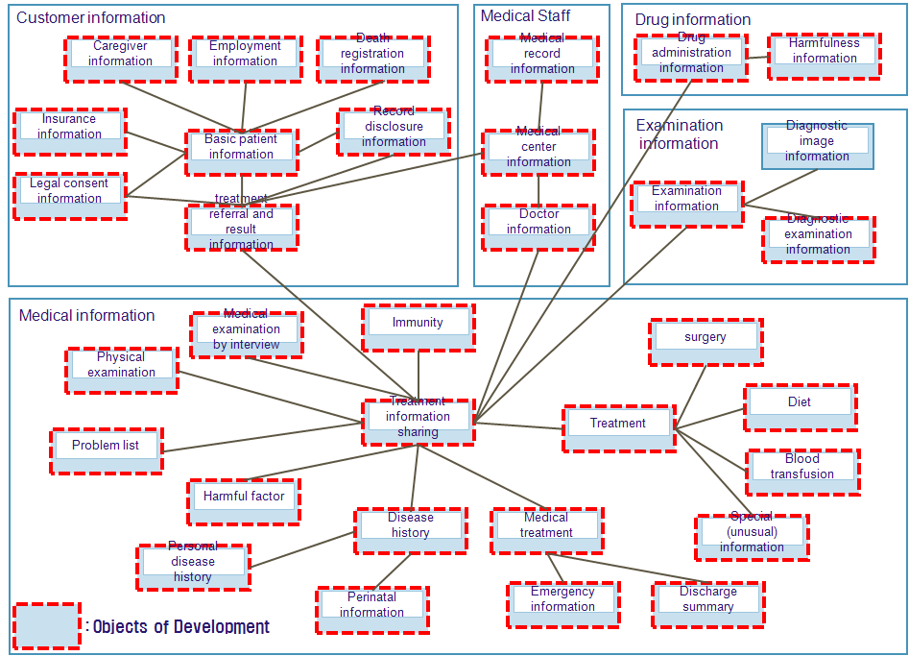
[Figure - 20] Target items for pilot central DB implementation

Information is temporarily stored in a server during the implementation of central HIS system without implementing a separate central DB.

Central DB Information Transmission
For the central DB, diverse factors need to be considered including information reliability, transmission processing time, immediate provision of analyzed information etc. Review and inspection are required to achieve efficient transmission between central HIS system and central DB. Also, in order to minimize system load and to reduce transmission time, information is classified into real-time transmission information and batch-processing transmission information. For the transmission of high-quality and highly reliable information, transmission is conducted based on various procedures which include data cleaning.

Pilot System Technological Architecture
Even there are two functions of pilot system, it is cost-efficient to install the central DB in the central HIS server without establishing a separate server because the DB is for design and verification use(not for service in real). The central HIS server will have the function of HA (high ability) which is to make the information service always available even during system failures.

H/W specification of HIS is as follows. The amount and detail specification are subject to change at the final proposal and the capacity is estimated based on Korea cases of HIS development. Two medical institutions are selected as targets – a hospital with 500 beds and a polyclinic with 100 outpatients. According to the Korea case, the number of outpatients is double of the number of beds, the CPOE per patient is 66.67 tpmC and EMR per patient is 33.33 tpmC for the central HIS. See the below for more details.

[Table - 37] Example of Sever cost estimation criteria
System |  | Outpatients | Inpatients | tpmC
CPOE |  | 1,100 | 400
 |  | SUM | 1,500 | 100,000
EMR |  | 1,100 | 400
 |  | SUM | 1,500 | 50,000
 |  |  | SUM (tmpc) | 150,000
 |  |  | Rate of available capacity 200% | 300,000

A CPU with 1 core processes 50,000 tpmC, so 6-core CPU is required to handle 300,000 tpmC. But the minimum CPU specification is over 4-core, it is the best to utilize total 8-core of CPU. (For the HA configuration : Active 8-core – Standby 8-core)

[Table - 38] Specification of pilot system
Items | Quantity | Specification
DB Server | 2 | HP rx2660 (CPU: over 4core) 16Gb Memory
Application Server | 2 | HP rx2660 (CPU: over 4core) 12Gb Memory
Development Server | 1 | HP rx2660 (CPU: over 2core) 8Gb Memory
Configuration management server | 1 | NT server
DNS server | 4 | NT server
Interface with Medical Equipment | 4 | NT server
Backup server | 1 | NT server
Storage(5 Tera) | 1 | 5 Tera Byte

See 6.2.1 Costs at Prototype phase for more details.

Plan for Integrated Implementation
According to incremental implementation(5.1.4) procedures based on implementation strategy, a ‘integration’ step is regarded as the scope expanding the functions of a pilot system developing IDC, performing the following.

Major Task related to System Integration
In the integration step, the central DB information temporarily saved in the HIS during pilot is stored in a dedicated server for information link service. Also, IDC is developed according to the expansion of target hospitals for central HIS service.
- Implementing database: Data model that was proven at pilot phase will be transferred to Central database. Data coming from medical institutions will be gathered, refined, processed according to the requirements and objectives. Then it will be stored at Central Database. Characteristics of data in Central Database are mostly aggregative and repetitive so it is very important to maintain information integrity. Medical information could be very frequently changed for example cancelling, delaying of reservation, appointment and so forth. So it is indispensible to establish some measures or functions so as to keep information integrity when storing data at Central Database.
- Implementing link system: link module (system or application programs) will be developed so that it can gather medical information from various medical institutions and can offer necessary information to institutions requiring that information. It will be necessary to develop online link, batch link for massive data and some application program for people to enter data directly. Establishing a link system only does not mean everything is done for information link. Specific rules or standards are very necessary to share data between information systems so absolutely there should be some efforts to establish rules and standards to share medical information thru health standardization and BPR/ISP, then should observe this while linking systems. HL7 CDA protocol is a global medical standard to share medical information between medical institutions so each medical institution should be able to transform medical information thru HL7 CDA to share medical information between medical institutions.
- Implementing a user portal system: application system will be implemented for people to utilize information such as personal medical information, drug prescriptions, health prevention for health, treatment reservation. At initial service phase, there might be no data enough to offer the information mentioned above so it is necessary to offer detail inquiry information rather than statistics so that it can promote the utilization of information on treatment activities. Since of course there are personal information and treatment information it could be used wrongly other than health. Therefore systematic and technical means such as security, information protection etc. should be established together.
- Implementing functions to handle authentication and authority: system to deal with user’s authentication and access control will be implemented since personal information within Central Database needs to be secured. It might be better to utilize e-ID system that are currently under construction in Armenia however if it might not be possible separate system should be established.
- Establishment of IDC center for HIS service expansion: The HIS system installed during pilot system implementation is relocated to IDC center. The HIS service is provided to 20% of hospitals and 20% of policlinics in the metropolitan area (which means about 10 hospitals and 20 policlinics). The metropolitan area has stable network infrastructure compared to other area and medical services for public are mostly provided in this area.

[Table - 39] Number of medical institutions by type
Classification | Yerevan | Other areas | total
Number of general hospitals | 48 | 82 | 130
Ambulatory-policlinic | 117 | 357 | 474

IDC is a new concept service which emerged with the growth of the Internet industry, and it is to provide maintenance and other services by renting or installing IT or network facilities. IDC provides the management and operation of server or communication equipment of large scale which one hospital may not afford to operate itself, and offers integrated services including high-tech facilities and security services.
There are two operational methods for IDC including ASP (Application Service Provider) and SaaS (Software as a Service). They are identical in that both install a central data center for service provision. However, the difference is that while the ASP offers different application S/W to different hospitals using its service, the SaaS provides identical application S/W to their client hospitals. We recommend the SaaS service, considering the current conditions at Armenia’s medical institutions.
The healthcare environment in Armenia is at the initial stage of technical systemization and there is a shortage of economic and technological capability of building their proprietary system by themselves. Considering these factors, it is recommended to take SaaS approach and it will also help apply medical standard process to hospitals.
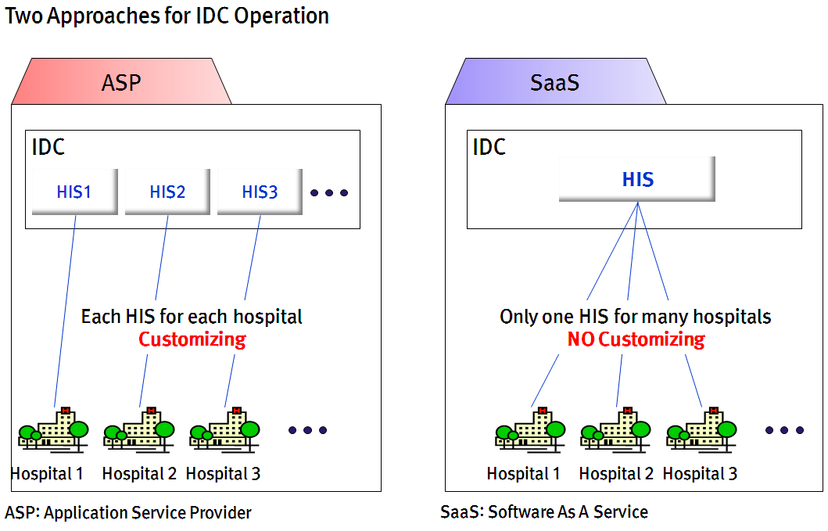
[Figure - 21] IDC Operation Method

The following shows the differences in system implementation and operation between the existing method and IDC method.

[Table - 40] Comparison between existing method and IDC method
Classification | Existing method | IDC
Classification | Existing method | ASP | SaaS
Implementation | Establishment of an information system at each hospital, and the implementation and operation of HIS | Establishment of all necessary systems such as server, network and security for information provision by the central IDC  Installation of PC and network at each hospital to meet the minimum requirement for service provision
Implementation |  | HIS implementation at each hospital for information service provision | Information service provision to all hospitals using only one HIS
Operation | Operation using the budget of the central or local governments | Operation using government budget, or  Operation based on service fees paid by hospitals after setting up an investment center by an outside private institution
Maintenance | Installation and operation of maintenance system at each hospital | Maintenance by IDC central level
Easy implementation | Consideration of specific operational and technological environments at each hospital | Consideration of hospital working environment | Need of a lot of time and effort to develop a standard when establishing an HIS to be used by all hospitals
Internet speed | No impact on Internet speed with the use of local networks at each hospital | The stability and speed of network infrastructure across Armenia is the key to success
Cost for implementation and expansion (government/MoH) | With an increase in the number of hospitals, implementation cost will rise proportionately | Since each hospital has to build its own HIS, the cost rises proportionately. However, the cost is much lower than the existing method due to the sharing of a central IT infrastructure | The effect of cost saving increases with system expansion due to the use of a single HIS and sharing of H/W infrastructure

Integrated System Technological Architecture
30 medical institutions use a system that integrates a server for HIS expansion and a server for central DB in IDC. For better understanding of integration system configuration, it is described by central HIS, central Data Base and link system.

30 targets are selected with 10 hospitals with 500 beds-size, 20 polyclinics with 100 outpatients. According to the Korea case, the number of outpatients is double of the number of beds, the CPOE per patient is 66.67 tpmC and EMR per patient is 33.33 tpmC for the central HIS. See the below for more details.

[Table - 41] Example of Sever cost estimation criteria
System |  | Outpatients | Inpatients | tpmC
CPOE |  | 7,000 | 4,000
 |  | SUM | 1,1000 | 733,333
EMR |  | 7,000 | 4,000
 |  | SUM | 1,1000 | 366,667
 |  |  | SUM (tmpc) | 1,100,000
 |  |  | Rate of available capacity 200% | 2,200,000

A CPU with 1 core processes 50,000 tpmC, so 44-core CPU is required to handle 2,200,000 tpmC. As the number of core increased by 4 times, this system requires 64-core. It uses HA configuration with Active 64-core – Standby 64-core.
[Table - 42] Specification of central HIS
Items | Quantity | Specification
HIS DB Server | 2 | HP SuperDome (32-core ) 128Gb Memory
HIS Application Server | 2 | HP SuperDome (32-core) 128Gb Memory
Application Server | 1 | HP rx2660 (CPU: over 2-core) 8Gb Memory
DNS Server | 1 | NT server
Interface with Medical Equipment | 30 | NT server
Configuration management server | 1 | NT server
Server Security | 1 | NT server
DBMS Security | 1 | NT server
USB Security | 1 | NT server
Integration PC Security | 1 | NT server
Storage (5Tera) | 5 | 25 Tera Byte

See 6.2.1 Costs at Prototype phase for more details.

The following is a technical architecture describing a central Data Base implementation and information link system. It consists of a central DB system having data from medical institutions using central HIS and using other HIS and a system providing PHR service, statistical service and information link service.
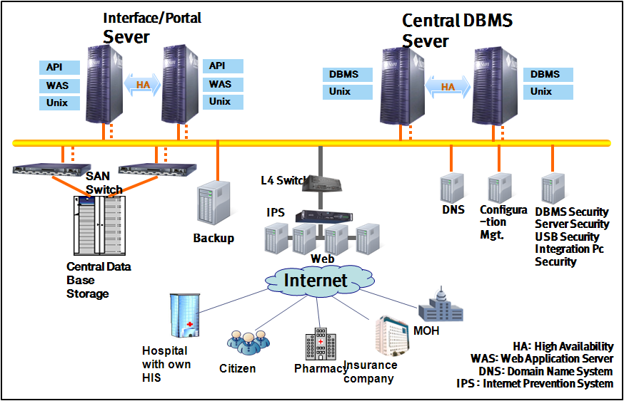
[Figure - 22] A technical architecture of Central DB and Information link

Also through the central database implementation, a portal service is provided in order to utilize central database information. In that case, e-ID system is used for user authentication.
[Table - 43] Specification of central DB
Items | Quantity | Specification
Central Data DB Server | 2 | HP SuperDome (32-core ) 128Gb Memory
Portal/Link Server | 2 | HP SuperDome (32-core) 128Gb Memory
Web Server | 4 | NT server
Storage (10Tera) | 5 | 50 Tera Byte
- .
See 6.2.1 Costs at Prototype phase for more details.

When an IDC center is established, most of the above-mentioned functions can be achieved at lower cost than the installation of a separate system even though the establishment of an IDC center would require the cost for its construction and diverse facilities for electricity, ventilation, fire-fighting, security etc. Also, its operational safety is ensured.

Expansion Plan
According to incremental implementation(5.1.4) procedures based on implementation strategy, a ‘expansion’ step is regarded as the scope of expanding system functions of the integration step.

Major Details related to System Expansion
In the expansion step, the central HIS service will be provided to 300 medical institutions in metropolitan area of Armenia – 65 hospitals and 235 polyclinics, and all functions of the central HIS will be implemented with additional expansion of PACS and ERP. So the PACS and EMR data will be implemented in the central DB and additional application and API will be developed for the information link service of accumulated data in the central DB. The expansion step is to materialize the concept model of Armenia’s e-Health project, and it means the completion of its national e-Health system.

- An information system is more than just a work supplementary tool, but it is an essential element for operations at medical institutions. When the information service is stopped, it means medical treatment process is also stopped, threatening the health of patients. Therefore, it is necessary to build up a fail-safe system and a system which ensures information recovery whenever needed.
- In addition, a DR system which is a counter-disaster system needs to be installed because most of information losses occur during natural or man-made disasters. When it comes to DR system implementation, diverse options are possible depending on the time required for recovery. The implementation costs and operation methods for DR system also differ depending on whether it will be used independently or shared with other industries.

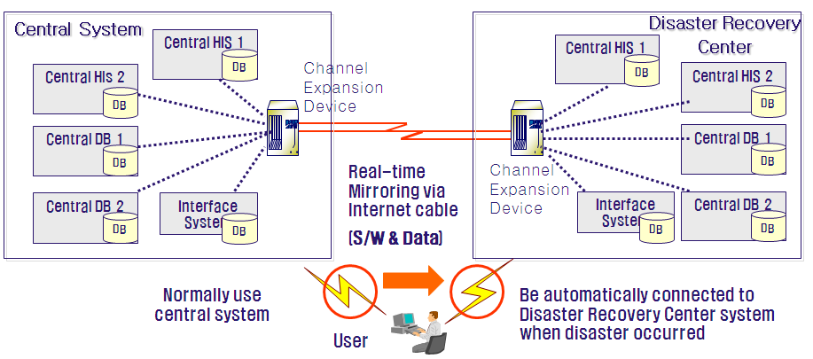
[Figure - 23] DR system configuration diagram

- Also, the modules for PACS, ERP etc. will be added to the central HIS service. However, if the bandwidth or speed of Armenia’s networks do not improve by the time of system expansion, the sharing service of video display will be difficult to provide. If required network infrastructure is available, however, a pilot system will be installed in IDC to validate the standards for PACS and ERP by selecting one large hospital and one policlinic. They should be representative of their respective fields for the reliable validation of the standards, and should have various treatment departments and processes. In addition to the standardized common feature, extending special feature should be considered aiming for the high utilization and satisfaction of information system.

Target Item for System Expansion
The central DB of an integrated system includes all information generated during medical treatments except radiological examination information, and therefore, its further expansion is not required. However, in the case of central HIS, it is inevitable to modify their components to keep up with changes in medical service models. Therefore, its maintenance should be conducted with focus on the response to changes.

- Change management of central DB: With the connection between the central DB and related organizations, more efficient utilization of medical information will be achieved on a national level. However, the emergency of new businesses will lead to new and additional requirements. In this sense, the implementation of the central DB system cannot be completed, but it will require continuous upgrades.

- Change management of central HIS: Just like the central DB, new requirements will emerge for the central HIS. A new or changed process in medical institutions effects HIS information and it leads the change of the central DB model. Therefore, close cooperation with management organizations of the central DB needs to be achieved.

Expanded System Technological Architecture
300 medical institutions use a system that integrates to a server for HIS expansion and a server for central DB in IDC. A technical architecture of expanded system is as follows.
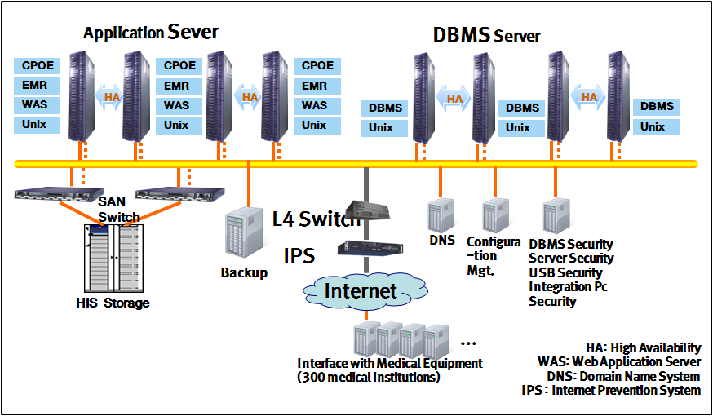
[Figure - 24] IDC technical architecture for expanding central HIS on 300 medical institutions

In 2009, the number of hospitals and polyclinics in Armenia were 600. Assuming that the hospitals where will use a central HIS are 50% of total, so 300 targets are selected with 65 hospitals, 235 polyclinics. According to the Korea case, the number of outpatients is double of the number of beds, the CPOE per patient is 66.67 tpmC and EMR per patient is 33.33 tpmC for the central HIS. See the below for more details.

[Table - 44] Example of Sever cost estimation criteria
System |  | Outpatients | Inpatients | tpmC
CPOE |  | 36,000 | 9,750
 |  | SUM | 45,750 | 3,050,000
EMR |  | 36,000 | 9,750
 |  | SUM | 45,750 | 1,525,000
 |  |  | SUM (tmpc) | 4,575,000
 |  |  | Rate of available capacity150% | 6,862,500

A CPU with 1 core processes 50,000 tpmC, so 137-core CPU is required to handle 6,862,500 tpmC. As the number of core increased by 4 times, this system requires 256-core. It uses HA configuration with Active 128-core – Standby 128-core.
[Table - 45] Specification of central HIS in 300 medical institutions
Items | Quantity | Specification
HIS DB Server | 4 | HP SuperDome (32 core ) 128Gb Memory
HIS Application Server | 4 | HP SuperDome (32 core) 128Gb Memory
DNS Server | 1 | NT server
Interface with Medical Equipment | 300 | NT server
Storage (10Tera) | 50 | 500 Tera Byte

See 6.2.1 Costs at Prototype phase for more details.

Next, PACS and ERP are installed for functional addition in the central HIS. The capacity of PACS is as the 500 sized in Korea and the specification is estimated assuming the system processes 1500 cases of imaging information. An ERP server is used as the central HIS in IDC.

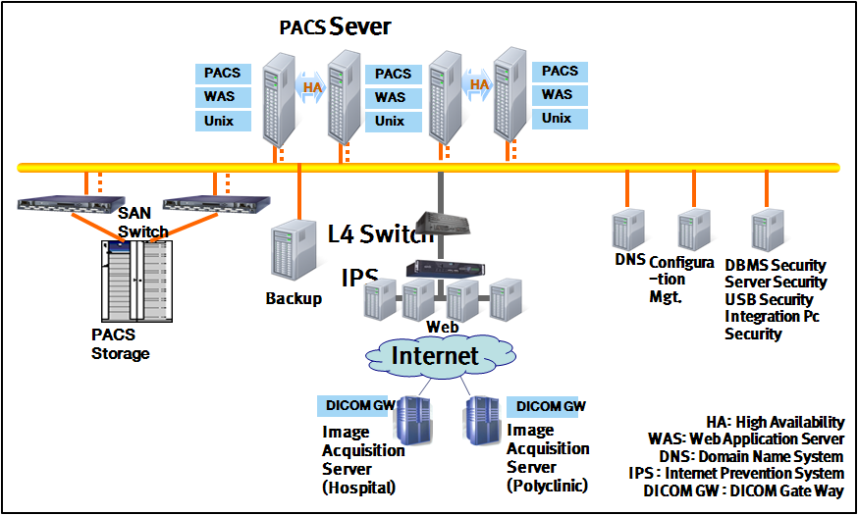
[Figure - 25] PACS Technical Architecture

[Table - 46] Specification of Central PACS
Items | Quantity | Specification
PACS Main DB Server | 2 | HP DL580 G6 Quad-Core 2.66GHz
HA Server | 2 | HP DL360 G6 Quad-Core 2.66GHz
Image Acquisition Server (Hospital) | 4 | HP DL360 G6 Quad-Core 2.4GHz
Image Acquisition Server (Polyclinic) | 1 | HP DL360 G6 Quad-Core 2.4GHz
WEB Server | 4 | HP DL360 G6 Quad-Core 2.66GHz
Storage (20Tera) | 2 | 40 Tera Byte
See 6.2.1 Costs at Prototype phase for more details.

Education Plan
Systematic management is required to deal with changes in related work environments due to the adoption of e-Health system in Armenia.
It is inevitable to face changes, and in particular, the adoption of a new system in the medical sector will lead to many changes in the way of working as well as in all related environments.
If Armenia does not handle these changes properly, its healthcare sector may fail to develop further, and its overall medical system may face a risk of deterioration.
In particular, in many cases, the major cause for the failure of change management is the lack of basic activities for change management, including: the resistance to change by related persons; lack of communication; and lack of understanding of the need of change. To deal with such problems, system operators and users need to be encouraged to have smooth communications between them, and to participate more actively in required efforts. To this end, appropriate training should be given to related persons so that the purpose of change management can be achieved and the e-Health system can be completed.
With this recognition, we suggest the following education and training program for system operators and users so as to minimize their resistance to changes after the adoption of e-Health system, and to ensure the stable and efficient operation of the system.

Outline
Major players in Armenia’s healthcare sector including healthcare policy makers, medical institutions and general users need to be provided with training on e-Health system itself as well as the overall environments of the system in order to make sure that they can utilize the system in a way that supports their efficient work operation and fits the purpose of system adoption.
A training plan should be developed, fully considering the features of Armenia’s medical environment, including the size and characteristics of medical institutions, IT environment, medical gap between regions etc.
Through the introduction of e-Health system and provision of comprehensive training which are conducted by reflecting the above-mentioned features, the following positive effects can be achieved: the maximization of user capacity to utilize the e-Health system; early establishment of e-Health system; stabilization of e-Health system by immediately dealing with errors or failures that may occur during system operation.
We propose the following training plan as a way to realize the purpose of e-Health system, and to operate e-Health system in an efficient and stable way.

Goal of Education
The goals of the training for the operators and users of e-Health system in Armenia are as follows:
- Understanding of the policies, instructions and standards (security, operation guideline etc) related to system operation, user IT technology utilization, IT technology development, IT system operation etc.
- Nurturing of experts in core operational technologies
- Training of users on operational environment and related technology
- Developing of the capacity for early establishment, operation and utilization of e-Health system

Principle for Training Plan Development
The principles for developing a training plan are as follows which aim to achieve the stable operation and use of the e-Health system, to improve work performance, and to maximize maintenance capacity.
- Development of training plans for each target trainee group
- Development of systematic training programs for each target field
- Development of training methods that meet diverse training needs
The above principles should be followed when establishing training plans so as to ensure the efficient conduct of training.

Target Trainee
The target trainees for Armenia’s e-Health system are all users of organizations in charge of system operation and maintenance.
[Table - 47] Target Trainee
 | Central DB System | Central HIS
Operator | - Central organization IT manager and staff | - Hospital IT manager and staff
User | - Persons in charge of data collection and policy-making for the central DB  - Persons in charge of data input at medical institutions (hospitals, insurers, pharmacies etc.) using the central DB  - Future users of the central portal service | - The management  - Medical professionals (doctors, nurses)  - Staff and other users

Training Content
Operators will be trained on the operation and maintenance of the system to be capable of dealing with problems that may occur during system operation and use. Meanwhile, users will be trained on system functions and data input so that they can perform their work in a more efficient and smooth way.
A systematic training program needs to be developed to meet the needs of target trainees, covering the following.

[Table - 48] Training Content
 | Central DB System | Central HIS
Common | - (Operator) Concept of the information environment the supports the processing of healthcare-related work  - (Operator) Purpose and need of the adoption of each system (central DB, HIS etc.)  - (Operator) Policies, standards and instructions for the operation of IT systems (e.g., IT-related law, security policy, operation, information sharing, back-up etc.)  - (Operator) Matters related to system operation including system monitoring, security, system configuration and troubleshooting etc.  - (User) Concepts of PC and information system (including basic concept and configuration), and related general matters (function, procedure, program utilization)
Operator | - Training on H/W, N/W, application S/W, and security technology for the management and operation of the central DB | - Training on H/W, N/W, application S/W, and security technology for the management and operation of HIS
User | - Detailed functions of, and utilization procedures for, the central DB system  - Data input according to standard | - Detailed functions of, and utilization procedures for, the HIS system  - System utilization methods for users (procedures, data input method etc.)

Conduct of Training
Training for system users and operators needs to be conducted in consideration of the following:
First, a presentation will be held for relevant persons from medical institutions in cities before system adoption to provide them with training on system concept, need of system adoption, and expected benefits so as to minimize their resistance to system introduction due to work environment changes.
Additionally, a plan will be developed to visit target trainees at medical institutions in the countryside and remote areas to provide training to them.
Second, after the adoption of system, operators and users will become more familiar with the system by using the manuals for system operation and use. Finally, online training will be provided so that system users and operators can receive training whenever and wherever they want to.
Given the low utilization rate of the IT system in Armenia, necessary training programs for online training will also be supported.

[Table - 49] Training Method
 | Details
Presentation | - A presentation will be held for system operators and users from central and related organizations before the adoption of e-Health system  - Training will be conducted on expected changes in work processing environments due to system adoption  - Training will be conducted on the concept, purpose and need for each information system
Visit training | - Visit training will be provided to target trainees at medical institutions in the countryside and remote areas.  - A plan will be developed for regular visit training.
Training manual | - Manuals for the use and operation of each system will be developed.  - System users and operators will be able to learn more about relevant information systems using manuals.  - Considering the low utilization rate of the IT system in Armenia, measures will be developed to help new workforce to learn about the system easily and efficiently (provision of e-manuals, video contents for education etc.)
On-line training | - A basis for online training for system users and operators will be prepared.  - Access to online training will be possible whenever and wherever users and operators want.  - Users and operators can receive training on relevant systems using the Internet.  - The communication and email exchange will be supported for efficient training.

Implementation Plan

System Implementation Schedule

Implementation Task
The major tasks for the implementation of Armenia’s e-Health system are as follows.
[Table - 50] Implementation Task
Stage | Implementation Goal | Major Task
Stage 1 | Preparation | - Establishment of laws, institutions and policies for e-Health service system including security issues  - Formation of a task force for the e-Health project
Stage 2 | Prototype | - Establishment of Armenia’s health standard based on global standard  - Standardization of business processes and Information Strategic Planning for the application services at central hospital  - Implementation of HIS (for general hospital and policlinic center) based on Armenia’s health standard  - Definition of management items and verification of utilization
Stage 3 | Integration | - Building of IDC center for central service (HIS, DB)  - Applying standard-based HIS that implemented at prototyping phase to central service, and extending it for 30 medical institutions  - Implementing central DB system (data storage), portal, information linking system, authentication and authorization functions (linking with e-ID)
Stage 4 | Extension | - Extending central HIS into 300 medical institutions  - Expanding functions of central HIS (offering additional module such as PACS, ERP)  - Increasing number of medical institutions that would be connected with central DB system (with disaster recovery)

The following shows details of each implementation task.
[Table - 51] Details of Implementation Task
Goal | Implementation Task |  | Duration | Details | Required man power
Preparation | - Formation of a task force for the e-Health project |  | 06 | - Formation of teams to be responsible for the operation, management and supervision of e-Health system implementation
Preparation | - Establishment of laws, institutions and policies |  | 06 | - Development of standards and regulations for the protection and use of health information, and establishment of laws, policies and institutions for the operation of Armenia’s e-Health system
Proto-type | - Development of Armenia’s medical standard/ BPR /ISP |  | 09 | - Development of medical standard for the implementation of e-Health system (terms, formats, codes, information exchange etc.)  - Defining business processes and performing ISP for building Armenia’s HIS services | - Consulting on standard terminology  - Establishing standards on clinical contents  - Consulting on treatment process  - Designing system architecture
Proto-type | - Implementing standard-based HIS |  | 09 | - Implementing Armenia standard HIS at target institutions (general hospital and policlinic center) | - CPOE: engineers for analysis, design and development of administration, treatment, prescription, auxiliary support  - EMR: engineers for analysis, design and development of treatment, nursing and integration  - Engineers for analysis, design and development of system functions and application optimization for polyclinic  - DBA (Database Administrator)
Proto-type | - Designing & Verification for Central DB |  | 09 | - Designing central DB where information is gathered from standard-based HIS, and verifying data | - Analysis and modeling for requirements on central DB
Integration | - Building an IDC |  | 06 | - Expanding standard HIS into each medical institution, and building central IDC | - Technical architecture  - Engineers for Operation and maintenance after implementation
Integration | - Implementing central HIS |  | 12 | - Applying standard HIS to central service, which were implemented at prototyping phase  - Commencing central HIS service to 30 medical institutions | - Engineers for central system  - Engineers to be dispatched for porting, testing and training (running 2 teams at the same time)
Integration | - Building central DB | - Construction for DB | 09 | - Building central DB system (data storage) | - Engineers for analysis, design and development related to implementing central DB  - Engineers for analysis, design and development related to portal  - Engineers for analysis, design and development related to API  - DBA
Integration | - Building central DB | - Implementation for Portal & Information Link system | 09 | - Implementing portal, information linking system, (authentication and authorization functions (linking with e-ID))
Extension | - Expanding central HIS |  | 15 | - Installation of essential medical service functions such as PACS, MIS and ERP based on the central HIS 2nd model  - Commencing central HIS service for 300 medical institutions | - Engineers for porting, testing and training
Extension | - Expanding functions of central HIS |  | 09 | - Expanding functions of central HIS (offering additional module such as PACS, ERP) | - Engineers to analyze, design and customize ERP  - Engineers for PACS  - Engineers for Operation and maintenance after implementation
Extension | - Expanding linkage into unlinked medical institutions |  | 09 | - Completing linkage between central DB system and all medical institutions in Armenia (expanding system performance and building disaster recovery center) | - DB modeler  - Engineers to develop additional requirements  - Engineers to support link

Implementation Schedule by Tasks
The following table shows the schedule for each task of Armenia e-Health implementation.
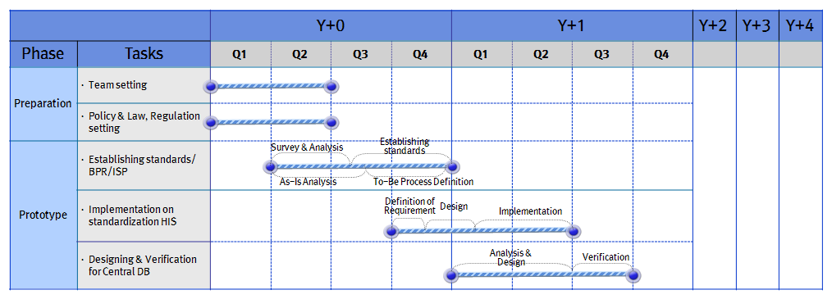
[Figure - 26] Schedule of Preparation & Prototype Implementation phase

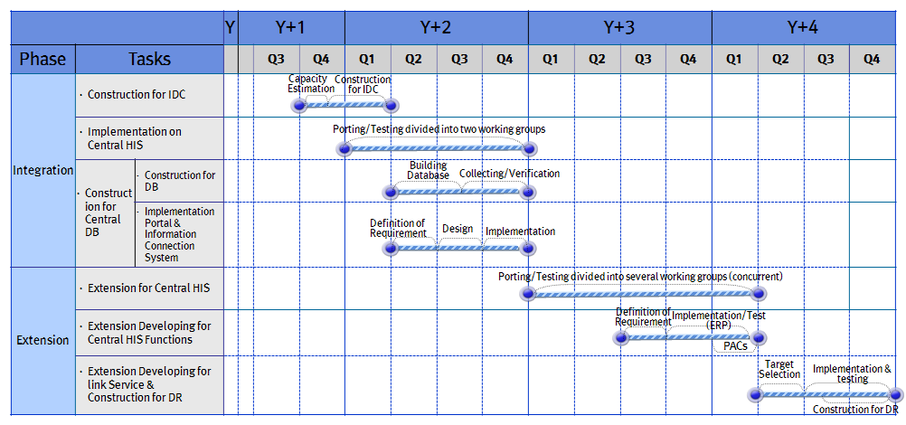
[Figure - 27] Schedule of Integration & Extension phase

Qualitative Analysis of the Effects
The introduction of e-Health system is expected to have the following effects for the government, medical institutions and general public of Armenia.

Effect for Government
The positive effects expected for Armenia’s government are as follows.

[Table - 52] Expected effects for policy institutions
Expected effects | Details
Fast acquisition of policy statistical data | - Through the creation and distribution of necessary health information electronically, the establishment of healthcare policies in a timely manner  - Real-time collection, writing and submission of health information using an information system.
Enhancement of the efficiency of policy development and management | - Fast and efficient conduct of health-related operations through the real-time collection and analysis of the evaluation results from medical institutions and basic data related to diseases  - Promotion of efficient work performance through health information exchange between the central system and medical institutions
Quality improvement of national healthcare service | - Online provision of the information related to the monitoring and inspection of diseases including infectious diseases, and the protection of public health by making an online notification to the public and related institutions regarding recommended vaccination in case of emergency  - Promotion of public health by providing latest information on the prevention, control, dietary therapy, special medical institution, medication etc. regarding chronic diseases such as diabetes and hypertension  - Electronic reporting of disease information, and the establishment of a national disease response system by securing a distribution system
Promotion of health information industry | - Dissemination of computerization in health and medical sector through the medical standardization  - Preparation for the advancement of medical IT by acquiring the technological capacity for e-Health information system  - Opportunity for export to neighboring countries if Armenia’s e-Health system is successful, leading to the medical information industry vitalization

Effect for Medical institution
The positive effects expected for medical institutions (hospitals, pharmacies, insurers etc.) as follows.
[Table - 53] Expected effects for medical institutions
Expected effect | Details
Enhancement of the operation efficiency of medical institutions | - Electronic management of health information flow from patient registration, prescription, examination, drug administration, patient transfer to patient discharge, leading to more efficient operations of medical institutions and saving unnecessary hospital visit and waiting time  - Electronic management of patient charts which are essential to patient treatment, eliminating the need for physically carrying them for patient examination or treatment. Online search of health information and prescription by doctors  - Reduction of time for miscellaneous work through the management of finance and accounting in an automatic and electronic way. Enhancement of work efficiency when creating reports or statistics by improving the accuracy of finance data  - Improvement of work satisfaction and training effect by providing online training and support service on a constant basis
Reduction of medical cost | - Reduction of unnecessary work time for medical treatment and hospital administration through the automation of management duties.  - Immediate identification of errors in medical prescription or fee through electronic information management and online information exchange. Reduction of cost for treatment and information management
Contribution to medical development | - Electronic provision of medical information and data (papers, research results, journals etc.), improving the accessibility of medical data and contributing to medical development
Contribution to medical error reduction | - The review of patient information and his/her medication history before the writing of a prescription by doctors in order to prevent the overlapping use of drugs and banned combination of drugs, thereby securing the safety of patients  - Prevention of drug-related accidents due to the abuse or misuse of drugs by requiring pharmacies to review relevant health information online before filling a prescription

Effect for the Public
The positive effects expected for Armenia’s general public are as follows.

[Table - 54] Expected Effect for the General Public
Expected Effect | Details
Enhanced satisfaction with medical service | - Using of online appointment service, which helps patients to visit hospital at their convenience or make an appointment for when they do not have to wait long  - Reduction of waiting time through automated work process at hospitals, and saving of work time through the electronic processing of information including patient registration, discharge, medical report issuance etc.  - Provision of customized services for health information provision through a central portal such as the information related to vaccination, health examination etc., improving the health and health management of the public
Patient safety through measures against medical errors | - Easy check of patient information by medical professionals with information access authority to use the treatment information sharing system, to prevent unnecessary reexaminations and misdiagnosis related to treatment and prescription
Convenience in using medical service | - Utilization of hospital information service provided by the government or the Ministry of Health, which helps patients or general public to select a hospital which can provide the best medical service to them based on information such as hospital names, locations, treatment areas, specialized services, customer satisfaction levels, hospital evaluation results etc.  - More choices for patients when they choose a hospital, and saving of time and cost by preventing unnecessary or long-distance visits to hospitals

Infrastructure Investor Armenia An Intelligence Report, 2009, PEI, www.infrastrueinvestor.com
Market Mechanisms & the Health Sector in Central & Eastern Europe, Alexander S. Preker, Richard G. Feachem, Washington, DC., World Bank technical paper 293, 1995.
Armenia 2005 Demographic and Health Survey, 2005, National Statistical Service of RA, http://www.armstat.am
Infrastructure Investor Armenia An Intelligence Report, 2009, PEI, www.infrastrueinvestor.com
Armenia Health system review, 2006, WHO Regional Office for Europe, www.euro.who.int
Armenia Health system review, 2006, WHO Regional Office for Europe, www.euro.who.int
Armenia 2005 Demographic and Health Survey, 2005, National Statistical Service of RA, http://www.armstat.am
Armenia Health system review, 2006, WHO Regional Office for Europe, www.euro.who.int
Infrastructure Investor Armenia An Intelligence Report, 2009, PEI, www.infrastrueinvestor.com
Armenia Health system review, 2006, WHO Regional Office for Europe, www.euro.who.int
Armenia: Health System Performance Assessment 2009, WHO Regional Office for Europe, www.euro.who.int
Armenia Health system review, 2006, WHO Regional Office for Europe, www.euro.who.int
Armenia: Health System Performance Assessment 2009, WHO Regional Office for Europe, www.euro.who.int
Armenia: Health System Performance Assessment 2009, WHO Regional Office for Europe, www.euro.who.int
Country Brief 2010, April 2010, World Bank, http://go.worldbank.org/03U3YND6C0
Armenia Project Briefs, 2010, http://siteresources.worldbank.org/
Armenia: Health System Performance Assessment 2009, WHO Regional Office for Europe, www.euro.who.int
Armenia Health system review, 2006, WHO Regional Office for Europe, www.euro.who.int
Voluntary Health Insurance In Armenia : Issues and Options, Health Financing Policy Paper 2007/3, WHO Regional Office for Europe, www.euro.who.int
Armenia Health system review, 2006, WHO Regional Office for Europe, www.euro.who.int
2008 HEALTH AND HEALTH CARE IN ARMENIA, 2009, Ministry of Health
National Health Insurance Corporation,
50 Years of Legislation History of the Republic of Korea, Legislation Information Center of the Ministry of Government Legislation, http://www.klaw.go.kr
Research on How to Improve Korea’s Healthcare Delivery System, Regional Welfare Policy Vol. 11
Armenia IT Industry Report, 2009, EIF
Building Information Society and IT Industry in Armenia, 2007, EIF
2010 Europe ICT Report, 2010, KOTRA
Armenia IT Industry Report, EIF, 2009
YEREVAN COMPUTER RESEARCH AND DEVELOPMENT INSTITUTE, http://www.ycrdi.am/
Health Project Implementation Unit , http://www.healthpiu.am
COMPUTER & INFORMATION SCIENCE PROGRAM, American University of Armenia, http://cis.aua.am/
Medical Fee Schedule: A standard list of medical service fee assigned by hospital or government.
It is to set up an IDC including security functions in order to operate an information system for medical professionals or centers who cannot afford to install and operate their own information system in return for fees for its application system.
Report of EHR Task Force of the Ministry of Health and Welfare
HL7 : Health Level 7
Clinical Document Architecture
International Organization for Standard 27001
Health Insurance and Accountability Act
Computerized Physician’s Order Entry
Electronic Medical Records
Picture Archiving & Communication System
Laboratory Information System
Enterprise Resource Planning
SLB : A software function to effectively utilize work processing capabilities of device.
HA : A function to provide non-stop system responding any fault events from the device.
ILM: A management method to increase ROI in conjunction with business application and reduce TCO managing application data life cycle.
Firewall : A computer security system including H/W, S/W and N/W policy for building a door between internal network and external network(e.g. Internet).
IPS : An automatic intrusion response function and induced intrusion feature focusing on prevent attacks before alerts.
Web security :A function to protect web applications and the related assets(servers, DB, etc.)
Internet Data Center

